World War II Homefront

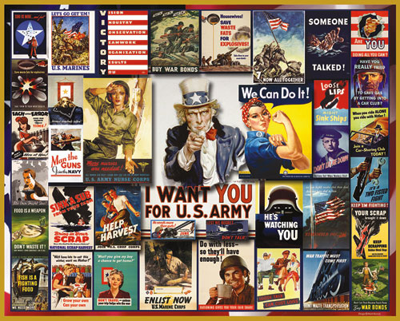

http://www.youtube.com/watch?v=LEItXS35g8o

THE HOME FRONT
http://www.history.com/interactives/inside-wwii-interactive
World War II was fought at home as well as on the battlefields. In fact, by 1942, the industrial capacity of the U.S. was equal to the three Axis nations combined and by 1944, it had doubled. Rationing was common-place as the production of war goods took precedence over consumer products. As in World War I, women and African Americans took factory jobs previously held by males and rights were taken away as well. Japanese-Americans living on the West Coast were forced to relocate to detention camps for the duration of the war.

PRESIDENT ROOSEVELT INCREASES HIS POWERS

COMMANDER IN CHIEF: Like Abraham Lincoln during the Civil war and Woodrow Wilson during World war II, President Roosevelt used his constitutional powers as Commander in Chief of the Armed Forces to increase the power of the Presidency. Roosevelt negotiated the Destroyer for Naval Bases Agreement with Great Britain helping equip them in their fight against Germany.

DOMESTIC POWERS USED TO HELP THE WAR EFFORT: Roosevelt was given broad powers which enabled him to direct the American economy and mobilize the necessary money and supplies for the war effort. Roosevelt also issued Executive Order 8802 which made the discrimination of African Americans illegal in factories producing war goods and in government positions. Executive Order 9066 was also issued which transferred the authority for the security of the West Coast to the Army. This allowed the internment of Japanese Americans into detention camps.

LOSS OF RIGHTS
SEGREGATION OF THE ARMED FORCES: A larger proportion of African Americans enlisted in World War II than white males. However, African Americans were not allowed into the Air Corps or the Marine Corps and were segregated in the Army. The Army used African American units as laborers and servants. Only after great pressure was mounted on President Roosevelt were African Americans allowed to organize into combat units and a few black officers were commissioned in the Air Force.

CURTAILMENT OF JAPANESE-AMERICANS CIVIL LIBERTIES: After the sneak attack on Pearl Harbor by the Japanese, many Americans feared the Japanese-Americans living on the West Coast might help sabotage American defenses to support the Japanese war effort. President Roosevelt issued Executive Order 9066 transferring authority for the security of the west Coast to the U.S. Army.
Shortly thereafter, Lt. General John DeWitt ordered the relocation of over 150,000 Japanese Americans from the West Coast to detention camps in the southwest and mid-west. Over two-thirds of the people who were relocated were Nisei (American-born citizens of Japanese ancestry.)

KOREMATSU V. U.S. (1944): Fred Korematsu was an American-born citizen of Japanese descent. Korematsu refused to obey the Executive order requiring all Japanese-Americans to leave their homes and be placed in detention camps. When Korematsu was arrested, he brought suit to federal court. Korematsu claimed that he was being denied his 14th Amendment rights (all citizens must be treated equally under the law) while the federal government claimed that the constitutional power to make war outweighed individual rights. In a 6-3 decision, the Supreme Court ruled against Korematsu. The Court stated that the 14th Amendment did not apply since we were al war and our national security demanded such measures. The Supreme Court stated that national security was more important that the protection of individual rights when we are at war

ECONOMIC
THE CHANGING LABOR FORCE: Over three million Women entered the work force to replace males drafted into the war effort. Also over one half million African Americans moved from the South into cities of the northeast to work in factories. President Roosevelt issued Executive Order 8802 making discrimination in the defense industries illegal.

GOVERNMENT CONTROL OF THE ECONOMY:
REVIEW: Homefront: World War I vs World War II
The WAR PRODUCTIONS BOARD controlled the products that each industry would produce. War goods were produced rather than consumer goods.
The WAR LABOR BOARD was a labor mediation board. Its purpose was to settle problems between workers and owners in order to prevent strikes and keep war production high.
The FAIR EMPLOYMENT PRACTICES COMMITTEE tried to curb the racial and religious discrimination within the work place.
The OFFICE OF PRICE ADMINISTRATION had to job of rationing materials that were needed for the war effort. To this end, items such as sugar, meat, and gasoline were not readily available to the American public. Rationing books were used to reduce demand on these products.

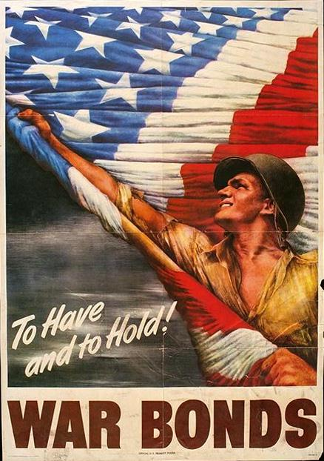

PAYING FOR THE WAR: For the first time, the federal government began taxing lower income people. The number of taxpaying workers rose from only 8 million to 55 million during the war. Also, federal taxes were withheld each week from workers paychecks. This gave the federal government working capital throughout the fiscal year.
FDR at War Conferences (Wartime Conferences)

