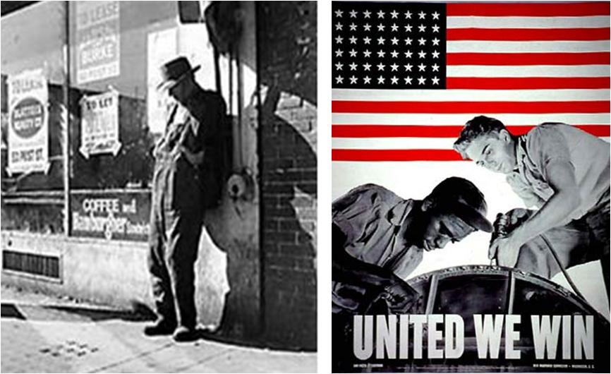

World War I 1917-1919 | World War II 1941 to 1945
Selective Service Act (1917)  10 Million men registered, 3 million served | Selective Service and Training Act ( September 1940) 5 million  volunteered. 16 million drafted
War Industries Board (WIB)  Encourages mass production and efficiency; increased production by 20% | War Production Board (WPB)  converted companies to wartime production; organized collection  of scrap metals, iron, tin, paper etc.
Fuel Administration Monitored coal supplies, rationed gasoline and heating oil | Office of Price Administration (OPA Posters)  Set up rationing of essential goods for the military
Committee on Public Information (CPI)  Progranganda agency that sold the war to the American people - paintings, posters, cartoons, and "four minute men" speeches | Propaganda Hollywood movies, musicals, plays, and magazines  (Life, Look, and Time) inform Americans about the war
Women Worked as volunteers. Encouraged the sale of bonds, planted victory gardens. Found in unfamiliar roles (jobs held by men) | Women
Office of Scientific Research and Development
(OSRD) Einsteins Letter
Enlisted scientists in the war effort.
Develop of radar, sonar, and the Atomic Bomb
 | African Americans , Native Americans , Japanese Americans

World War I Civil Liberties  Review Link 1798-1942  Schenck v. United States (1919)  ISSUE: Was the Espionage Act of 1917 (during World War I) unconstitutional because it violated the First Amendment right to freedom of speech?  DECISION: The Court upheld the Espionage Act of 1917, maintaining that freedom of speech & press could be constrained if “the words used…create a clear and present danger…” | World War II Civil Liberties  Review Link 1798-1942  Korematsu v. United States (1944)  ISSUE: The balance between government security and the civil liberties of the individual (during World War II).  DECISION: The Court upheld the government’s internment of Japanese citizens because the U.S. was at war, “…feared an invasion…,” and therefore was allowed “…to take proper security measures.”

