Woodrow Wilson

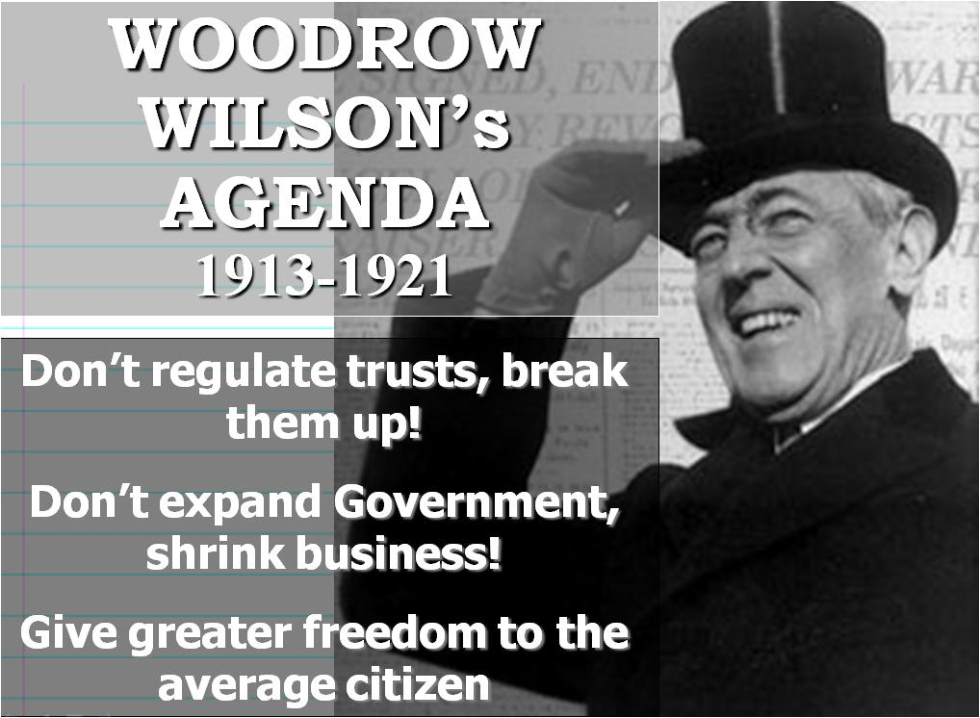

Overview
Born: December 28, 1856 in Staunton, Virginia...

Wilson was the first president since John Adams to address a joint session of Congress in person.

Displaying a potent intellect and a bold vision of expanded presidential influence, Wilson successfully refined the relationship between the executive and legislative branches of government.

A passionate defender of pacifism and America's official neutrality during the first three years of World War I, he found himself drawn into an intervention in Mexico and U.S. participation in the Great War.

He also sought, and failed, to rally his countrymen toward a spirit of international cooperation in its aftermath. Wilson’s burning idealism—especially his desire to reform ever-present wickedness—drove him forward faster than lesser spirits were willing to go. His found compromise difficult; black was black, wrong sense of moral righteousness was such that he often was wrong, and one should never compromise.

Wilson believed that the wall separating the executive and legislative branches of government was a hindrance to programs that would benefit the entire nation. He tried to work closely with Congress, especially with members of his own party.

Wilson, a strong progressive, attempted to free national politics from the grips of entrenched party machines and became a strong -- though not highly effective -- advocate of the primary process.

He entered the White House as a reformer. Although he disagreed with Theodore Roosevelt on several matters of policy, Wilson admired the way in which TR had used an aggressive style of leadership to champion certain causes.

President Woodrow Wilson's Domestic Policies

Wilson built on TR's notion of an expanded presidency.
He led the charge to attack the "triple wall of privilege”: the tariff, the banks, and the trusts.

LIMITS OF PROGRESSIVISM
African Americans

WOMEN in the PROGRESSIVE ERA
Impact of Triangle Shirtwaist Factory Fire: http://youtu.be/4ulaG9x4GpE

