William Taft
The Presidency of William Howard Taft: 1909–1912
A Review of 1 Term Presidents

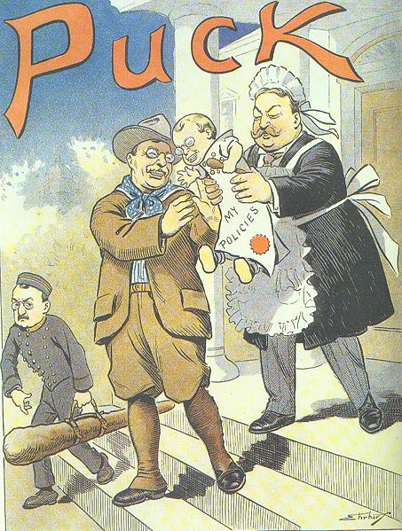

In 1904 TR vows not to run for re-election after his second term. He hand picks his successor William Howard Taft who wins easily in 1908. “Some people felt that TAFT stood for Takes Advice From Teddy

William Howard Taft (1857 - 1930)

1892-1900 - US Court of Appeals for the Sixth Circuit
1901-1903 - Governor-General of the Philippines

1904-1908 - Secretary of War

1906 - Provisional Governor of Cuba

1909-1913 - President of the United States

More Trust-Busting!!
After these unsuccessful attempts at diplomacy, Taft devoted himself to domestic matters, making trust-busting his top priority.

Amazingly, he filed 90 lawsuits against monopolistic trusts in just four years—more than twice as many as Roosevelt had filed in a little less than eight years.

In 1911, the Supreme Court finally used the previously neglected Sherman Anti-Trust Act to dissolve John D. Rockefeller’s Standard Oil Company for “unreasonably” stifling its competition. Later that year, Taft famously filed a lawsuit against J.P. Morgan’s U.S. Steel Corporation.

The lawsuit infuriated Taft’s predecessor and political ally Theodore Roosevelt, who had helped form the company back in 1901.

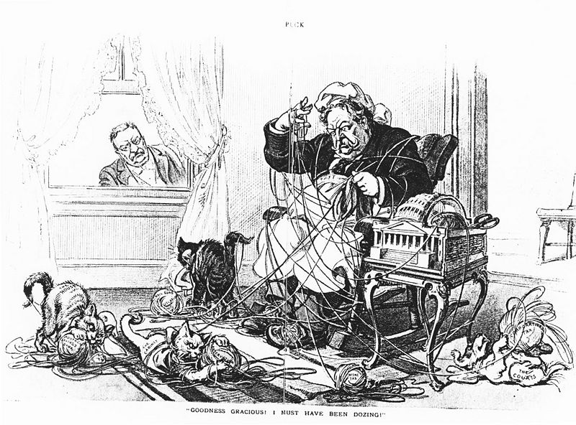

Why was Taft a one term President?

Mis-step #1 Taft alienated many liberal Republicans who later formed the Progressive Party, by defending the Payne-Aldrich Act which unexpectedly continued high tariff rates.

Mis-step #2 Taft further antagonized progressives by upholding his secretary of the interior Ballinger ( The Ballinger-Pinchot Affair) , accused of failing to carry out [former President Theodore] Roosevelt's conservation policies

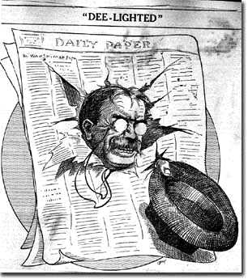

Roosevelt announced in early 1910 that his “hat was in the ring.” Taft proved a rugged political campaigner, using patronage and conservative favors to secure the Republican nomination. This set the stage for a four-man race after TR founded the Progressive Party (nicknamed the “Bull Moose” Party)
in early 1912.

A Quick Review Party of Politics

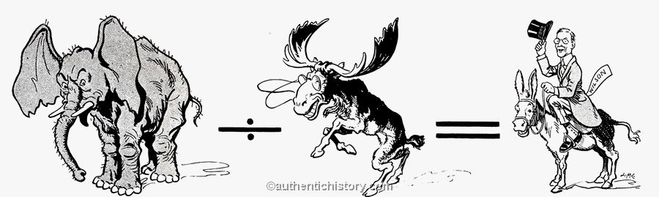

The content of the election – two candidates/antagonist discussion ideas inaugurated a national conversation about how to regulate business – Historians love this election because it is full of ideas with two intelligent men arguing about the direction of the country exciting to have a high level of engagement, discourse, and discussion!!! Personalities involved in the election of 1912 that will both have a role in transforming the office of the Presidents.

Previous presidents were weak… Review: Presidents 1877 to 1896
1. Teddy Roosevelt and Woodrow Wilson come to the floor with a plan.
2. They both have ideas and they are both articulate.

In many ways, then, the Election of 1912 was a referendum on how Progressive reform, especially business regulation and government “welfare,” should be approached. --To that end, it is important to understand the differences between TR’s and Wilson’s ideology:

Teddy Roosevelt's New Nationalism and Woodrow Wilson's New Freedom

The election of 1912 was notable for three things:

1. The division of the Republican Party and the best showing ever for a Third Party Candidate;

2. The first time since the Civil War that a Democrat had won the electoral college convincingly

3. The best showing ever for a Socialist candidate.

Moreover, the election of 1912 weakened the “reform wing” of the Republican Party, as the GOP turned right and thus set the stage for the supremely conservative party of the 1920s.

Review Key Elections in American History 1800-1912
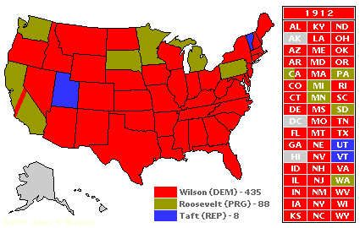

http://presidentelect.org/images/e1912_ecmap.GIF

http://thisnation.com/question/042.html

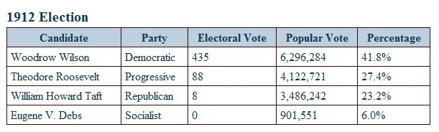
Eugene V. Debs Info
http://thecontenders.c-span.org/Contender/5/Eugene-Debs.aspx

Candidate | Comments
Woodrow Wilson (Democrat) | Former Princeton University Head and former Governor of NJ, Wilson was a well-known “reformer”: 6.2 million popular votes / 435 electoral
TR (Progressive): | Former Republican president and Progressive stalwart: 4.1 million / 88 electoral
Taft (Republican): | Incumbent president and Republican stalwart: 3.5 million / 8 electoral
Eugene V. Debs (Socialist): | Head of the IWW and noted radical: 950,000

