Washington’s Presidency
APUSH Talking Points 3.8
Launching the New Ship of State - The Presidency of George Washington

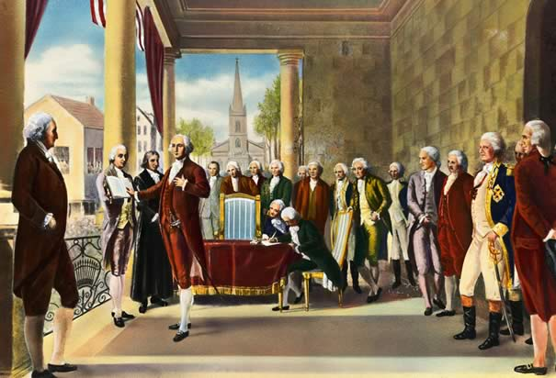 WWashington Takes the Oath
(video clip from HBO's John Adams)

AP Focus: As secretary of the treasury, Hamilton has a profound impact on establishing policies that will determine the nation’s economic direction and growth. Deficit spending, initiated in large part by Hamilton, endures as an economic and political tool. (it will be used extensively by FDR in the 1930’s)
Historical Context: After the gov’t was all set up, Washington was elected to be the first President. He was cautious, knowing he was setting precedents for the future [ex. the Cabinet, the State of the Union Address, no big title for President, President not using veto power often].

"I walk on untrodden ground" GW

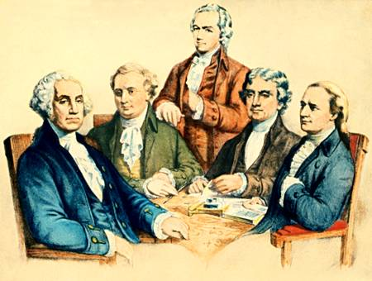

PRECEDENT #1 GW’s Cabinet : Alexander Hamilton (Treasury), Thomas Jefferson (State), Henry Knox (War), and Edmund Randolph (Attorney General ). These executive department heads were also his chief advisers.

IMPACT: Alexander Hamilton believed the economic stability of the nation was determined by its industrial might. He created a plan to provide a strong monetary system for merchants, creditors, and manufacturers.

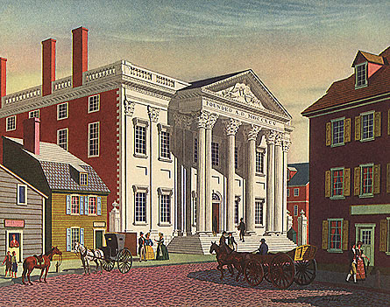

Bank of the U.S.; Excise Taxes; Funding at Par; Assumption of State Debts; Tariffs

James Madison, objected to the Assumption Bill because it gave the central government too much power and Virginia already paid their debt. He objected to the new securities b/c he felt it was ripping off the original holders. In the end the passage of the Assumption Bill was exchanged in a series of compromises for the location of the capital in the south [on the Potomac].
#1 Report on Public Credit (1790) – Hamilton proposed that Congress assume state debts, combine them w/the national debt, and redistribute the burden of the debt equally throughout the states. He also wanted to issue new government securities covering unpaid interest.

Economic Issues
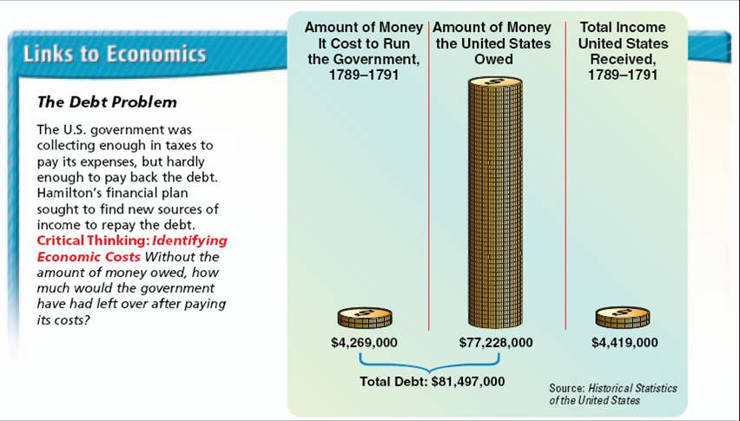

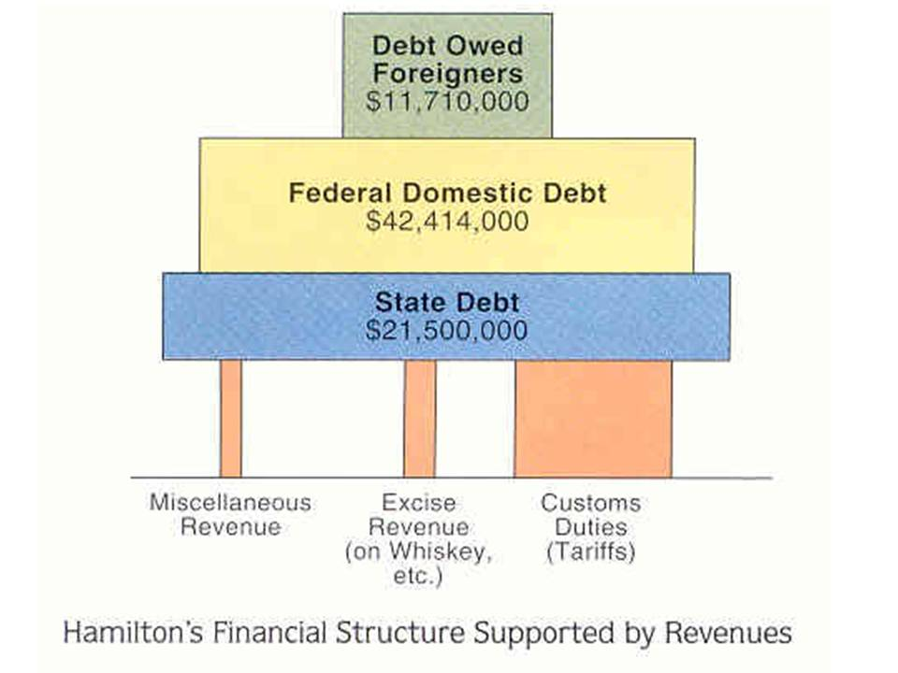

OPPOSITION:
#2 The Bank of the United States – Hamilton submitted another report on recommending the chartering of a national bank that would be capitalized at $10 million and would mainly be funded by private investors. The bank would circulate currency and collect and lend $ to the Treasury. But the big question was – did the Constitution allow the creation of the Bank?

#3 Report on Manufactures (1791) – this last suggestion, which was to encourage American industry through protective tariffs, was rejected.

Loose Constructionists. | Strict Constructionists
HAMILTON said in his Defense of the  Constitutionality of the Bank(Feb. 1791):  the Congress has all the powers it is not  specifically denied so if it doesn’t say you  can’t you can! POV of the loose constructionists. | MADISON (also Jefferson and Randolph)  said: no way, if the Constitution  doesn’t say you can, you can’t.  Besides, the elastic clause only allows for  necessary bills, and this is NOT necessary.  POV of the strict constructionists.

In the end Washington agreed and the bill was passed and helped the economy. - Set a precedent for enormous federal powers - The elastic clause -- Provided for passing any laws "necessary & proper" to carry out the powers vested in the various governmental agencies.” Also known as Congress’ Implied Powers

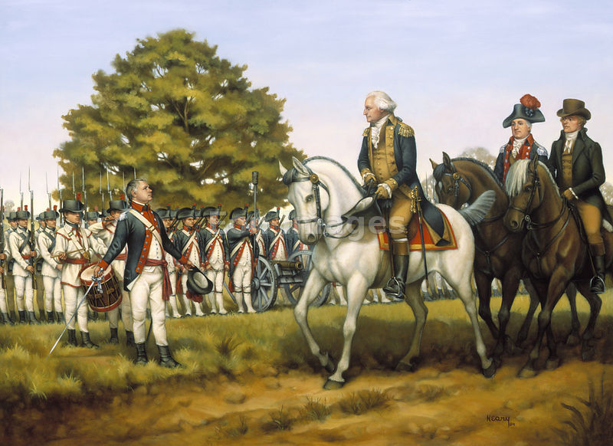
Historical Context | Part of Hamilton’s financial plan was a tax on Whiskey [to pay for assumption].  Southwestern Pennsylvania backcountry folks hard hit by Hamilton's excise tax.
Reactions | “Whiskey Boys” posed a major challenge to the new national government –They torched buildings,  tarred & feathered revenue officers, chased gov’t supporters from the region;  some talked of secession from U.S. = Tax collections came to a halt.  Washington summoned the militia of several states resulting in 13,000-man army. Washington  accompanied troops part of the way; Hamilton all the way. When the troops reached  the hills of w. Penn., the Whiskey Boys dispersed. Washington later pardoned the  two convicted participants to heal the rift.
Significance | Federal government showed it could ensure domestic tranquility  Proved that another Shays’-type rebellion could not succeed under the new Constitution.  Jeffersonians condemned the action as a brutal display of force and gained increasingly more  support from ordinary farmers.

Shays Rebellion(1786) v The Whiskey Rebellion (1794)

