APUSH Talking Points 16.3
Wartime Intolerance

AP Focus: Entering World War I in response to Germany’s unrestricted submarine warfare, Wilson turned America’s participation into a fervent ideological crusade for democracy that successfully stirred the public to a great voluntary war effort, but at some cost to traditional civil liberties.
http://www.pbs.org/moyers/journal/07132007/civilliberties.html

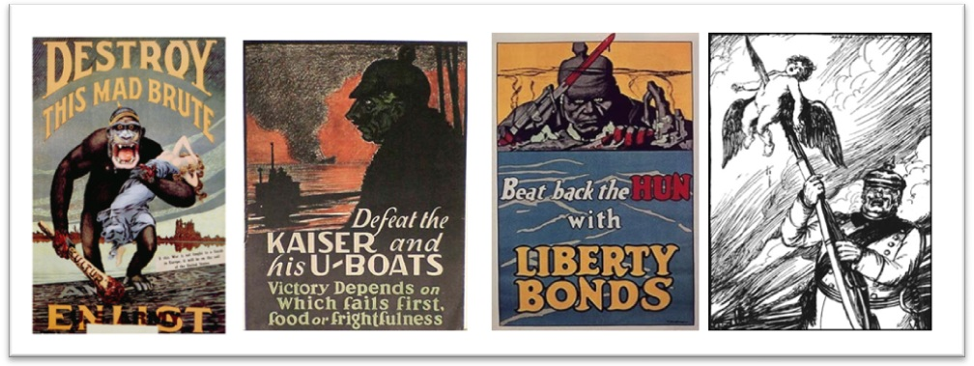

The Germans were dehumanized by the Allies, portrayed as the evil, conniving “Hun” through propaganda campaigns. Such propaganda campaigns were designed to instill a patriotic fervor in the young men of the Allied countries, so they would enlist to fight.

Examples of Anti-Germanism
German Americans had a complex response to the attacks on their loyalty that emerged when the United States went to war against Germany in 1917. During and after the war, many German Americans began to conceal their ethnic identity—some changed their names; others stopped speaking German; still others quit German-American organizations

German-American schools and newspapers by the thousands were forced to permanently close. In cities and towns across the nation, libraries burned their German-language books in public burnings. The officials of German-named towns that had been founded by German-Americans were intimidated by county, state, and federal government officials into anglicizing their names, and into destroying all traces of their German heritage.
In cities across the United States, German-sounding street names were banned. Many families with a German-sounding last name changed their surname. The vast majority of German-Americans, however, were loyal to their adopted country and thousands of them served in the United States military.

Newspapers in New York and other places published lists of inhabitants names and addresses, labeled as Enemy Aliens, thereby inviting neighbors to hostile actions.
As the public atmosphere became increasingly hysterical, vigilantes burned "pro-German" books, spied on neighbors, and attacked and murdered immigrants and radicals. Anti-German tension culminated on April 4, 1918, in the brutal lynching of German immigrant Robert Prager, a coal miner living in Collinsville, Illinois, who was accused of making "disloyal remarks".In June 1918 a bill was introduced in the House of Representatives by Representative John M. C. Smith with the aim to wipe out German names from the map of the United States.

In Hilger, Montana citizens burned history texts that mentioned Germany, -16 states banned the teaching of German, -Citizens were often bullied into making “Liberty Loans”, -Professors & school teachers who questioned the war were often fired

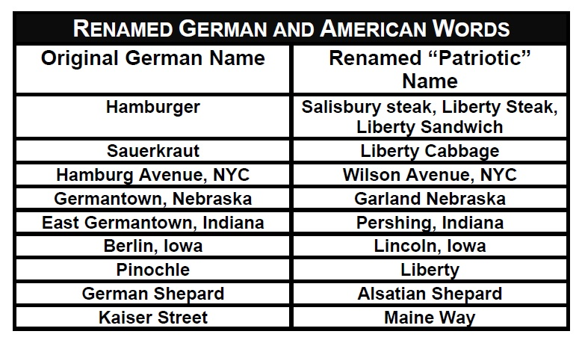

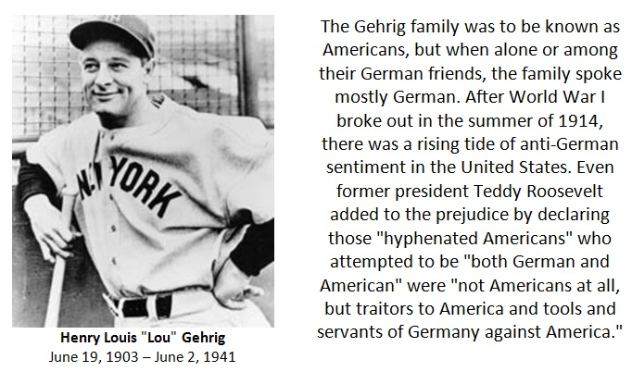

German-Americans and World War One

The 1910 U.S. census reported a population of roughly 92 million, of whom 14.7% were foreign-born. Thirty-two million people, or over one-third of the population, were either foreign born or the children of immigrants. Perhaps more worrying, as the U.S. confronted the inevitability of entering World War I, was that more than 10 million were immigrants from the nations of the Central Powers. There were also millions of Irish-Americans whose hatred of England caused them to sympathize with the Central Powers.

The German-American and Irish-American communities were strongly in favor of neutrality; they spoke out strongly against massive U.S. loans and arms sales to the Allies as a violation of neutrality. Theodore Roosevelt, who was president from 1901-1909, had questioned whether these communities were loyal to their mother country or to the United States, saying that "hyphenated-Americans who terrorized American politicians by threats of the foreign vote were engaged in treason to the American Republic."

As WWI began, President Woodrow Wilson's administration (1913-1921) felt that public opinion needed to be mobilized in support of the war. The federal government embarked on a domestic propaganda campaign. Wilson chose journalist George Creel to head a government Committee on Public Information (CPI). The CPI placed pro-war advertisements in magazines and distributed 75 million copies of pamphlets defending America's role in the war. A massive advertising campaign for war bonds was also launched, and filmmakers were encouraged to produce movies that featured alleged German atrocities, such as The Kaiser, the Beast of Berlin [YouTube] (1918, with Lon Chaney).

However, such acts as the U-boat sinking of the passenger liner Lusitania in 1915, killing 1198 passengers, several acts of sabotage and espionage within the U.S., and the decoding of the "Zimmermann telegram" [or 'Zimmermann note'] in January 1917 (a telegram from German foreign secretary Arthur Zimmermann to the German Ambassador in the U.S. which said that if the U.S. were to enter the war, then German would align itself with Mexico and attempt to help the Mexicans reclaim Texas, New Mexico and Arizona) had done a considerable amount already in inflaming American public opinion toward the sizeable numbers of German-Americans (see 1910 German-American population density).

The Results of Anti-German Sentiment
Once the U.S. entered the war against Germany and the Central Powers, a search for spies and saboteurs escalated into efforts to suppress German culture in America. Many German-language newspapers were closed down. Public schools stopped teaching German. Many of the numerous churches which had been founded by German-speaking immigrants stopped holding services in German and began changing over to English. The result of all of these was a blurring of German ethnic and linguistic identity in the face of rising anti-German sentiment.

Germans were called "Huns." In the name of patriotism, musicians no longer played Bach and Beethoven. Americans renamed sauerkraut "liberty cabbage"; dachshunds "liberty hounds"; and somewhat paradoxically, even German measles as "liberty measles." Cincinnati, with its large German-American population, removed pretzels from the free lunch counters in saloons. Vigilante groups attacked anyone suspected of being unpatriotic, and German-Americans and Irish-Americans who refused to buy war bonds often suffered harsh retribution. The legal system backed the suppression. Juries routinely released defendants accused of violence against individuals or groups critical of the war.

A St. Louis newspaper campaigned to "wipe out everything German in this city," even though St. Louis (home of the Anheuser-Busch brewery, among other well-known ethnic-German firms) had a large German-American population. Berlin Avenue was renamed Pershing; Bismark Street became Fourth Street; and Kaiser Street was changed to Gresham. Even the names of towns were changed: Luxembourg, Mo. was renamed "Lemay" (Digital History).

German-Americans often encountered persecution, with the result that many "Americanized" the spellings, forms and pronunciation of their names (such as "Schmidt" into "Smith" or Lüchow's [a New York restaurant] into Luchow's) in order to better assimilate. In one Midwestern family, the original German surname "Rau" (or "Rauh," depending on the records consulted) was anglicized to "Rowe," though retaining the German prounciation. Later, one of the family's sons changed the pronunciation of his family name to "Row" (as in "row, row, row the boat ...") when he joined the U.S. Army and went to Europe to fight against Germany.

[Feelings about which language should prevail also worked the other way around. In the second generation of the family one of their sons was named "William" Rowe. However, on his daughter's German-language baptism certificate "William" was Germanicized to "Wilhelm," a form the church thought was more representative of its German-language heritage.]
During this period of ethnic tension, German language instruction was dropped from many high schools, and in some cases German books were removed from public libraries and even burned. German-Americans, who still often spoke German within their communities and churches, were forbidden from speaking German to each other on the "party line" telephones of the day, so the English-speaking operators could listen to their conversations.
SOURCE LINK
http://www.uta.fi/FAST/US1/REF/germ-ww1.html

THEMES TO FOLLOW
“History Doesn’t repeat itself, but at least it rhymes”





