US Entry in World War I

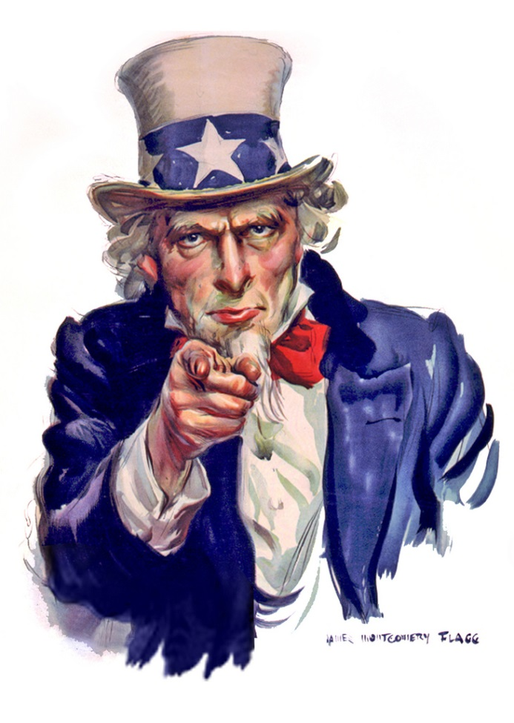
When World War I broke out in Europe, Wilson issued a proclamation of American neutrality on August 4, 1914. The value of American trade with the Central Powers fell from $169 million in 1914 to almost nothing in 1916, but trade with the Allies rose from $825 million to $3.2 billion during the same period.

In addition, the British and French had borrowed about $3.25 billion from American lenders by 1917. The United States had become a major supplier of Allied munitions, food, and raw materials.

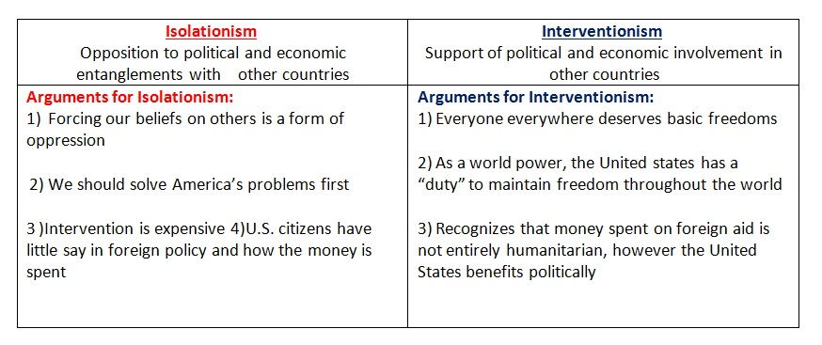
United States in World War I Timeline

1914

Aug. 4 Wilson issues Proclamation of Neutrality?

Aug. 19 Wilson appeals to Americans to be neutral or “impartial in thought as well as in action.” Are subsequent actions by Wilson “impartial… in action?”
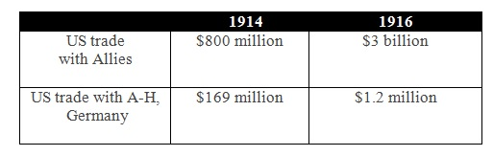

Blood Money? Sept.Wilson agrees to loans to belligerents. By 1917, United States investors had purchased $2.3 billion in bonds from the Allies and $40 million in German bonds.

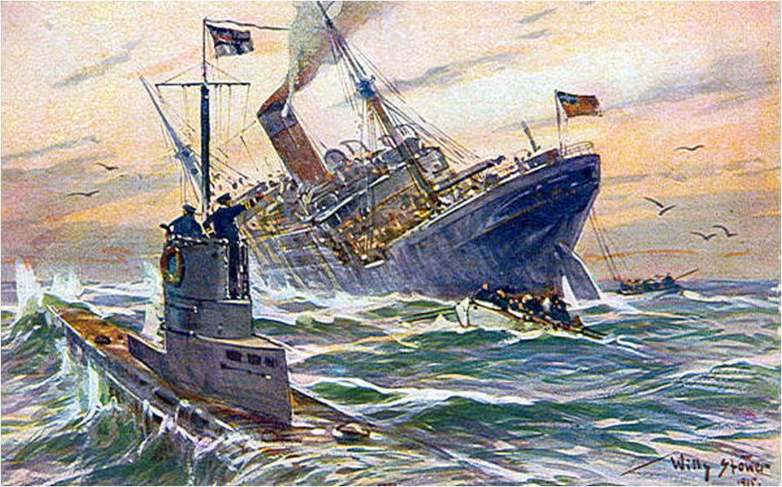

US Entry Documents
1915

May 7 The sinking of the Cunard ocean liner RMS Lusitania

May 13 Lusitania Note: demanded that Germany abandon unrestricted submarine warfare and make reparation for loss of American lives.

June 6 Second Lusitania Note: Bryan says he cannot cosign it because he fears that it could lead to war – Bryan resigns as Secretary of State.

1916
McLemore Resolution –Requested that President warn Americans not to travel on armed vessels.

1917

Wilson orders American merchant ships armed. (without Congressional approval ; Wilson wanted Congressional approval but Robert LaFollette led a Senate filibuster to prevent a vote).

Wilson pushed for a draft – he felt that conscription (a draft) was the only democratic and efficient way to recruit a large army. The Speaker of the House of Reps., Champ Clark – a fellow Democrat, led the opposition to a draft as a threat to democracy and favored voluntarism.

Germany announced on January 31, 1917, that it would sink all ships, belligerent or neutral, without warning in a large war zone off the coasts of the Allied nations in the eastern Atlantic and the Mediterranean.

The Germans realized that the U.S. might declare war, but they believed that, after cutting the flow of supplies to the Allies, they could win the war before the Americans could send any sizable force to Europe. Wilson broke diplomatic relations with Germany on February 3, 1917. During February and March several U.S. merchant ships were sunk by U-boats

On the evening of April 2, 1917, President Wilson appeared before a joint session of Congress and asked for a declaration of war against Germany in order to "make the world safe for democracy." On April 4, Congress granted Wilson's request.

Mobilizing the Home Front: War Hysteria
A number of volunteer organizations sprang up around the U.S. to search for draft dodgers, enforce the sale of war bond, and report any opinion or conversation considered suspicious.

The American Protective League (25,000 members)
Publicly humiliated people accused of not buying war bonds
Persecuted, beat, and sometimes killed people of German descent.

As a result of the CPI and vigilante groups:
German language instruction in schools was banned
German music was banned in many areas (i.e. Bach & Beethoven)
German measles became “liberty measles”
Sauerkraut became “liberty cabbage”
Pretzels were banned in some cities Anti-German hysteria was far worse in the U.S. than either Britain or France

Selective Service Act f 1917, all males aged 18 to 45 were eligible. By the end of World War I, some 2.8 million had been drafted. This meant that more than half of the almost 4.8 million Americans who served in the armed forces were drafted.

Financing the War  “Work or Fight” | George Creel  Committee on Public Information | Bernard Baruch  production and efficiency
Herbert Hoover  Food Administration | Mobilizing Women  Volunteers in unfamiliar roles | African Americans  segregated support troops  http://www.tubechop.com/watch/2263091
 | Comparing 1917 with 1941

US Entry - Journal Set-Up

