Theodore Roosevelt

Like to present himself as an ordinary man, not very accurate…Descendant of NY Dutch aristocracy. Intelligent and active; had a number of health defects – he was weak and bookish as a child – begins a transformation in his teens to a ideal manly type through an intense fitness regime – the strenuous life
Constructs a Horatio Alger tale about himself, despite his patrician background – presenting himself as a moral exemplar - Immature, dynamic personality – wants to be the center of attention. TR creates an outside power base using the press to promote his image and joins the governing class in NYS politics. Middle class readership fascinated with the wealth and well-placed “culture of celebrity” The Western persona - only allows photos of him on horseback and hunting (no golf or tennis) drawing on the western myth!!! TR is never anonymous

Ideas and Politics
Loyal to the Republican Party and a team player, however he is part of the reforming wing of NYS politics – Police commissioner of NY

A blend of ideas - Hamiltonian – uses the government to create a strong state and stimulate the idea of national greatness and dash of Jeffersonian – faith in the people and a faith in larger democratic participation.
1897 | Assistant Secretary of the Navy
1898 | fights with The Rough Riders in Spanish American War – make’s TR’s career on the national level - romanticized view of western cowboys and aristocrats charging up San Juan Hill  IMAGE
1899-1900 | Elected reform Governor of NY
1900 | Vice Presidential nomination on McKinley ticket
1901 | McKinley assassination and TR continues McKinley’s policy
1902 | Conservation and wise use policy and develop land wisely – the Reclamation Act (1902) – sell public land and develop irrigation systems; takes unilateral action
1904 | 1904 Elected in his own right - announces he will not run for President again – give everyone an equal shot  burst of activity in Pure food and drug Hepburn  Business must knows its place – things have to balanced.
 | Success? Dynamic, aggressive, radical, excitable guy who is in a conservative party
1908 | 1908 – Goes to Africa to hunt game and go on several tour stops
TR’s Square Deal

CONSUMER PROTECTION

After botulism was found in American meats, foreign governments threatened to ban all American meat imports. Backed by the public, President Roosevelt passed the

Meat Inspection Act of 1906. The act stated that the preparation of meat shipped over state lines would be subject to federal inspection.

The Pure Food and Drug Act of 1906 was designed to prevent the adulteration and mislabeling of foods and pharmaceuticals.

LABOR

Anthracite Coal Strike
In 1902, coal miners in Pennsylvania went on strike and demanded a 20% raise in pay and a workday decrease from 10 hours to 9 hours.

A deal was struck in which the miners received a 10% pay raise and an hour workday reduction

CONSERVATION POLICY

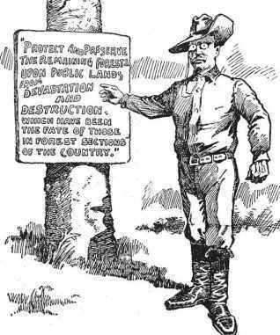

"Protect and preserve the remaining forests upon public lands from Devastation and Destruction
which has been the fate of those in forest sections of the country."

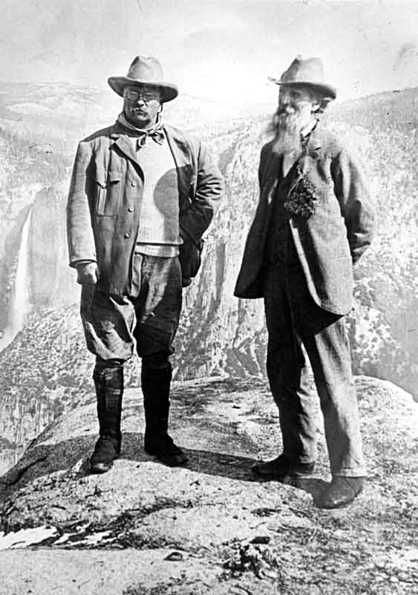

Newlands Act of 1902, which authorized the federal government to collect money from the sale of public lands in western states and then use these funds for the development of irrigation projects.

Pelican Island Federal Bird Reservation, 1903

Antiquities Act of 1906: Authorized the president to declare historic landmarks and structures as official National Monuments
Preserves such wonders such as Devil's Tower (1906), El Morro (1906), Montezuma Castle (1906)

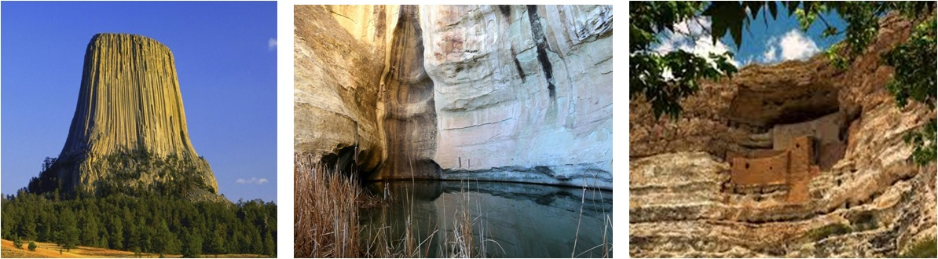

In 1900 Roosevelt, attempting to preserve the nation's shrinking forests, set aside 125 million acres of land in federal reserves.

Under President Roosevelt, professional foresters and engineers developed a policy of "multiple-use resource management." They sought to combine recreation, sustained-yield logging, watershed protection, and summer stock grazing on the same expanse of federal land. Many westerners soon realized how to work with federal conservation programs and not resist the federal management of natural resources.

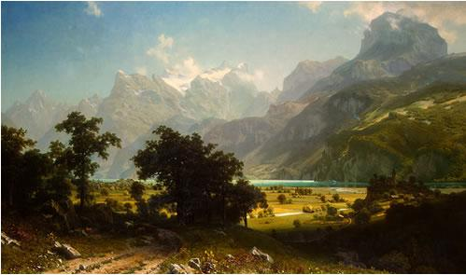
Albert Bierstadt, School: Hudson River School Lake Lucerne, 1858

CORPORATE REFORM
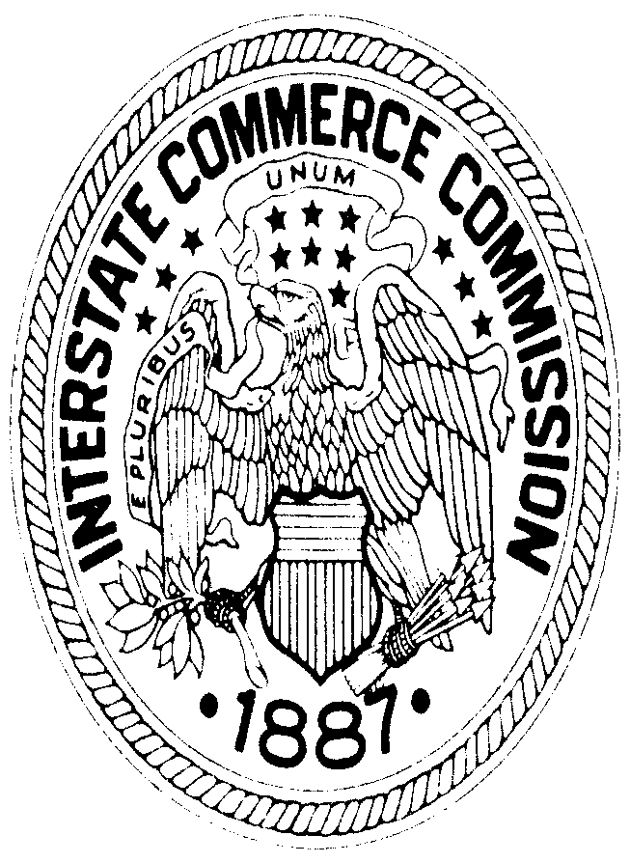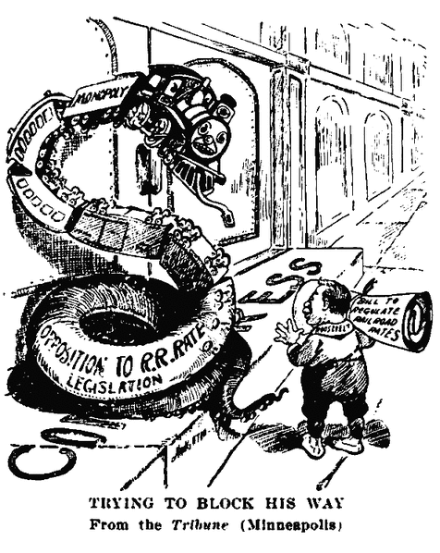

Although the Interstate Commerce Commission was created in 1887, railroad barons were still able to have high shipping rates because of their ability to appeal the commission's decisions on high rates to the federal courts.

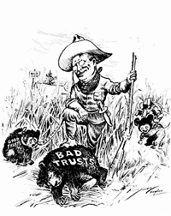

In 1902, President Roosevelt challenged the Northern Securities Company, a railroad trust company that sought to achieve a monopoly of the railroads in the Northwest. The Supreme Court upheld the President and the trust was forced to be dissolved

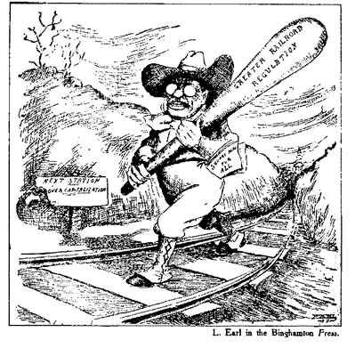

1903 Elkins Act, heavy fines on railroads that gave rebates.

1906 Hepburn Act of 1906, restricting free passes and expanded the Interstate Commerce Commission to include express companies, sleeping-car companies, and pipelines.

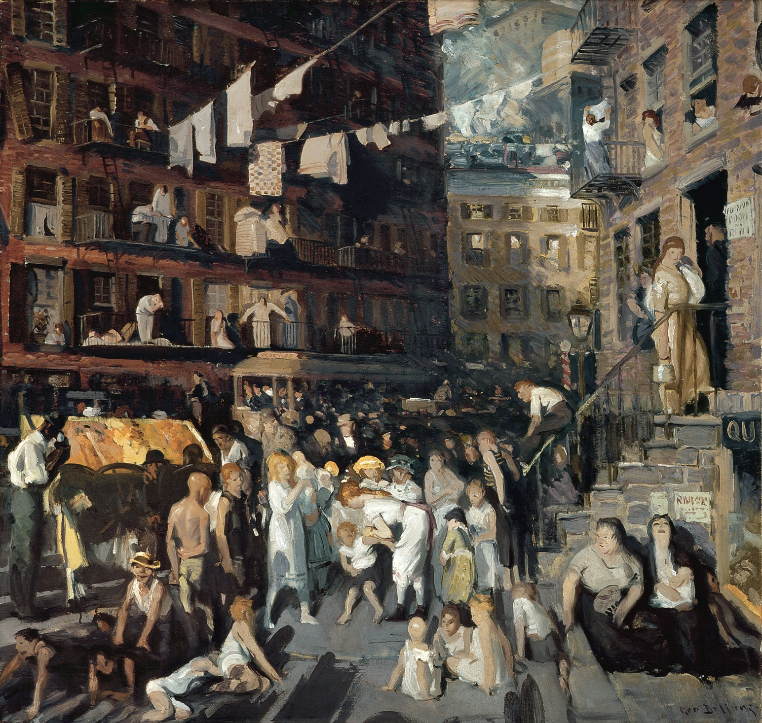
George Bellows, Cliff Dwellers, Ashcan School, 1913

