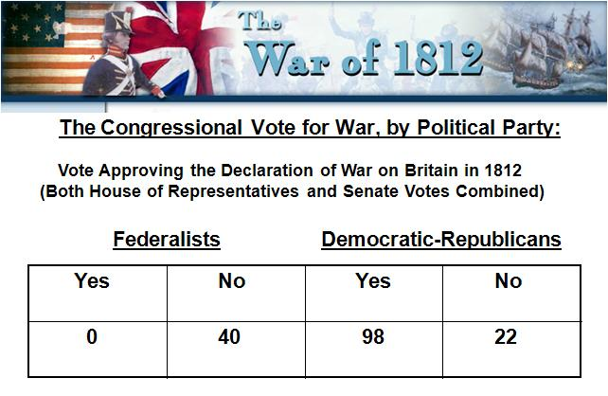
War Declarations

While the Western Republicans– the War Hawks – were pushing for and getting war – the Federalists were at Hartford, Conn making one last attempt at hanging on

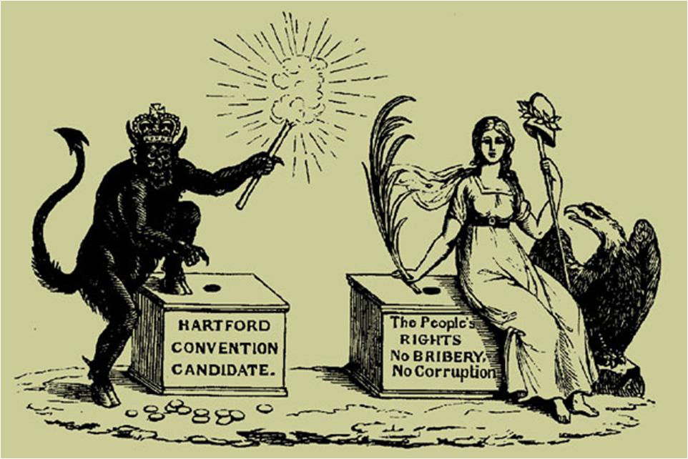

The Hartford Convention (Dec. 15, 1814 thru Jan. 5, 1815)

Almost from the start the states of New England had refused to co-operate with the war effort
The leadership in Mass. called for a meeting to discuss what they could do
They talked about secession and came up with several resolutions and wanted to see them proposed as amendments to the Constitution:
#1 No embargo shall last more than 60 days
#2 2/3 vote should be required to : declare war, place restrictions on trade, admit new states to the union
#3 no naturalized citizens shall hold public office
#4 taxation and representation based only on the number of free inhabitants
#5 president shall serve only one term
#6 no two consecutive presidents can come from the same state

The resolutions were written up and sent to DC and arrived at the same time as news of the Battle of New Orleans and the Treaty of Ghent
They were never acted upon - this was the last straw for the Federalist Party on the national level

States Rights Timeline

The Results of the War
We had beaten Britain twice in 40 years!!

Treaty of Ghent - December 24, 1814 - Ended the War of 1812
Restored the status quo (Everything as it had been before the war )For the most part, territory captured in the war was returned to the original owner. It also set up a commission to determine the disputed Canada/U.S.

THINGS TO REMEMBER for the WAR of 1812
#1 We were now seen in Europe’s eyes as a nation - Nascent nationalism, great pride and patriotism

#2 End of the Federalist Party – the Republicans were now in complete control

#3 The significance of the Battle of New Orleans

#4 Interruption of global trade leads to increase domestic manufacturing and the promotion of Industrialization

