The Truman Show 1945 to 1952

AP Focus: The first president without a college education in many years, President Harry S Truman was known as "average man's average man." He had down-home authenticity, few pretensions, rock-solid probity, and the political ability called "moxie" - the ability to face difficulty with courage.
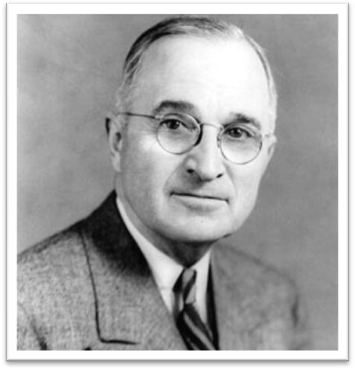
Harry S Truman
The 33rd President of the United States
1945–1953

The first president without a college education in many years, known as "average man's average man." He had down-home authenticity, few pretensions, rock-solid probity, and the political ability called "moxie" - the ability to face difficulty with courage.

Truman's presidency was also eventful in foreign affairs, with the end of World War II and his decision to use nuclear weapons against Japan

As a Wilsonian internationalist, Truman strongly supported the creation of the United Nations, the Marshall Plan to rebuild Europe, the Truman Doctrine to contain communism, the beginning of the Cold War, the Berlin Airlift, the creation of the North Atlantic Treaty Organization (NATO), Chinese Civil War, and the Korean War.

He used executive orders to begin desegregation of the military and to create loyalty checks which dismissed thousands of communist supporters from office, even though he strongly opposed mandatory loyalty oaths for governmental employees, a stance that led to charges that his administration was soft on communism.
REVIEW
Which vice presidents have become president after the death or resignation of their predecessor?
Based on the Presidential Succession Act of 1792, 1886, and 1947
Vice President | Became President | Days as President | Comments
John Tyler | Harrison died of pneumonia in 1842 | 1,430 | Didn't run for President
Millard Fillmore | Taylor died in 1850 from illness | 969 | Lost nomination.
Andrew Johnson | Lincoln assassinated in 1865 | 1,419 | Impeached; Failed to win the nomination in 1868
Chester A. Arthur | Garfield was assassinated in 1881 | 1,262 | Garfield’s assassination leads to Pendleton Act.
Theodore Roosevelt | McKinley assassinated was in 1901 | 1,267 | Elected to a full term. Did not run in 1908. Was defeated in 1912 as Third Party “ Bull Moose” candidate
Calvin Coolidge | Harding died of a heart attack in 1923 | 580 | Elected to a full term. Did not run for a second term.
Harry S. Truman | Roosevelt died of a cerebral hemorrhage in 1945 | 1,379 | Elected to a full term but did not run again.
Lyndon B. Johnson | Kennedy assassinated in 1963 | 425 | Elected to a full term but didn't seek re-election in 1968 (This was shocking to America!!)
Gerald R. Ford | Nixon resigned in 1974 | 895 | Lost election to Jimmy Carter in 1976

