The Presidency of John Quincy Adams

AP Focus: Andrew Jackson handily wins the popular vote in 1824 election but fails to win the necessary electoral votes. The U.S. House of Representatives selects his opponents, John Quincy Adams. But in 1828 Jackson easily defeats Adams, ushering in what many see as a period of democratic growth. Claiming he attacked entrenched political forces, Jackson rewards his political supporters with patronage positions in government.

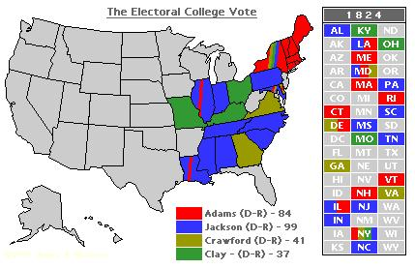

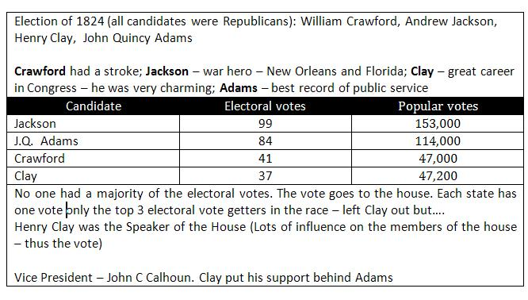

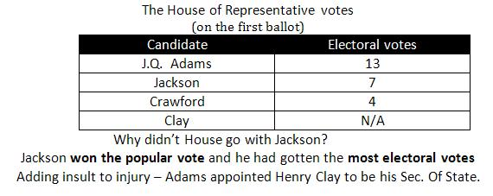

This brought an end to the Era of Good feelings. When the dust settled – 2 parties existed.
National Republicans: Clay and Adams
Democratic Republicans – Jackson and his supporters

The Democratic Republicans called the election the “corrupt bargain” There is no evidence that Adams and Clay did anything “corrupt”. However, Clay went with Adams mainly because Adams supported Clay’s American System

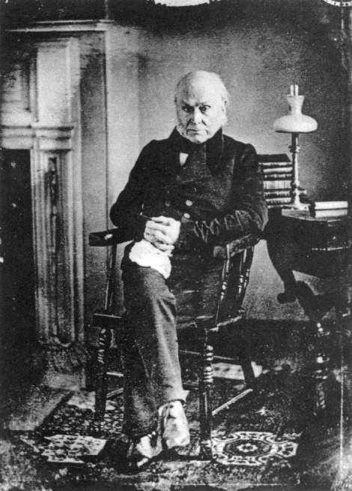

RESUME - Road to the White House
Son of 2nd President John Adams

Ambassador/Minister to 4 different nations

Secretary of State under James Monroe – wrote the Monroe Doctrine

Served as President 1824-28

POST PRESIDENCY
1831 – was reelected to the house and served 17 years

1848 – suffered a stroke in Congress and died (they say his ghost still roams the capital)

He served this country well – except when he was president

