The Newburgh Conspiracy (1783)

Q? What does the Newburgh conspiracy reveal about Washington's ability to lead?

Q? What does the Newburgh conspiracy reveal about the problems we have under the Articles of Confederation?

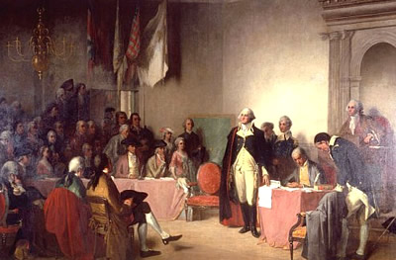
Newburgh, New York - March 15, 1783

On the morning of March 15, 1783, General George Washington makes a surprise appearance at an assembly of army officers at Newburgh, New York, to calm the growing frustration and distrust they had been openly expressing towards Congress in the previous few weeks. Angry with Congress for failing to honor its promise to pay them and for its failure to settle accounts for repayment of food and clothing, officers began circulating an anonymous letter condemning Congress and calling for a revolt.

When word of the letter and its call for an unsanctioned meeting of officers reached him, Washington issued a general order forbidding any unsanctioned meetings and called for a general assembly of officers for March 15. At the meeting, Washington began his speech to the officers by saying, "Gentlemen: By an anonymous summons, an attempt has been made to convene you together; how inconsistent with the rules of propriety! How unmilitary! And how subversive of all order and discipline..."

Washington continued by pledging, "to exert whatever ability I am possessed of, in your favor." He added, "Let me entreat you, gentlemen, on your part, not to take any measures, which viewed in the calm light of reason, will lessen the dignity, and sully the glory you have hitherto maintained; let me request you to rely on the plighted faith of your country, and place a full confidence in the purity of the intentions of Congress."

When he finished, Washington removed a letter from his breast pocket that he had received from a member of the Continental Congress. He hesitated for a moment as he looked down at the letter before fumbling to retrieve a pair of spectacles from his pocket. Before reading the letter, Washington, in an almost apologetic tone said, "Gentlemen, you must pardon me. I have grown old in the service of my country and now find that I am growing blind." The eyes of most of his audience filled with tears. The content of the letter became irrelevant as the assembled officers realized that Washington had given as much or more in the service of the new nation as any of them. Within minutes, the officers voted unanimously to express confidence in Congress and their country.

In a letter to the Continental Congress dated March 18, 1783, Washington wrote to assure the body that the unrest of officers was over, writing, "The result of the proceedings of the grand convention of the officers, which I have the honor of enclosing to your Excellency for the inspection of Congress, will, I flatter myself, be considered as the last glorious proof of patriotism which could have been given by men who aspired to the distinction of a Patriot army; and will not only confirm their claim to the justice, but will increase their title to the gratitude of their country."

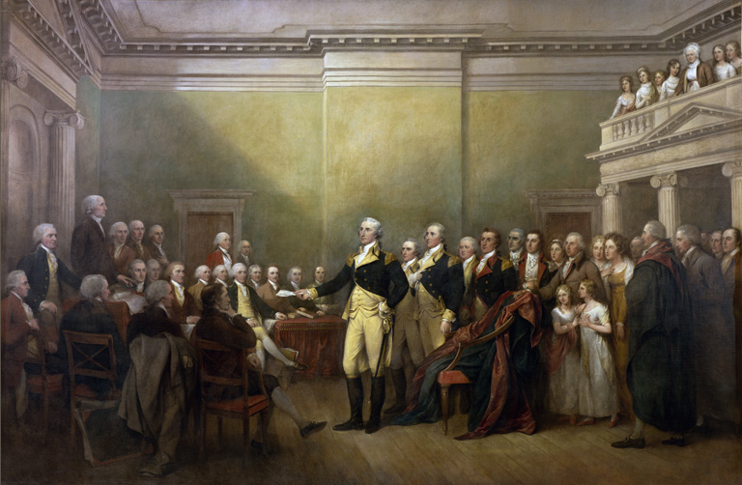
General George Washington Resigning His Commission - December 23, 1783

