The Market Revolution
Thematic Connections and Illustrative Examples

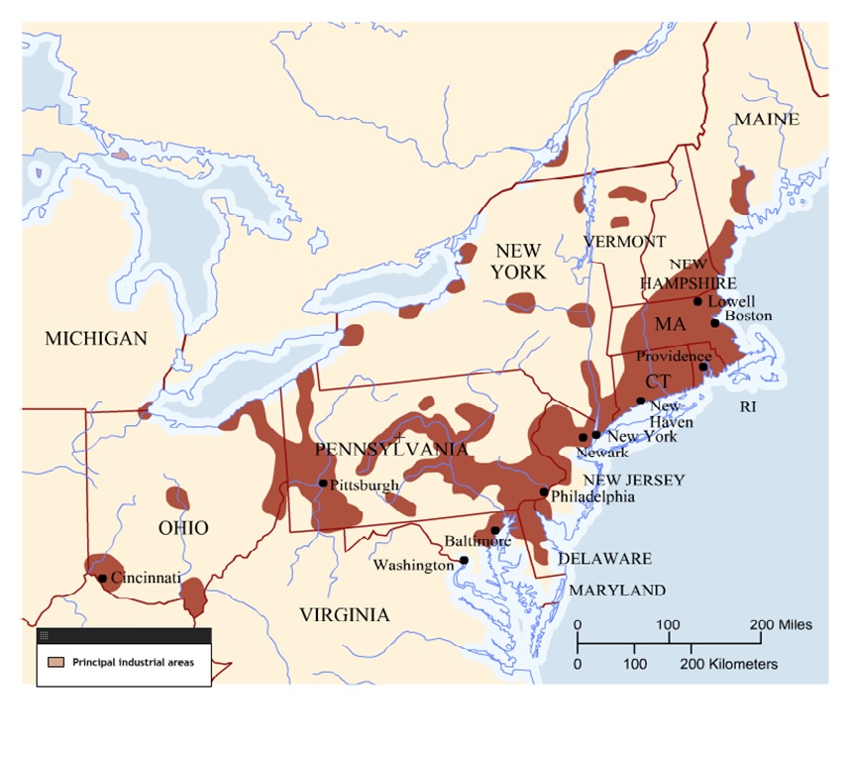
The Market Revolution was a drastic change in the manual labor system originating in the South (and soon moving to the North) and later spreading to the entire world. Traditional commerce was made obsolete by improvements in transportation and communication. This is thought to have been caused by increasing industrialization, such as Eli Whitney's invention, the Cotton Gin.

i - T- R - I - P Market Revolution (1815–1860)

iNVENTIONS - TRANSPORTATION REVOLUTION - IMMIGRATION - POPULATION EXPLOSION

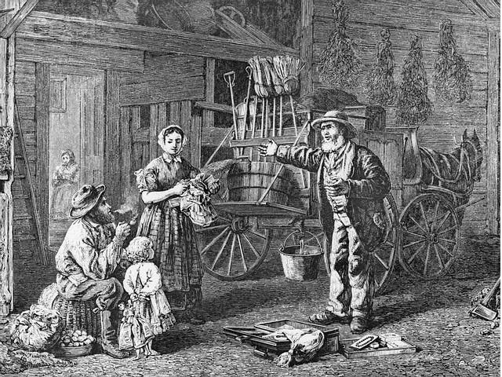
http://sierrasolutions.com/ - the modern yankee peddler ?

The northern states by the Antebellum Period, the market was booming. The market society has commercial, consumerist mentalities, and its belief--eventually, its faith in, its defense of--free labor for the common man.

What is the Yankee peddler peddling?

How does this image represent the Market Revolution?

Part of this anxiety is directly connected to immigration. In the 1830s 600,000 immigrants came to the United States, almost entirely from Western Europe; in the 1840s alone 1.5 million; and in the 1850s, almost 3 million more.

IRISH | GERMAN
Limited means (the American Wake)  Too poor to buy land so they lived in cities  Accepted low wages  Conflicts with African Americans | Wealth and means  Migrated with family sustaining language, culture and traditions

Were they Welcome? (Not really and not always)
Business owners welcomed the influx of cheap labor but most others didn’t want them here they thought that the immigrants were bad for the country
“Native” Americans (NOT INDIANS!!!!) were primarily WASP (White Anglo-Saxon Protestant)

A big portion of the immigrants were Catholic. -“Natives” blamed the Catholics for an increase in political corruption – will the Pope take over????
Anxiety: Social disorder - all immigrants did was drink and steal.

We even saw an organized Anti-Immigrant movement. Began as the secret society – Order of the Star Spangled Banner
Developed into a political party - American Party AKA the Know – Nothing Party

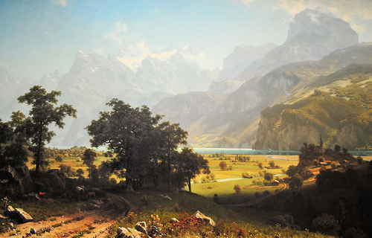

The Market Revolution also leads to a lot of natural environmental degradation. People got to be--got worried about rivers, they really did. There's now an environmental history being written of the impact of the Market Revolution.

In any society changing this much, this fast, doubling its own population--doubling--in twenty-five years. Any era of great change, great ferment, usually causes reform, anxiety, people who get worried, want to change things.

THE REFORM IMPULSE!!!!
Fundamental challenges to the social order in Antebellum America are exemplified in the anti-slavery movement (see earlier talking points)

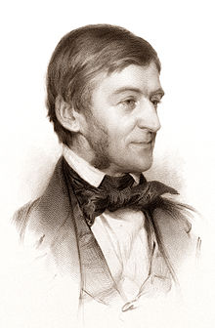

Ralph Waldo Emerson "Man the Reformer"
What is man born for? What is man born for but to be a reformer? Isn’t man a re-maker of what he has made, a renouncer of lies, a restorer of truth and good, imitating that great Nature?

Let him renounce everything which is not true to him, and put all his practices back on their first thoughts, and do nothing for which he has not the whole world for his reason.
Emerson is arguing, right or wrong, that you are a reformer by nature. Nature recreates itself daily and so do humans. Is he right?

Impact of the Market Revolution

