The Legacy of The New Deal
Analyze how and why the New Deal sought to change the federal
government's role in U.S. political, social, and economic life

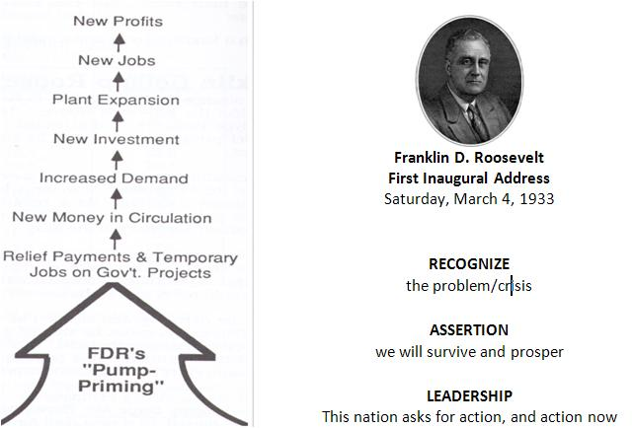

Franklin Delano Roosevelt
First Inaugural Address
4 March 1933

The Great Depression fundamentally reshapes the way the American people think about the role of government Relief, Recovery and Reform
#1 Creates security in the system to change the length and harshness of business cycle
#2 Changes the expectations about what government could and should do; Depression Era Images

Federal Budget: 1920 $3 billion to 1930 $6 billion

Court Challenges - The New Deal on Trial
Analyze how and why the New Deal sought to change the federal
government's role in U.S. political, social, and economic life

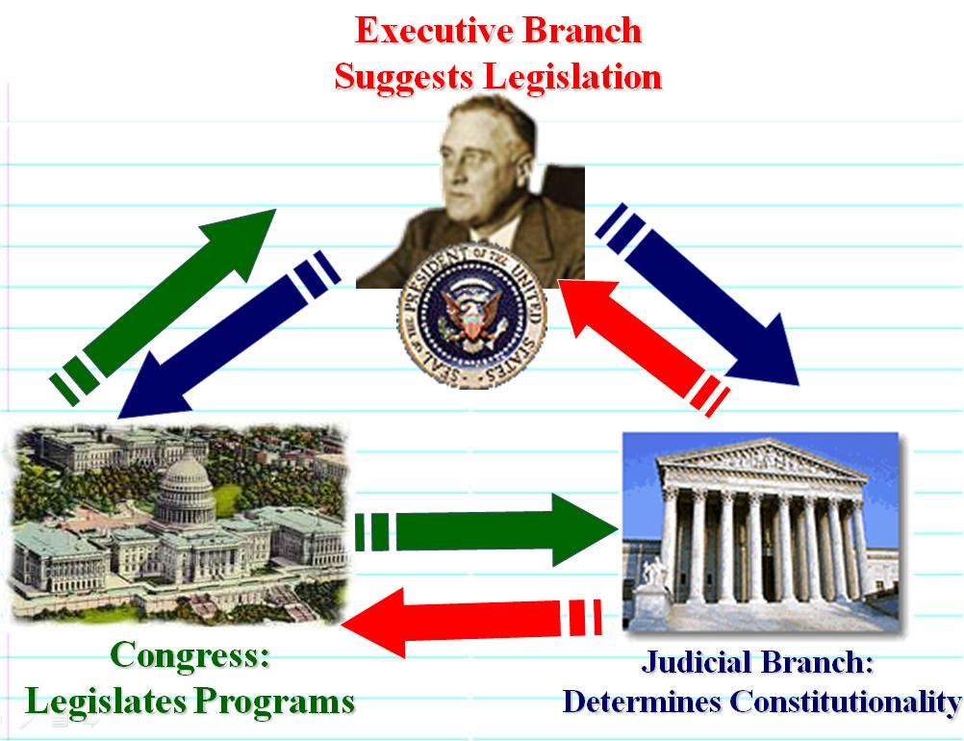
THE AGRICULTURAL ADJUSTMENT ACT - Court Challenges
The AAA helped increase farm profits by reducing production. Set up Agricultural Adjustment Administration – which controlled wheat, cotton, corn production by paying farmers not to plant that crop.

FDR's “COURT PACKING” PLAN Court Packing Documents Court Packing Redux - John Adams and FDR

