The Legacy of 1848 - What did the Mexican War unleash?

The issue of slavery in the territories acquired from Mexico disrupted American politics from 1848 to 1850. The Compromise of 1850, orchestrated by Henry Clay, attempted to deal with the issue of slavery.

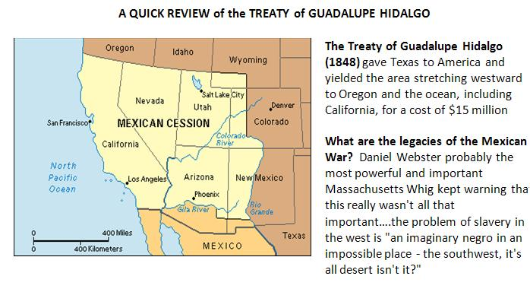

PERSPECTIVES ON THE SPOILS OF WAR – THE NORTHERN VIEW
Why was the North concerned about slavery in the West?
#1 Northerners believed that slavery could take root in the southwest because…..
- Slaves could be used to mine for silver and gold
- Slaves could be used to build railroads and canals
- Slaves are competition for white free laborers

#2 Northerners favored a non-extension approach to slavery on constitutional grounds. They would not attack slavery where it already existed--because slaves were property and protected by the Fifth Amendment--they nevertheless believed they could use the Constitution, under Congress's sole authority to admit new states to the union, to stop this system from expanding (cordon off slavery and blunt its future).

#3 There where bills before Congress to establish the territories now of Utah and New Mexico and large swaths of land that could become more than two states. Northerners who found these bills simply personally obnoxious, and they were being asked to be complications now in the expansion of slavery….."Look, I can't stop anything that's going on in Alabama and I won't try, but don't ask me to vote to create a new territory that will become a slave state."

#4 The Free Soil Party, (eventually in that Republican Party) goal was to make slavery sectional but freedom national. Slave labor--sectional, regional, bound to a place--but free labor national, eternal and the definition of a future.

#5 The race card There was also racism as a motive in this. Many northerners saw the West as the hope of the northern immigrant, young farmers in Ohio who's got three sons, and they want to go West, and they don't want black people around

PERSPECTIVES ON THE SPOILS OF WAR – THE SOUTHERN VIEW
Why did the South care about slavery in the West?

#1 Practical - It is destiny of the American people to expand west, it was not only the destiny of the slave society to expand west- slavery must expand or it would die!! Slaves in existing states, came to realize, were becoming a burden, possibly a danger. As the slave population in a Georgia or an Alabama or a Mississippi continues to grow and grow and grow and grow, but nowhere to expand to, that slave population may become indeed a powder keg.

#2 Economic - If they couldn't expand this system beyond its limits and beyond its borders--get into Arkansas, get out into Oklahoma, Texas, West Texas, further west, Caribbean--that the south would begin to shrink as an economic entity, as a political culture, as a force in the national government. And if you cordoned off slavery, what's going to happen to the price of slaves around its borders? Well, they might begin to go down.
#3 Political - Every new state meant two new senators. And the number of states--free states to slave states, in 1850, was 15 to 15. They wanted to sustain that parity. California is out there--it's going to have a sudden statehood in 1850 because of gold being discovered--is going to be the problem and the test case.
#4 Constitutional - The question of checks and balances (the states' rights question) Did anybody have the right to prohibit anybody from taking their property anywhere? John C. Calhoun claimed “ You have no right--you northerners have no right to stop me from taking my wagon and my horse and my slave anywhere I wish." And he would just recite the Fifth Amendment.

#5 Moral - The idea set in among northerners that the legal status of slavery in the western territories stood as a measure of its moral standing everywhere. If you tell Southerners that slavery is wrong enough that you will not have it in America's future, then you're telling Southerners it's wrong where they have it!!

PLANS FOR THE WESTERN TERRITORIES
What kind of future will America have? Four plans are going to come together around this debate over slavery in the territories

#1 The Wilmot Proviso (a rally cry of the Free Soil Movement). David Wilmot proposed an amendment that stated that the territory from Mexico should remain slave-free. The language was borrowed from the Northwest Ordinance. All but one northern state legislature endorsed it. All southern legislatures condemned it (a sign of things to come???).

#2 State sovereignty (states' rights) The question of the individual's constitutional right of ownership in slaves as property and transport of slaves as property. State sovereignty, states' rights was indeed deeply at the root of the South's growing position here that, ultimately, no Federal Legislature, President--no Federal authority--existed to stop slavery's expansion.

#3 Popular sovereignty (a compromise position) not a new idea in the midst of the Mexican War and its aftermath – the idea that there would be no Act of Congress on slavery in the territories. Take Congress out of the story and simply let the people in the Western Territory have a vote. Let them have a referendum. Let there be popular democracy.

#4 Geographical division – Remember the Missouri Compromise of 1820 the 36º30' parallel from the Mississippi River to the Pacific Ocean and slavery would never exist north of that line. The problem was that half of California was already north of that line.

