AP Focus: Herbert Hoover had been President less than one year when the stock market “crashed” on October 29, 1929. From November of 1929 until Franklin Roosevelt took office in March 1933, the depression grew steadily worse. Thousands of factories, banks, and forms went bankrupt while unemployment reached a staggering 25%. The presidential election of the depression. With the election of Franklin Roosevelt in 1932, the government took on active role in helping the U.S. economy recover.

Overview: Causes of the Great Depression: The crash caused a chain reaction that triggered the start of the worst depression in US history. The US had experienced a number of economic panics and two short depressions but the depression of the 1930s seemed much different. It lasted far longer, caused more business failures and unemployment, and affected more people than any preceding period of hard time. Before it was over, two presidents—Herbert Hoover and Franklin Roosevelt—would devote 12 years to seeking the elusive path toward recovery.

The Stock Market Crash of October 1929 What caused the spectacular business boom of the 1920s to collapse in October 1929? On October 24, 1929, or “Black Thursday”, stock prices plunged as a result of an unprecedented volume of selling on Wall Street. Hoping to stave off disaster, a group of bankers bought millions of dollars of stock. However, the selling frenzy resumed and on October 29—“Black Tuesday”—the bottom fell out as millions of panicky investors ordered their brokers to sell, when there was practically no buyers to be found. The “crash”, a $14 billion loss in stock prices collectively, shook people’s confidence in the economy and triggered a chain reaction of business failures, bank failures, and massive unemployment.

Causes of the Stock Market Crash: “False Prosperity” of the Twenties While the collapse of the stock market in 1929 may have triggered economic turmoil, it alone was not responsible for the ensuring depression. The global depression was the result of a combination of factors that matured during the 1920s.

Weak Farm Economy-the prosperity of the 1920s never reached farmers, who had suffered from overproduction, high debt, and low prices since the end of World War I. High protective tariffs protected US industries by hurt farmers and international trade. As the depression continued through the 1930s, severe weather and a long drought exacerbated farmers’ difficulties.

Global Economic Problems-War reparations burdening Germany and debts owed to the US by allies in World War I hampered economic growth in Europe. At the same time US tariff polices greatly reduced the sale of European good in America. With the stock market crash in 1929, the US suspended loans to Germany, who in turn, defaulted on their reparations to other European nations. Europe’s difficulties contributed to the depression in the US which in turn, became a worldwide Great Depression

Overproduction - Underconsumption-business growth, aided by increased productivity and use of credit, had produced a volume of goods that workers with stagnant wages could not continue to purchase.

Excessive Use of Credit-a belief of both consumers and business that the economic boom was permanent led to increased installment buying. Advertising stimulated consumers’ desire for the exciting new appliances and cars that were being produced in abundance.

Stock Market Speculation-speculation in the stock market, the practice of buying stocks and reselling for profit, reached its highest levels during the 1920s. As speculation increased, many began buying stocks on margin (paying only a small percentage of the stock’s value and paying the rest on installment). Investors depended that the price of the stock would increase so that they could repay the loan. When stock prices dropped, the market collapsed, and many lost everything they had borrowed and invested.

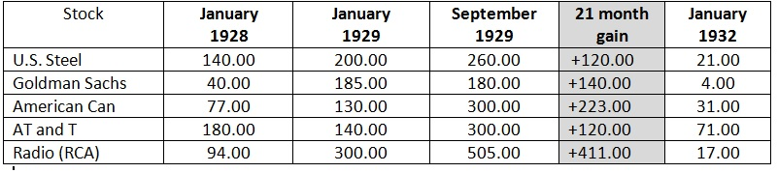

Unsound Banking Practices- Unencumbered by regulation, many banks invested their deposits in unsound ventures including buying stocks on margin. Approximately 5,000 banks failed in the year following the stock market crash and resulted in the loss of $3.25 billion uninsured deposits.

Uneven Distribution of Wealth-economic success was not shared by all, as the top 5% of the richest Americans controlled over 33% of all income. As the disparity between the wealthy and poor grew, many consumers were unable to afford to buy items they had purchased.

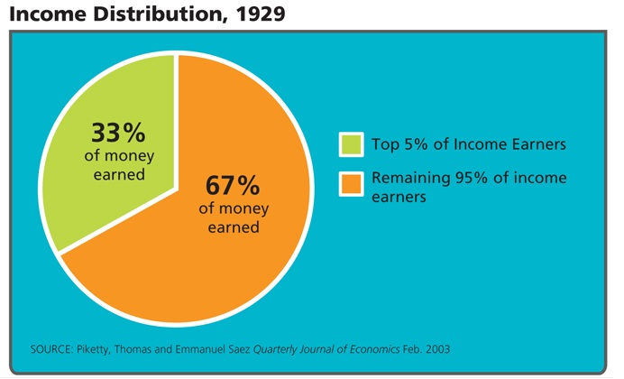
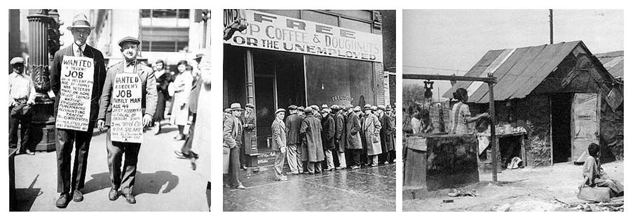

HUMAN MISERY
Farmers: Farmers of the Great Plain’s faced several years of drought during the early 1930”s. Dust storms swept across the plains removing much needed topsoil. Many “Okies,” or migrant farmers, moved westward to find work. Such hardships were depicted in John Steinbeck’s novel, The Grapes of Wrath. Due to problems such as the Dust Bowl and surplus food stuffs, over one-half million farmers lost their farms during the Great Depression.

Workers: By 1932, twelve million people, or 25% of the labor force, were unemployed. Those workers who kept their jobs were forced to work for low wages. Many of the unemployed lived in “Hoovervilles,” or rundown towns, whose makeshift houses were made of cardboard and tin collected from dumps. For millions of Americans, soup kitchens offered their only meals.
Minorities: African Americans and women were extremely hard hit by the depression since they were the first to lose their jobs. Both lost jobs at a more rapid rate than white males. In fact, the unemployment rate for them was twice that of whites.

Bonus Army: In the summer of 1932, thousands of World War I veterans, many of whom were unemployed, marched to Washington, D.C. They set up camp and vowed to stay until they received their war service bonuses due to be paid to them in 1945. When a bill in Congress to provide early payment was defeated, all but 2,000 of the veterans grudgingly left the Capital. President Hoover sent in the U.S. Army to forcibly remove the remaining veterans. http://www.youtube.com/watch?v=IiMuzkpT8Xs

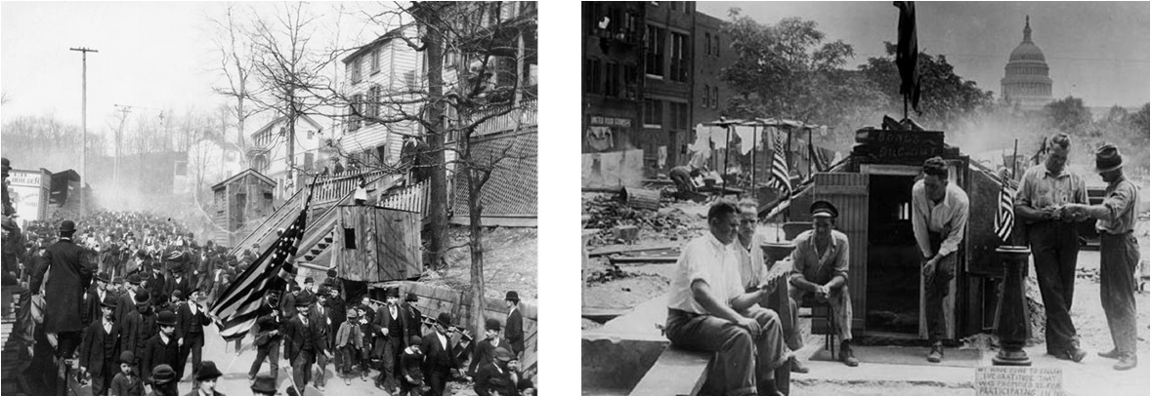
Coxey's Army (1894) vs. The Bonus Army (1932)

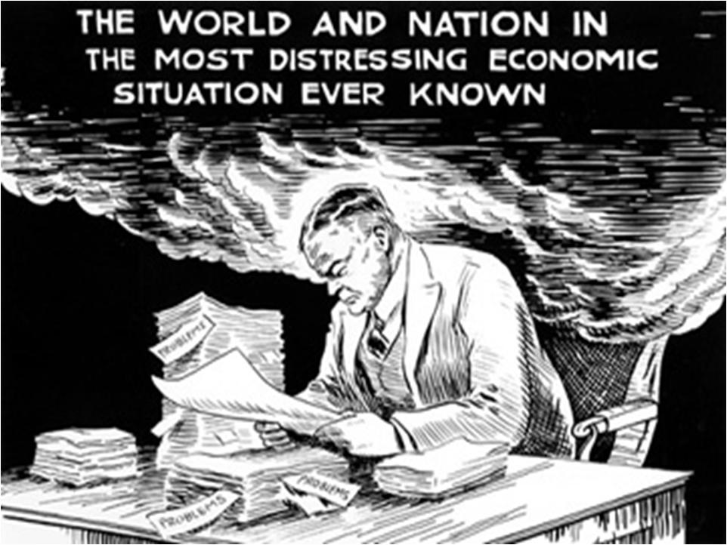
Hoover and limited government

Hoover’s “Trickle Down” Economics: Too Little Too Late?
Hoover believed, wrongly, that prosperity would soon return and that government should not interfere in the economy’s recovery. Between 1929-1930 he made private overtures to business leaders, asking that they voluntarily keep wages stable as well as make public pronouncement to restore confidence in the economy. In addition, he vowed to maintain a balanced federal budget and hesitated to ask Congress for legislative action on the economy, fearing that government assistance to individuals would destroy their self-reliance. Between 1930-1931 Hoover signed into law the Smoot-Hawley Tariff (1930) to protect US industries and proposed a moratorium (1931) on the payment of international debts. The international economy suffered from massive loan defaults, and banks on both sides of the Atlantic scramble to meet the demands of the many depositors withdrawing their money.

By 1931, Hoover was convinced that some government action was needed to pull the US economy out of its doldrums. Between 1931-1932 he supported and signed into law programs that offered assistance to indebted farmers and struggling businesses.

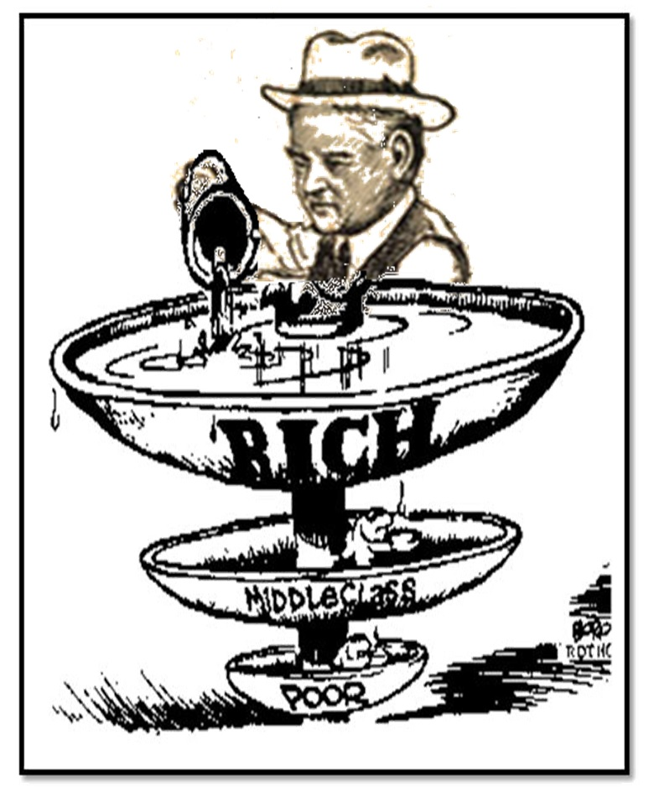

Federal Farm Board-the Farm board was actually created in 1929, but its powers were later enlarged to meet the economic crisis. The board was authorized to help farmers stabilize prices by temporarily holding surplus grain and cotton in storage. The program, however, was too modest to handle the continued overproduction of farm goods.

Relief Payments-believing them to be primarily a local concern, Hoover provided the state governments with 20% of the funds needed to help those suffering from the depression. Unfortunately, the states were unable to adequately provide the necessary funds to make up the difference.

Reconstruction Finance Corporation: “Trickle Down” Economics-this federally-funded, government-owned corporation was created by Congress in 1932 as a measure for propping up faltering railroads, banks, life insurance companies and other financial institutions. The president reasoned that emergency loans from the RFC could help to stabilize these key industries. The benefits would then “trickle down” to smaller businesses and workers and ultimately bring recovery. Overall, by 1932, millions of unemployed workers and impoverished farmers were in a state bordering on desperation. The depression’s worst year—1932—happened to be a presidential election year. The disheartened Republicans nominated Hoover, who warned that a Democratic victory would only result in worse economic problems. In the voters minds, the only real issue was the depression, and which candidate—Hoover or Franklin Roosevelt—could “pilot” the economy back to recover. Almost 60% of them concluded that it was time for a change.

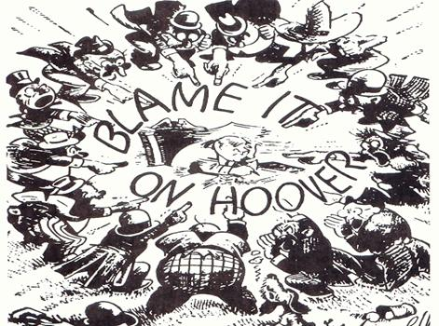

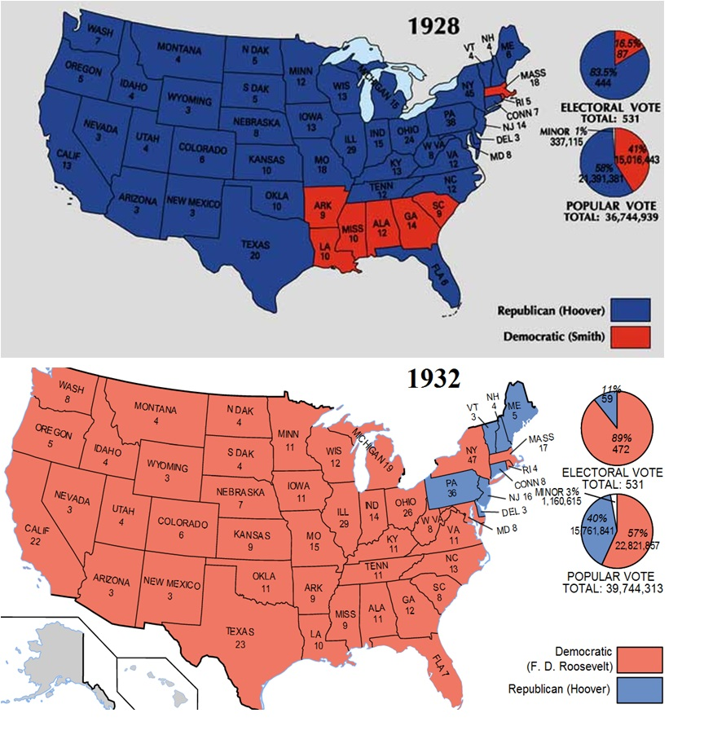
Franklin Roosevelt: A Democrat, President Roosevelt felt the federal government should guide the country out of the depression. He created a Relief, Recovery, and Reform program which called for a tremendous increase in taxes and the use of deficit financing in order to create millions of jobs for the unemployed. Called “pump priming,” Roosevelt wanted to increase employment and create new programs to aid the poor. Roosevelt hoped this would lead to increased consumer spending and in turn help businesses prosper as sales increased.

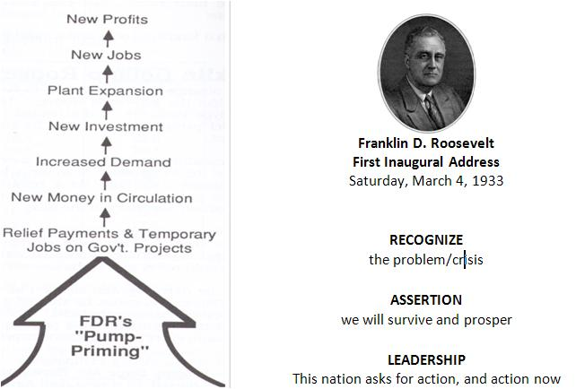

The Great Depression fundamentally reshapes the way the American people think about the role of government
#1 Creates security in the system to change the length and harshness of business cycle
#2 Changes the expectations about what government could and should do
Federal Budget: 1920 $3 billion to 1930 $6 billion

