The French and Indian War and the Imperial Tax Program
(or…How to End Salutary Neglect in North America and Change The World Forever)

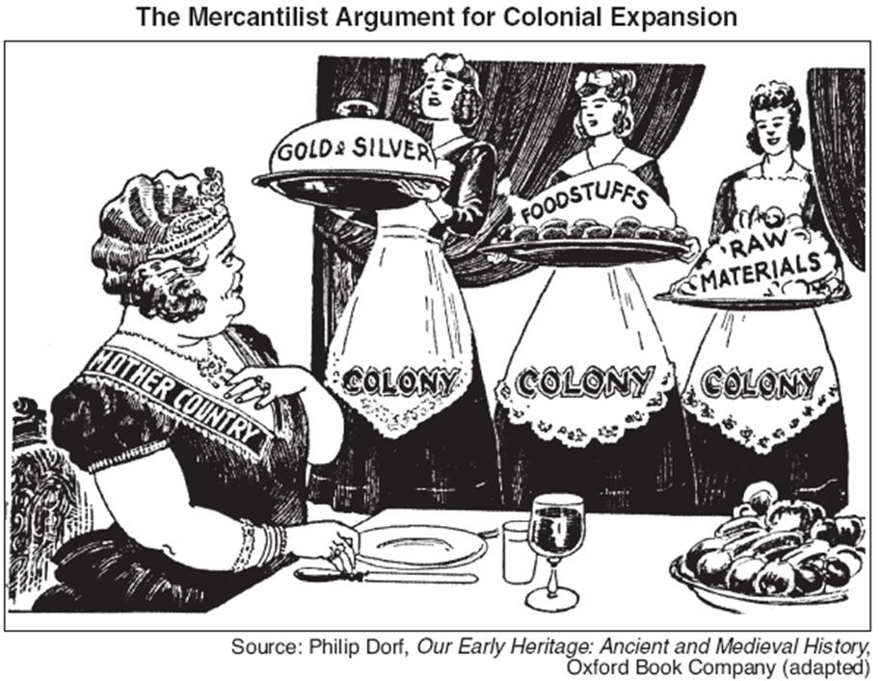
Economic Theory – Mercantilism
Scientific (enlightened thought?) tool for regulating colonial activity and re-integrating the colonies into the mother country
Governments are responsible for overseeing, equipping, and managing natural resources – What not manage trade?
Nations can defend themselves economically HOW?
Tariffs are used to protect domestic activity and keep currency in the country and out of the pockets of your enemies
Economic Theory in Action: Mercantilism can be used to target rivals – HOW?
France became the model for centralizing and regulating the economy
#1 Predictable tax revenue
#2 Impose tariffs
#3 Organize colonies to serve the mother country (put the colonies to work for you)
#4 If this fails make the colonies join your war efforts

REVISIT TALKING POINTS – European Settlement
French did not succeed in creating strong settler society WHY NOT?
Primary activity was religious
Government saw only minimal returns from Colonization
Forbade emigration of religious dissidents – Huguenots
Unable to support/ fund additional` exploration

The earliest contests among the European powers for control of North America, known to the British colonists as King William’s War (1689–1697) and Queen Anne’s War (1702–1713), mostly pitted British colonists against the French with both sides recruiting whatever Indian allies they could. Neither France nor Britain at this stage considered America worth the commitment of large detachments of regular troops, so the combatants waged a kind of primitive guerrilla warfare. In the early history of America, settlers of competing countries often waged brutal conflicts with each other when their homelands went to war.
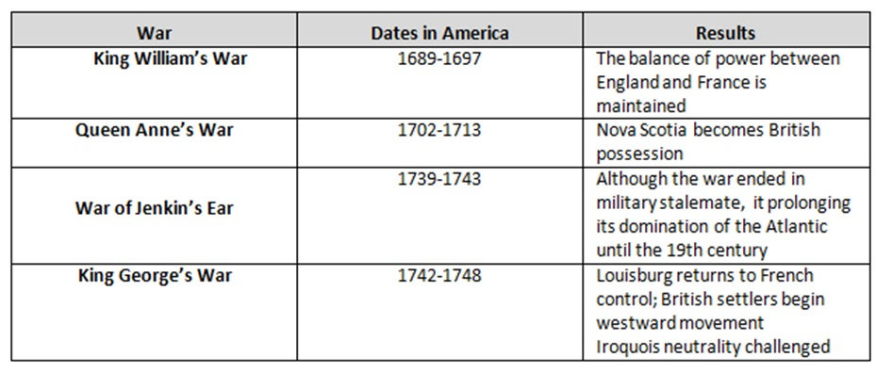
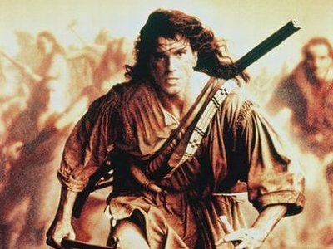

" Americans colonists are a most rude, depraved and degenerate race and it is a mortification to use
that they speak English and can trace themselves from that stock"
British Customs Clerk
Facts:
Known as the Seven Years War in Europe - France and the Indians vs England for control of North America . The Iroquois of New York were the only Indians to side with England

1753 – Gov. Dinwiddle of Virginia sent George Washington to instruct the French to leave the Allegheny-Monongahela Rivers area. Washington carried out assignment and then left

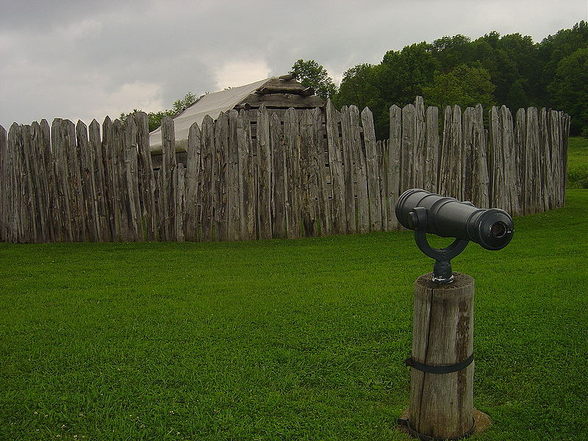

1754 – Instead of leaving the French built Fort Duquesne at the junction of the two rivers. Washington then returned and built Fort Necessity nearby. The two groups had their first conflict in Great Meadows and the war officially began. The French won and Ft. Necessity was surrendered on July 4

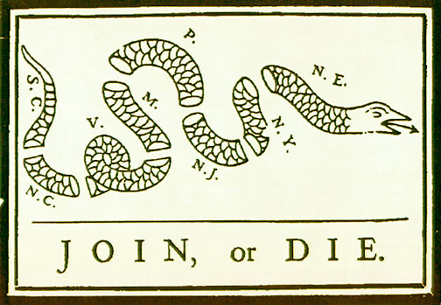

1754 – Benjamin Franklin proposed the Albany Plan of Union – it was the first major plan to unify the colonies with the goal of dealing with the common issues that existed – defense problems and Native American affairs. The plan was passed by the delegation in Albany, but the colonies rejected it, as did King George II.

1755 – General Braddock with about 2000 men – 1400 British regulars and 600 Virginia Militia men – launched a second attack on Ft. Duquesne with Lt. Col. George Washington as his second in command. The English were defeated again in the Battle of the Wilderness. Braddock was killed and Washington led the troops to Ft. Cumberland in Maryland

1756 – The fight intensifies in Europe. Prussia teams with England and Austria with France

1757 – The French take Ft. William Henry at Lake George, New York

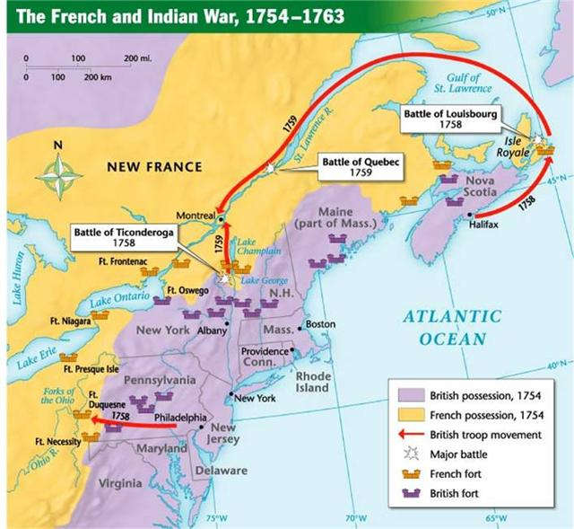

1758 – Lord Jeffery Amherst and James Wolfe become the new British commanders and along with Washington begin to make progress. They take Ft. Louisbourg for the English.

1758 – The English capture Ft. Frontenac and Ft. Duquesne – Duquesne is renamed Ft. Pitt – today the city is Pittsburgh

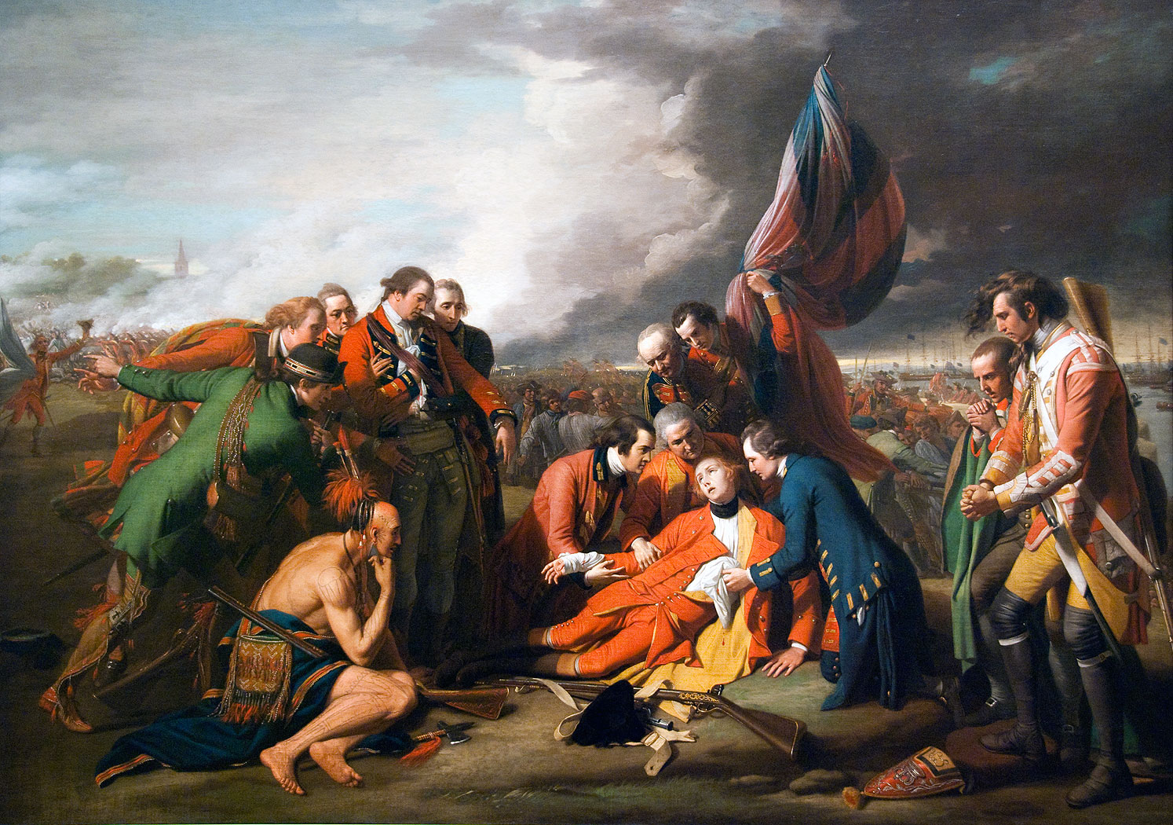
The Death of General Wolfe

1759 – Gen. Wolfe defeats Gen. Montcalm on the Plains of Abraham to take the great fortress of Quebec. Both generals are killed. A major turning point – England took control and it was only a matter of time before they win the war.

1760 – General Amherst takes Montreal – the capital of the French colonies. A few days later Detroit falls and all the other forts along the Great Lakes are deserted.

1762 – Treaty of San Ildefonso – between France and Spain – transfers all the French land west of the Mississippi and New Orleans to the Spanish. Spain had come in on the side of France in the war and France decided to give land to Spain before the English could capture it

1763 – Treaty of Paris - 1 France gives up all of Canada to England 2. France and Spain give all lands east of the Mississippi except New Orleans to the English 3. The West Indies were unscrambled and re-divided to look more like they did prior to the war 4. France got two small islands off the coast of Newfoundland as bases for their fishing fleet and were guaranteed fishing rights off Newfoundland 5. Spain’s title to New Orleans and lands west of the Mississippi river as arranged by the Treaty of San Ildefonso were recognized

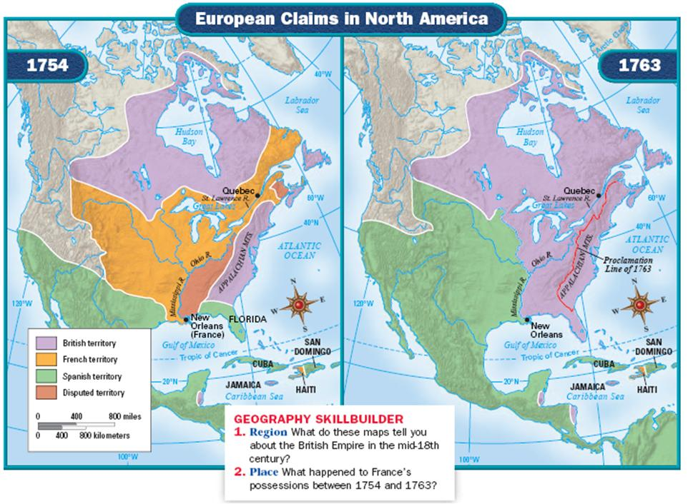

The Great War for Empire left the British government in economic and political disarray

The Empire had spent itself into debt
1. Total national debt was more than 140 million
2. Service (interest ) on the debt was 4.5 million
3. The home islands were the most heavily taxed in Europe
4. Costs of maintaining a military in new regions was 200,000 per year

Disagreement over the nature of government power
1. Stuarts and the French style absolute monarch of the 1600s led to Civil War with Puritans and then Parliament
2. republicanism - citizens subordinate their private selfish interest to the common good

Important Thinkers Influencing American Political Theory

The Need for a Standing Army in North America
Pontiac's Rebellion (1763), The Proclamation of 1763, and the Paxton Boys (1763 to 1764)

Parliament’s solution was to compel the colonies to shoulder the burden of the imperial debt.

Parliament had never before levied DIRECT taxes on the colonies the colonies raised their own money through taxation to pay for costs
The colonies were considered plantations (and thus had not legal standing) and parliament insisted that it had the authority to levy direct taxes.

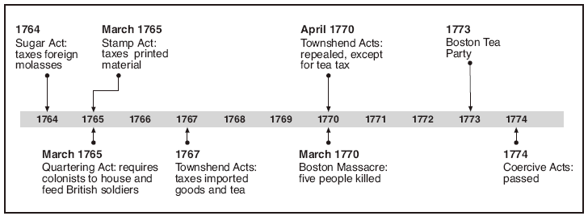

George Grenville Search for Revenue "Fiscal Aggression"
Grenville imposed a series of direct levies, culminating in the Stamp Act (1765)

Sugar Act | threatened triangular trade by interfering with French molasses imports. Some colonists argued that Sugar Act  was illegal, that all taxes needed to arise from the people
Currency Act | forbade the issue of paper money
Western problems | Ottawa Indian leader Pontiac led an uprising against settlers, killing over 2000 and destroying British forts  Proclamation of 1763 prevented western migration past the Appalachian Mountains
Stamp Act (1765) | Sought to raise funds for defense of America by requiring all legal documents, as well as newspapers,  playing cards, etc. to bear a government stamp.

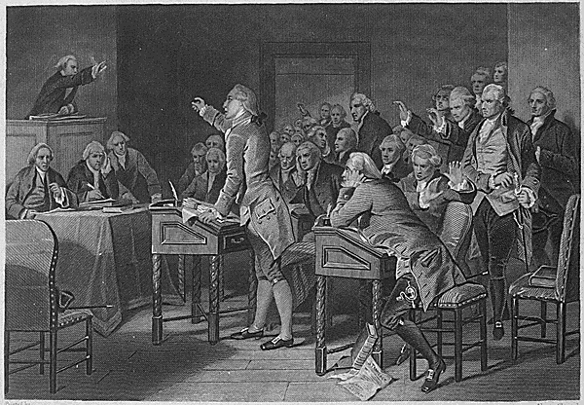
The Stamp Act Congress, or First Congress of the American Colonies, was a meeting held between October 7 and 25, 1765 in New York City

Stamp Act Crisis | 1. Colonial opposition to the Stamp Act (Stamp Act affected lawyers, merchants, editors most heavily)  2. Unlike the Sugar Act, this was the first internal tax intended to raise revenue  3. Stamp Act Congress met to call for boycott of British goods and state that Parliament had no right to tax colonies without consent.  4. Sons of Liberty used mob violence to force all stamp agents to resign.

MPERIAL TAX PROGRAM
Reactions and Responses from the Crown (1767-1776)

Charles Townshend threatened American colonial traditions of self-government and imposed revenue duties on a number of items necessary to the colonies.

Townshend Acts  (1767-1770) | New duties placed on a number of goods (paper, paint, glass, and tea) led to protests against the collection of customs duties.  Samuel Adams led radicals in urging a renewed boycott of British goods and provided an issue to unify American sentiment  2. Boston Massacre resulted in deaths of four persons (1770) when soldiers sent to protect agents were attacked by a mob.  3. By 1770 all duties except that on tea were repealed. Tea tax was seen as symbolic of Parliament's supremacy
Tea Act (1773) | In an attempt to support the East India Tea Company, Parliament removed the tax on tea and allowed it to be sold in the colonies through its own agents, not American retailers. British tea was cheaper, but to buy it was to pay a Townshend duty.
Boston Tea Party | Mobs turned back tea ships in several ports and dumped shiploads into Boston Harbor.
Coercive  (Intolerable) Acts (1774) | Closed Boston Harbor  b) Removed trials involving royal officials out of New England  c) Allowed for quartering of troops in colonists' homes  d) Extended Quebec's boundaries south, convincing colonists that liberty was threatened.
First Continental Congress (1774) | Radical delegates favored active resistance while moderates argued for conciliation.  Declaration of Rights and Grievances condemned Coercive Acts, denied Parliament's right to tax colonies, but promised obedience to the king  Set up Continental Association to prohibit importation of English goods and later the export of American goods to England.

Proclamation of 1763
Stamp Act, 1765
Townshend Acts, 1767
Boston Massacre, 1770
Tea Act, 1773
Committees of Correspondence
“Intolerable Acts,” 1774
First Continental Congress
Lexington and Concord
Second Continental Congress
Declaration of Independence

