The Era of Good Feelings? July 4 1819

Rush –Bagot Treaty 1817

No war ships on the Great Lakes
Set the 49th parallel as the border between Canada and the Louisiana Territory

U.S. political leaders had long expressed interest in disarming the Great Lakes and had proposed such a measure during negotiations that led to the 1794 Jay Treaty, but British officials had rejected this proposal.

During the War of 1812, both Great Britain and the United States had built fleets of ships on lakes Erie and Ontario, and fought many battles in the region. Near the end of the war, U.S. forces had achieved dominance over the Lakes. After the war, both powers were wary of one another’s military strength and a postwar shipbuilding race ensued. However, both countries also wished to reduce their military expenditures.

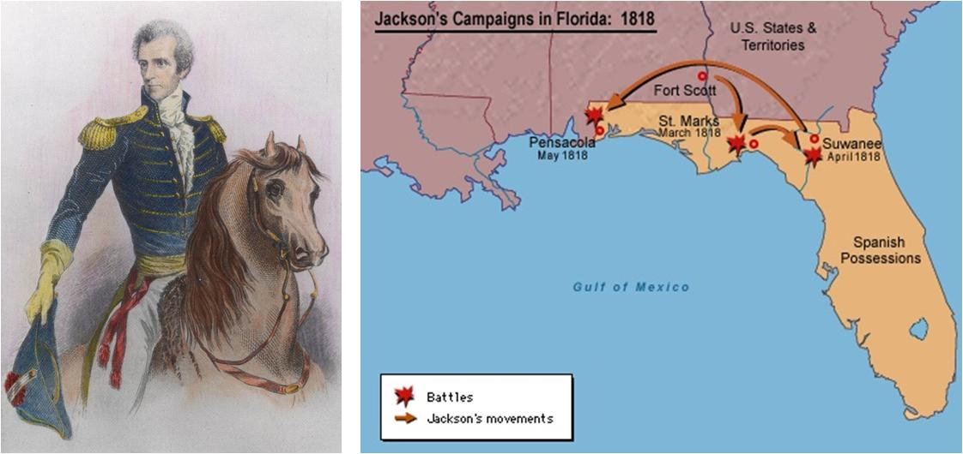

http://www.tubechop.com/watch/4146964

Foreign Relations – Acquisition of Florida
1817 – Andrew Jackson put in command of a patrol in Georgia that was to guard the border
he did have permission to pursue hostile Indians into Florida if necessary Jackson also let Monroe know that his force could take Florida in 60 days

When Monroe didn’t tell Jackson no – Jackson took it as an OK. Spring 1818 – Jackson went after a group of Indians 175 miles into Florida 2 English traders were killed
In the West Jackson was acclaimed a hero In the Senate and House – he was condemned and they wanted Monroe to discipline Jackson.Monroe and Adams – John Quincy Adams Sec. Of State – both said NO

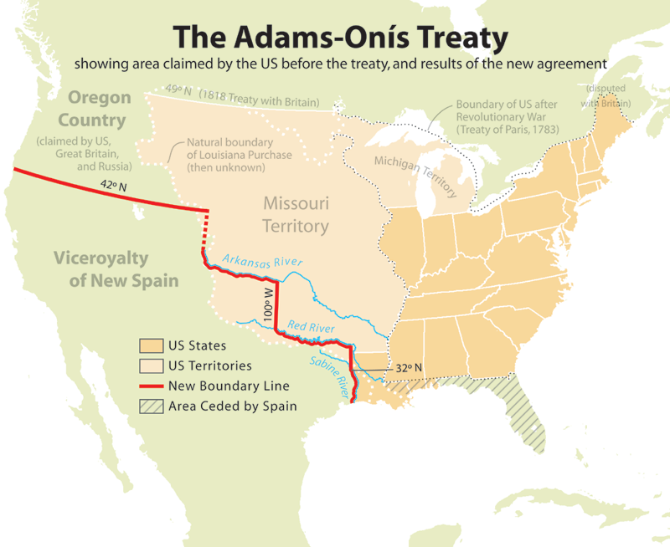

1819 – Adams-Onis Treaty
#1 Florida became part of the United States
#2 Spain got $5 million
#3 A more specific line was drawn between Louisiana and Spanish Mexico

Also recognized the U.S. claims in Oregon and Spain stopped claiming land there

