The End of World War II
TIME LINE SUMMARY
1939: On August 23, Germany and the U.S.S.R. signed the Non-Aggression Pact. On September 1, Germany invaded Poland. World War II officially began on September 3, when Great Britain and France declared war on Germany.

1940: Germany occupied the neutral countries of Norway and Denmark, Holland, Belgium, and Luxemburg were conquered when German troops bypassed the Maginot Line (a defensive line of fortifications between France and Germany). In June, France surrendered to German forces leaving Great Britain alone to fight Germany. The first turning point for the Allies was the Battle of Britain in August. The Royal Air Force repulsed the German Luftwaffe, and saved Britain from attack. In November, Romania and Hungary joined the Axis alliance.

1941: On June 22nd, Hitler broke the Non-Aggression Pact and invaded the Soviet Union. On December 7, Japan attacked Pearl Harbor bringing the U.S. into World War II. Japan simultaneously invaded Wake Island, Guam, British Malasia, Singapore, Dutch East Indies, Burma, Thailand, and the Philippines. In November, General Dwight Eisenhower landed in Africa and took Casablanca, Oran, and the Algiers.

1942: On June 3-6, the Battle of Midway took place in the Pacific. Japan lost four aircraft carriers and about 275 planes. This was the turning point in the Pacific War for the U.S. Soviet troops stopped the Nazi offensive at Stalingrad in the fall. Over 300,000 German troops were captured and Soviet troops began an offensive which lasted until 1945 when Soviet troops invaded German soil.

1943: Over 250,000 Axis troops surrendered on May 13 bringing the North Africa campaign to a close. On July 9, the Allies invaded Italy on the island of Sicily. Mussolini was overthrown on July 25.

1944: General Eisenhower was made Supreme Commander of Allied troops in June. On June 6, “D-Day,” Allied troops successfully invaded Europe by crossing the English Channel opening up a second front against Nazi Germany. By September, American troops were on German soil. In the Pacific war, the Philippines fell to the United States.

1945: In the Pacific War, the 74 day battle at Iwo Jima ended in a costly victory for the U.S. VE Day (Victory in Europe) came on May 8 when Germany surrendered. On August 6, the first atomic bomb was dropped on Hiroshima killing 260,000 people. A second bomb was dropped on Nagasaki on August 9. Five days later, Japan surrendered (VJ Day) ending World War II.

Wartime Conferences

The Truman Show .; Potsdam Conference

Review of Executive Action

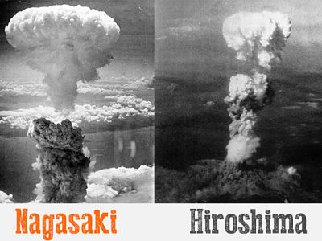

The Atomic Bomb (1942 to 1946) The Manhattan Project was responsible for developing the atomic bomb for the U.S. On July 16, 1945, the first atomic bomb was detonated in the desert of New Mexico. Three weeks later, on August 6, the U.S. dropped an atomic bomb on Hiroshima, Japan and three days later on Nagasaki, Japan. Japan officially surrendered on August 14th.

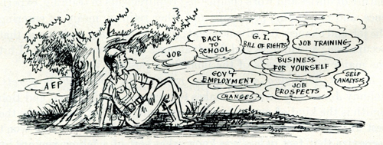
Servicemen's Readjustment Act (1944) The law, which was later amended to include all veterans, originally guaranteed a year of college or trade education to ex-World War II servicemen with at least 90 days in the armed forces. CLIP: Eugene Sledge on campus

It also mandated that they receive up to $500 a year for tuition, books, and supplies. Of the nearly 8 million veterans who took advantage of this first G.I. bill, 450,000 became engineers, 240,000 accountants, 238,000 teachers, 67,000 doctors, and 22,000 dentists, while thousands more chose other professional careers. Veterans also made use of the bill’s guaranteed mortgages and low interest rates to buy new homes in the suburbs, kicking off a development boom.

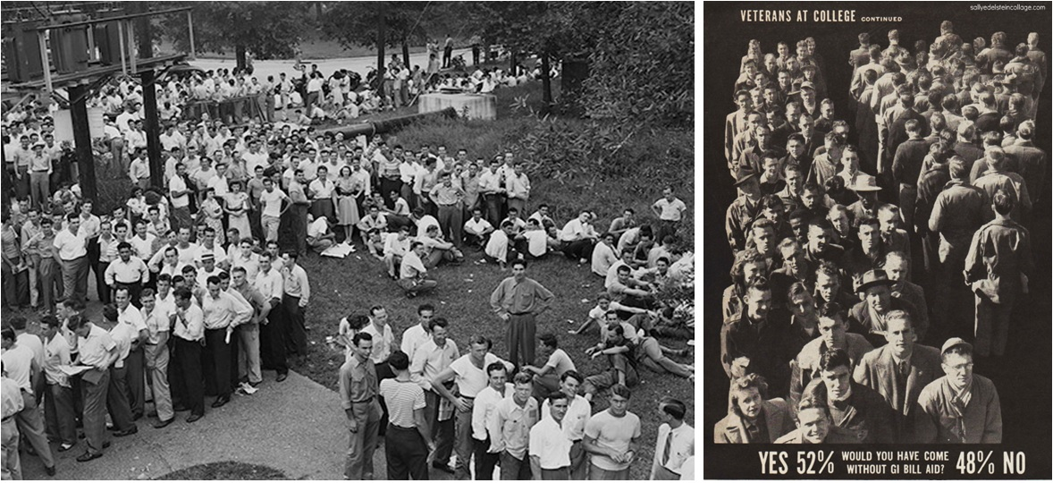

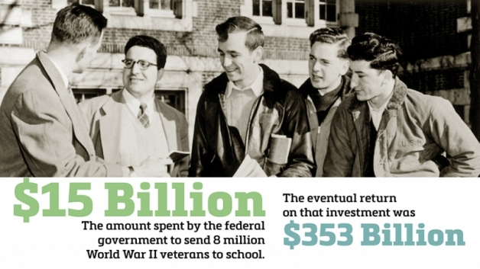

GI BILL POST SCRIPT: Some of this improved—and suddenly—after the war. A key to the change was passage of the GI Bill of Rights in 1944. 22 This was a remarkably broad piece of legislation, which not only offered veterans aid in purchasing housing, and loans to start businesses, but also provided monthly stipends for veterans who wanted help with educational costs. These stipends were not huge: $65 per month at first for single veterans, $90 for those with dependents, and a maximum of $500 per year for tuition and books. But they were a real inducement, especially for veterans with savings, and millions jumped at the opportunity.

By 1956, when the programs ended, 7.8 million veterans, approximately 50 percent of all who had served, had taken part. A total of 2.2 million (97.1 percent of them men) went to colleges, 3.5 million to technical schools below the college level, and 700,000 to agricultural instruction on farms. The GI Bill spent $14.5 billion, a huge sum in those years, for educational benefits between 1944 and 1956. 23 The GI Bill indeed promoted an educational boom. Colleges and universities were nearly swamped by the change; almost 497,000 Americans (329,000 of them men) received university degrees in the academic year 1949–50, compared to 216,500 in 1940. T

he influx jolted faculty and administrators, who had to reach out beyond the predominantly upper-middle-class young people whom they previously had served, to deal with older students, to offer married housing, to accelerate instruction, and to provide a range of more practical, career-oriented courses. The GI Bill was almost certainly worth it economically, helping millions of Americans to acquire skills and technical training, to move ahead in life, and therefore to return in income taxes the money advanced to them by the government. It was the most significant development in the modern history of American education.

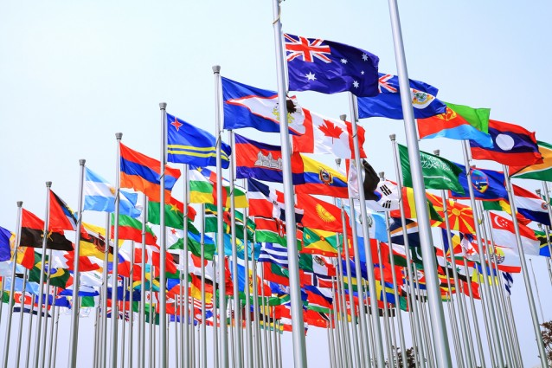

Creation of the United Nations (1945) : Established to promote international co-operation. A replacement for the ineffective League of Nations, the organization was created following the Second World War to prevent another such conflict. Similar to the League of Nations, the United Nations consisted of over 50 nations with the goal maintaining international peace and security

