The Election of 1860 and the Formation of the Confederacy
Thematic Connections and Illustrative Examples
1. Centrifugal force – the newly formed Republican Party anti-slavery stance
2. Centripetal force – the democratic party is split over slavery

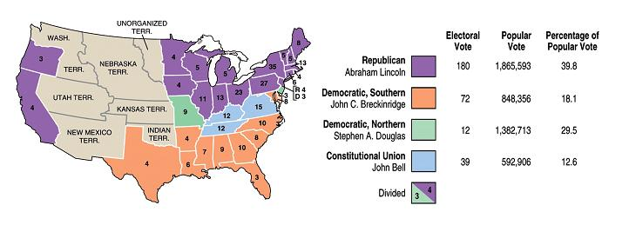

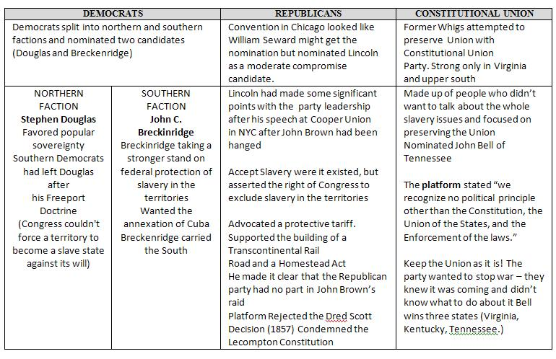

The South viewed Lincoln as a “savior to the slaves” and this represented a threat to the survival of slavery – REALITY? Loss of political power? Eliminate leads to elimination….
The South viewed Lincoln as a “savior to the slaves” and this represented a threat to the survival of slavery – REALITY? Loss of political power? Eliminate leads to elimination….
Post Election Reactions - December, 1860

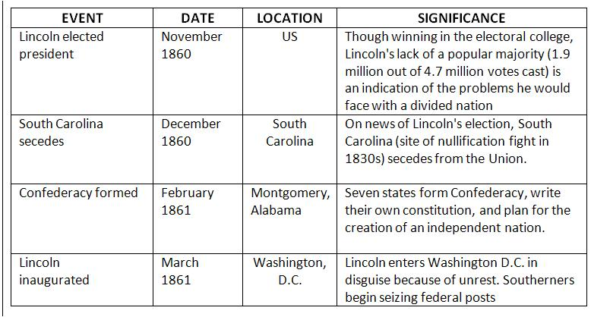

Lincoln's First Inauguration (March 4, 1861)
KEY IDEAS and THEMES
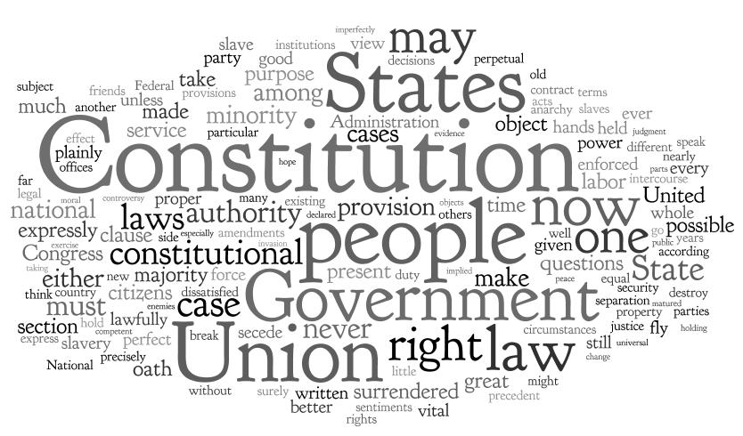

BACKGROUND: In March of 1861, the eyes of the nation were focused on Fort Sumter, in the harbor of Charleston, South Carolina. It was under threat from the new Confederacy, which claimed it. While still in Springfield, Lincoln had secretly asked the chief of the United States army "to either hold, or retake, the forts, as the case may require, at, and after the inauguration.)
Property - Without mentioning Sumter directly, Lincoln reiterated in his inaugural address that: "The power confided to me will be used to hold, occupy, and possess the property and places belonging to the Government."
Slavery - To avoid further alienating the South, Lincoln declared: "I have no purpose, directly or indirectly, to interfere with the institution of slavery in the States where it exists. I believe I have no lawful right to do so...."
Union Lincoln declared the North would take no action against the South except in the case of aggression; however, he swore to preserve the Union should such aggression occur Lincoln directly addresses dissident Southerners: "In your hands, my dissatisfied fellow-countrymen, and not in mine, is the momentous issue of civil war.... You can have no conflict without being yourselves the aggressors. You have no oath registered in heaven to destroy the Government, while I shall have the most solemn one to 'preserve, protect, and defend it.' "I am loath to close. We are not enemies, but friends. We must not be enemies..."

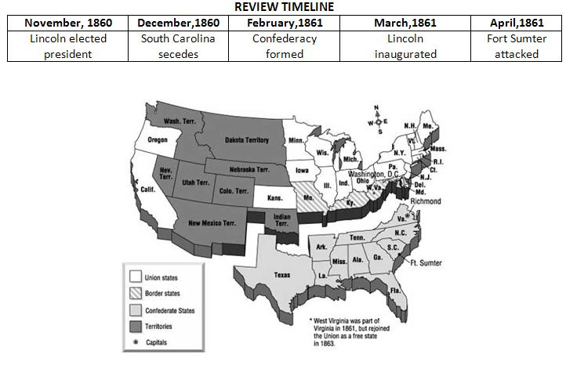

The importance of the border-states (states bordering the North): Missouri, Maryland, Delaware, and Kentucky. They were slave states, but did not secede. LOCAL CONNECTIONS Elmer Ellsworth and Abner Doubleday

