The Cold War Begins 1945-1952

"...Americans on the home front suffered little from the war, compared to the people of the other fighting nations.
By the end of the war much of the planet was a smoking ruin. But in America the war invigorated the economy
and lifted the country out of a decade-long depression." – Page 831

Cold War defined: Diplomatic tension between nations with no actual combat. Usually refers to the state of tension between the US and Soviet Union from the late 1940's to late 1980's.

USA vs. USSR Ideological differences:
#1. Communism versus Capitalism
#2 Each economic system calls for the destruction of the other

1947 FP

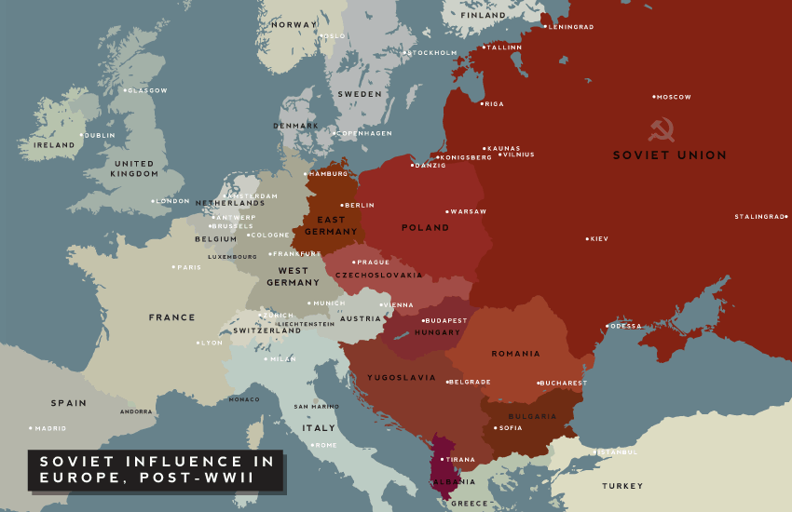

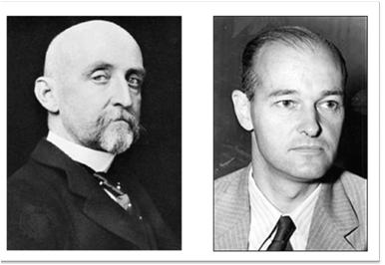
How did Alfred T. Mahan and George F. Kennan influence U.S. foreign policy?
What do Alfred T. Mahan and George F. Kennan have in common?'
Their writings influenced the course of US foreign policy!!!!

Mahan (1890)
The development of a new steel navy also focused attention overseas. Captain Alfred Thayer Mahan’s book of 1890, The Influence of Sea Power upon History , 1660–1783 , argued that control of the sea was the key to world dominance. (One of the most influential public policy books ever published)

Mahan analyzed the role a Navy played in history. He determined the US needed to look beyond its borders and have a strong Navy to protect its economic interests. Nice summary of Mahan's Influence (7 minutes)

Read by the English, Germans, and Japanese, as well as by his fellow Americans, Mahan helped stimulate the naval race among the great powers that gained momentum around the turn of the century. This books impacts intellectuals and elites concerned about expansion and economic development

Kennan (1947)
Kennan was an American advisor, diplomat, political scientist, and historian, and architect of U.S. containment policy and a key figure in the emergence of the Cold War.

His "Long Telegram" (under the pseudonym X)from Moscow in 1946, and the subsequent 1947 article "The Sources of Soviet Conduct" argued that firm, vigilant containment patiently over the long term if needed. "Soviet pressure against the free institutions of the Western world is something that can be contained by the adroit and vigilant application of counter-force at a series of constantly shifting geographical and political points."

Soviet regime was inherently expansionist and that its influence had to be "contained" in areas of vital strategic importance to the United States.

These texts quickly emerged as foundational texts of the Cold War, expressing the Truman administration's new anti-Soviet Union policy. Kennan also played a leading role in the development of definitive Cold War programs and institutions, most notably the Marshall Plan
NSC-68
A 58-page classified report issued by the United States National Security Council on April 14, 1950
Kennan's theory of containment articulated a multifaceted approach for U.S. foreign policy in response to the perceived Soviet threat, NSC-68 recommended policies that emphasized military over diplomatic action. Kennan's influential telegram advocated a policy of containment towards the Soviet Union. In NSC-68, it can be defined as "a policy of calculated and gradual coercion." That said, the NSC-68 called for significant peacetime military spending, in which the U.S. possessed "superior overall power" and "in dependable combination with other like-minded nations." It calls for a military capable of:
- Defending the Western Hemisphere and essential allied areas in order that their war-making capabilities can be developed;
- Providing and protecting a mobilization base while the offensive forces required for victory were being built up;
- Conducting offensive operations to destroy vital elements of the Soviet war-making capacity, and to keep the enemy off balance until the full offensive strength of the United States and its allies can be brought to bear;
- Defending and maintaining the lines of communication and base areas necessary to the execution of the above tasks; and
- Providing such aid to allies as is essential to the execution of their role in the above tasks.

This would cost, by its estimates, a significant portion, perhaps more than the 20% of GDP the United States was already committing to defense. The specific costs were left to subsequent group in the NSC to analyze and budget.

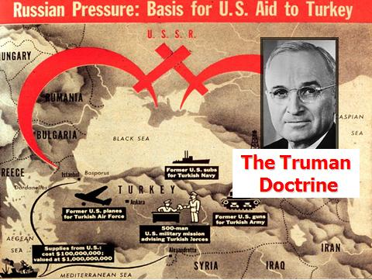

Truman Doctrine – 1947 ($400 million in aid)
In 1947 President Truman asked for and received from the U.S. Congress $400 million to provide assistance “to support free peoples who are resisting attempted subjugation [enslavement] by armed minorities [communists] or by outside pressures.” Providing military and economic assistance to nations resisting communist takeovers became known as the Truman Doctrine. The first nations to receive aid under the Truman Doctrine were Greece and Turkey, both of which then successfully defeated attempted communist takeovers.

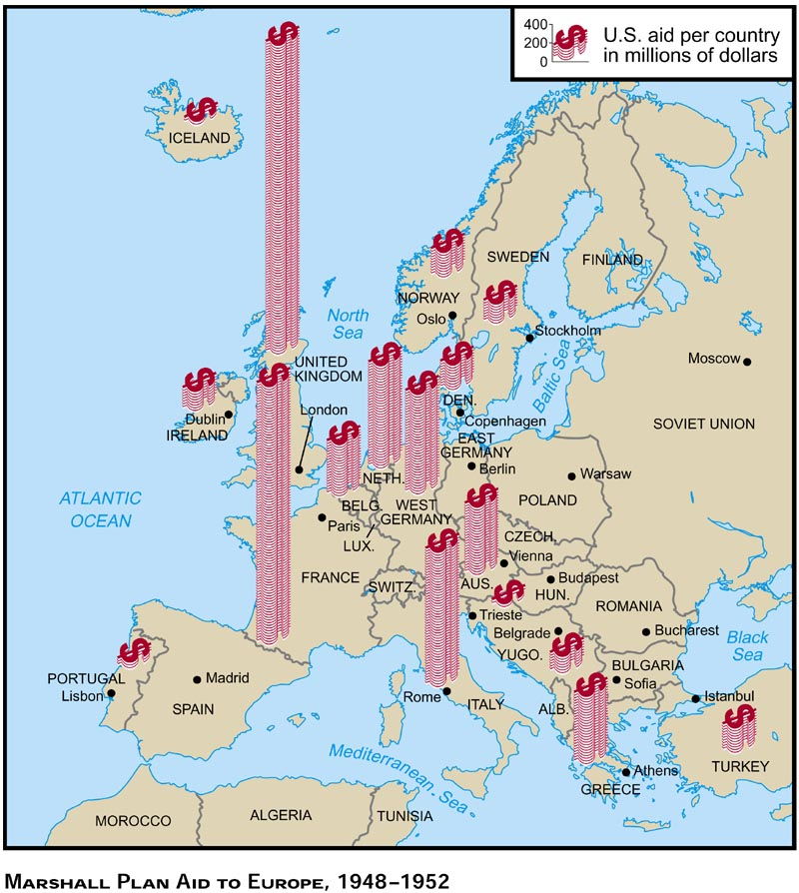

"The Marshall Plan was a spectacular success. American dollars pumped reviving blood into the
economic veins of the anemic Western European nations." American Pageant - Page 871

Marshall Plan -1947 ($17 billion in aid)
In 1947 U.S. Secretary of State George Marshall created a plan to rebuild a Europe devastated by World War II. All European nations, including the Soviet Union, could receive U.S. dollars to rebuild their devastated economies as long as the money was spent on products made in the United States. In 1948 the U.S. Congress approved $17 billion in aid. Nations receiving Marshall Plan aid were Great Britain, France, Portugal, Spain, Belgium, the Netherlands, Luxembourg, West Germany, Denmark, Norway, Sweden, Switzerland, Austria, Italy, Greece, and Turkey.

FP 48
Page historylast edited by Mr. Hengsterman 3 months ago

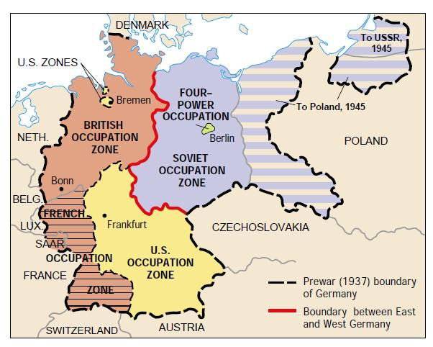
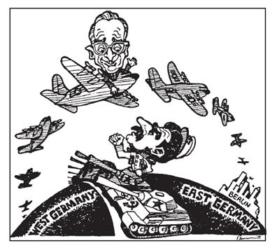

http://www.tubechop.com/watch/1113774

Berlin Blockade and Airlift – 1948-49
The Berlin Blockade of 1948 left two million West Berliners without electricity, food, and fuel needed for survival. Unwilling to give up West Berlin to the Soviet Union and unwilling to fight the Soviet army and risk starting World War III, President Truman decided to launch the Berlin Airlift. For 10 months, starting in August 1948, the United States sent two million tons of supplies to West Berlin on cargo planes. The planes had to land and take off 24 hours a day to keep from having to give up the West’s occupation zones in the German capital. The Soviet Union lifted the blockade in May 1949.

FP 49

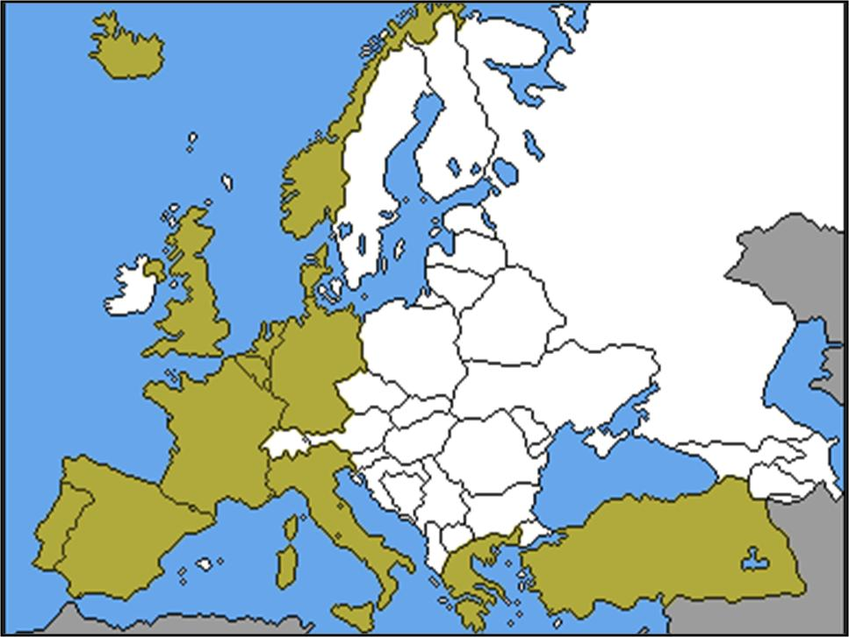

North Atlantic Treaty Organization (NATO) - 1949
Fearful that western European nations could not resist a Soviet attack from eastern Europe, President Truman signed a treaty that created a military alliance (a pact between states in a common cause) known as the North Atlantic Treaty Organization (NATO). NATO linked the United States and western Europe in such a way that, as Truman said, “an armed attack against one or more of the [nations] in Europe or North America shall be considered an attack against them all.” Members of NATO in 1949 were Canada, the United States, Great Britain, France, Iceland, Portugal, Belgium, the Netherlands, Luxembourg, Denmark, Norway, Switzerland, and Italy. Greece and
Turkey joined the alliance in 1952, and East Germany was admitted in 1954

Historical Context: Led by Mao Zedong, the Chinese Communists defeated the Chinese nationalists and declared the People’s Republic of China.
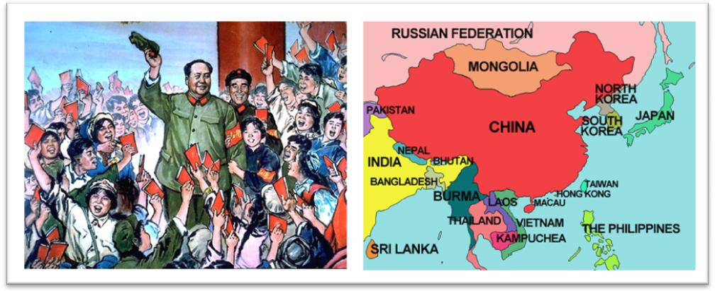

http://www.tubechop.com/watch/1113777

Communist Victory in China (1949)
In 1927, Chiang Kai-shek (Jiang Jieshi), leader of the Chinese Nationalist government, sought to destroy the Chinese Communist forces under Mao Zedong. In 1931, the Japanese invaded Manchuria and in 1936 invaded China. Faced with this crisis, the Chinese Nationalists and Communists fought the invader separately. But after the defeat of Japan in 1945, the civil war continued. With the support of the peasants Mao’s growing army inflicted one defeat after another on the Nationalists. By December 1949 Chiang Kai-shek and his followers fled to the island of Formosa (Taiwan) and established the Nationalist government there. The communist Chinese led by Mao now controlled all of mainland China. The United States, however, continued to recognize Chiang’s government on Taiwan as the “legitimate” government of China.

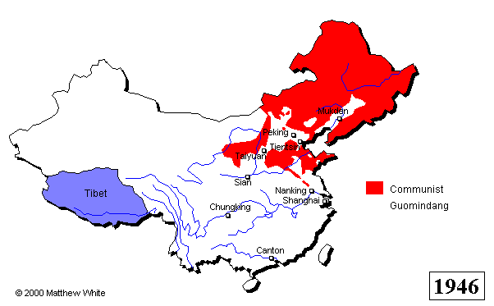

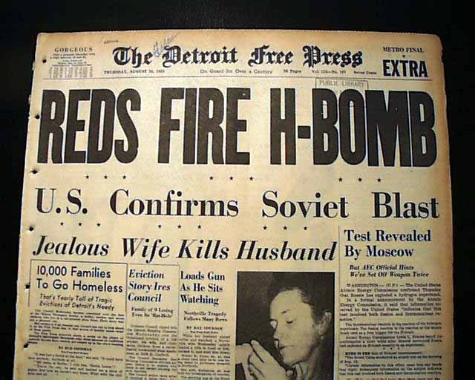

FP 1950
The Korean War
After World War II, Soviet forces entered Korea from the north and U.S. forces from the south. Two Koreas were formed with a dividing line drawn at the 38’ parallel between communist North Korea and Democratic South Korea.

The U.S.S.R. and U.S. withdrew their forces in 1949. On June 25, 1950, North Korean troops launched a full-scale attack on South Korea in an attempt to unite both nations under a communist government.

UN and U.S. troops were dispatched to Korea as a “police action” to remove the North Koreans from the south. General Douglas MacArthur quickly drove back communist forces into North Korea, but when MacArthur’s troops approached the border with China at the Yalu River, they were caught in a trap by Chinese armies.

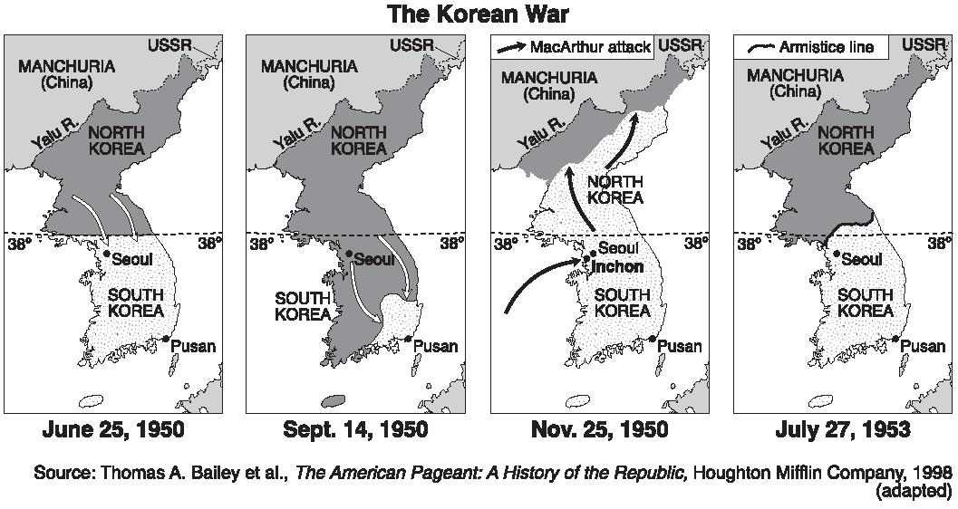
NSC 68 -- National Security Council recommended increasing US defense spending by 4X, initially ignored, was resurrected by the Korean crisis when Truman recommended raising the armed forces to 3.5 million men and spending 13% of the GNP ($50 billion) annually on defense.

FP 1952
Page historylast edited by Mr. Hengsterman 3 months ago

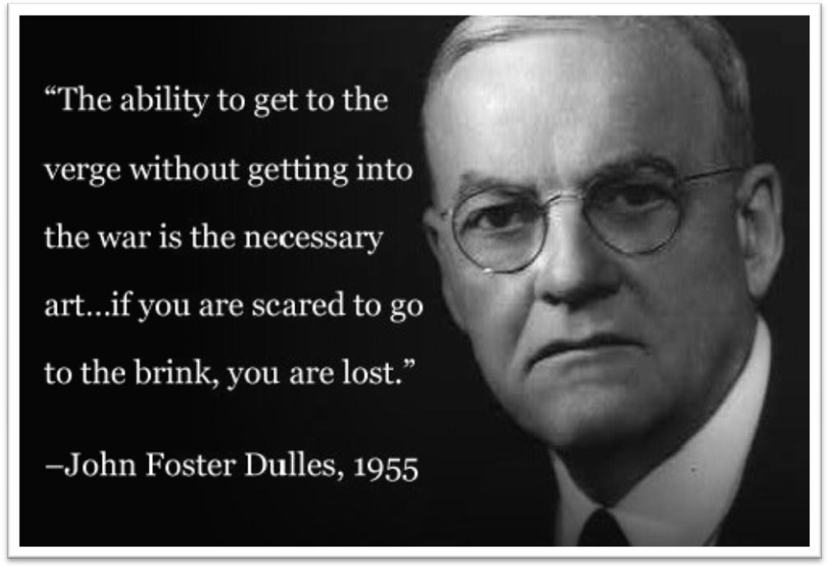

John Foster Dulles (Ikes’ Secretary of State)– churchgoer – push back (roll back) Communist advances, “liberate captive people” Also try to balance budget by reducing military spending.

COLD WAR LANGUAGE

Brinkmanship - The practice of threatening an enemy with massive retaliation for any aggression.

Containment - The blocking of another nation’s attempts to spread its influence especially the efforts of the U.S. to block the spread of Soviet influence starting in the late 1940s,
Massive Retaliation - Policies of both the U.S. & the Soviet Union to build up enough nuclear weapons in order to show that it could still destroy the other side, even if attacked first

