The Cold War: Domestic Policies and Events

The Wagner Act 1935

The act provided for collective bargaining, handling labor disputes and recognized the right of workers to choose representatives to represent themselves in a bargaining unit. The act included the right for employees to unionize and also established the National Labor Board (NLB)

National Labor Relations Act 1935
This law set limits on how employers may react to employees that organize or try to organize labor unions, engage in collective bargaining, and take part in strikes and other forms of mutual activity to support their causes

The Taft-Hartley Act

(also known as the Labor Management Relations Act of 1947), was created after a great number of large-scale strikes had nearly disabled the automobile, steel, and packing industries, among others. These work stoppages had caused a ripple effect through the economy, leading to public panic.

Whereas the Wagner Act had spoken only of the right to participate in union activities, the new act included the right to refrain from union activities.

It was clear that this new act was designed to level the unfair playing field formerly tipped in favor of labor unions.

1947-Jackie Robinson integrates Major League Baseball for the 1st time since 1889 (Moses Fleetwood Walker).

DP 1948

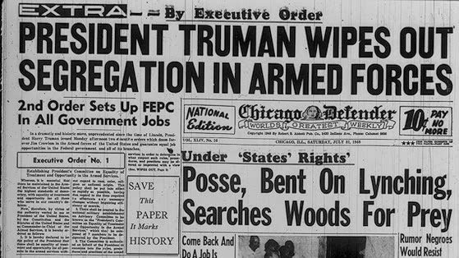

On July 26, 1948, President Harry S. Truman signed this executive order establishing the President's Committee on
Equality of Treatment and Opportunity in the Armed Services, committing the government to integrating the segregated military.

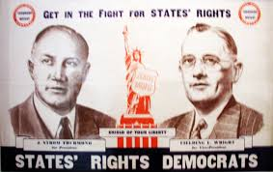

1948: THE POLLSTERS’ DEFEAT
Democratic prospects seemed hopeless in 1948. Harry Truman, who had become President on Franklin D. Roosevelt’s death in 1945, had little popular appeal.

Truman faced a strong Republican contender, Thomas E. Dewey, and third-party pressures from Progressives and “Dixiecrats.” (Southern Democrats in the States’ Rights Party)

Political experts-and nearly every public opinion poll-predicted a Dewey victory. Chicago’s Tribune (see photo) felt safe in printing a “Dewey Defeats Truman” headline before all the votes were counted. Actually, Truman defeated Dewey-with 24,105,812 popular votes and 303 electoral votes. Dewey won 21,970,065 popular votes and 189 electoral votes.

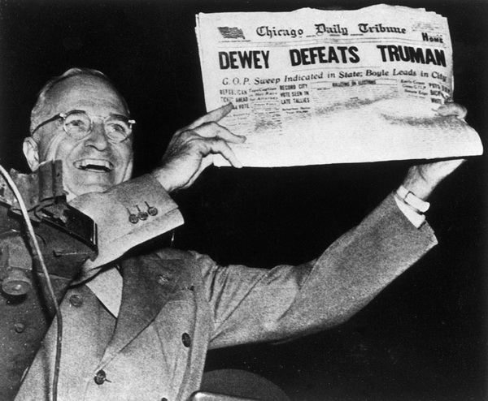

DP 1949
Page historylast edited by Mr. Hengsterman 3 months ago

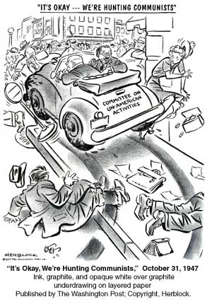

HUAC (The House Un-American Committee)

The House Committee to Investigate Un-American Activities was established in the House of Representatives in 1938 to hold hearings, examine witnesses, and issue reports concerning disloyalty.

HUAC first made headlines in 1947 when it began to investigate Communist influence in Hollywood. Hollywood did contain a substantial number of left-wingers, socialists and communists.

The “Hollywood Ten” were witnesses who refused to “name names” of communists in the business and were sentenced to prison for refusing to cooperate with HUAC. In response, Hollywood executives formed “blacklists” that banned those perceived to have an association with communism from working in movies. Nearly 500 actors, writers, producers, and directors had their careers ruined because they could no longer work in film

1950 DP

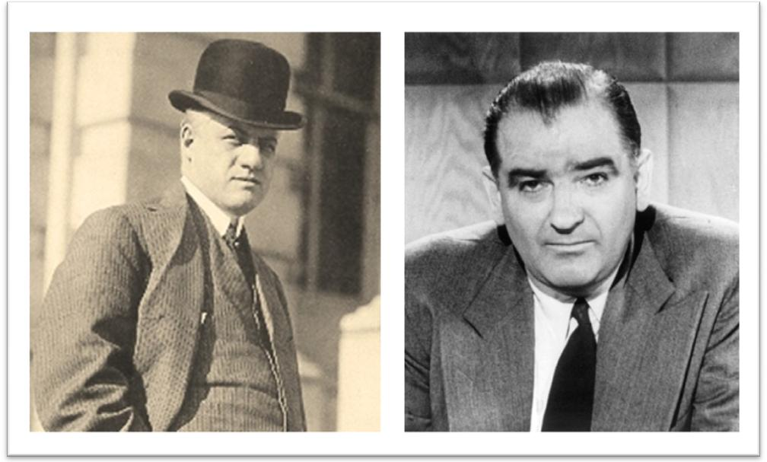
Seeing Red- A. Mitchell Palmer and Senator Joseph McCarthy

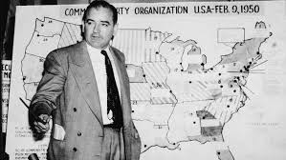

McCarthyism (another Second Red Scare)

The most famous anti-Communist activist was Republican Senator Joseph McCarthy. In 1950, he claimed to have a list with the names of Communists in the State Department and charged the Democratic Party with treason for allowing Communist infiltration of the U.S. government.

McCarthy never produced the list, but managed to conduct hearings that investigated government officials, colleges, and the media resulting in the ruining of many careers. Many disliked his tactics, but supported his cause.

The McCarran Internal Security Act (1950) A McCarthy era federal law passed over President Harry Truman's veto. The anti-communist fervor was bi-partisan and only seven Democratic senators voted to uphold the veto.

It required Communist organizations to register with the United States Attorney General and established the Subversive Activities Control Board to investigate persons suspected of engaging in subversive activities or otherwise promoting the establishment of a "totalitarian dictatorship," either fascist or communist. Members of these groups could not become citizens and in some cases were prevented from entering or leaving the country. Citizens found in violation could lose their citizenship in five years. The act also contained an Emergency Detention statute, giving the President the authority to apprehend and detain “each person as to whom there is a reasonable ground to believe that such person probably will engage in, or probably will conspire with others to engage in, acts of espionage or sabotage.”

A key institution in the era of the Cold War, it tightened alien exclusion and deportation laws and allowed for the detention of dangerous, disloyal, or subversive persons in times of war or "internal security emergency". The Democratic-controlled Congress overrode President Harry S. Truman's veto to pass it.

President Truman called it "the greatest danger to freedom of speech, press, and assembly since the Alien and Sedition Laws of 1798," a "mockery of the Bill of Rights"and a "long step toward totalitarianism.

1952 DP

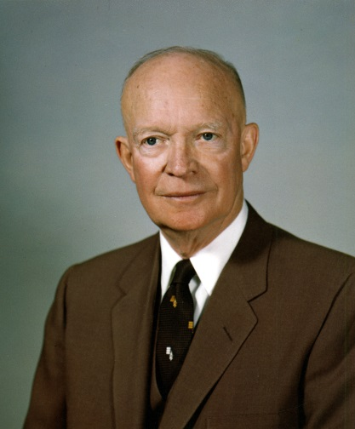

Dwight David "Ike" Eisenhower
34th President of the United States 1952-1960
“conservative when it comes to money and liberal when it comes to human beings.”

Ike cut the federal budget and instituted measures to increase states' rights but at the same time increased Social Security and raised the minimum wage.

Created the Department of Health, Education, and Welfare, which he placed under the guidance of Oveta Culp Hobby of Texas.

Eisenhower signed legislation that created the Interstate Highway System, laying the basis for the modern interstate system used today.

Many of the existing New Deal programs established by his predecessors remained during Eisenhower’s tenure, and the primary focus of his presidency dealt with diffusing the mounting tension of the early Cold War.

How did we pay for all of this? Tax rates for millionaires was over 90%

