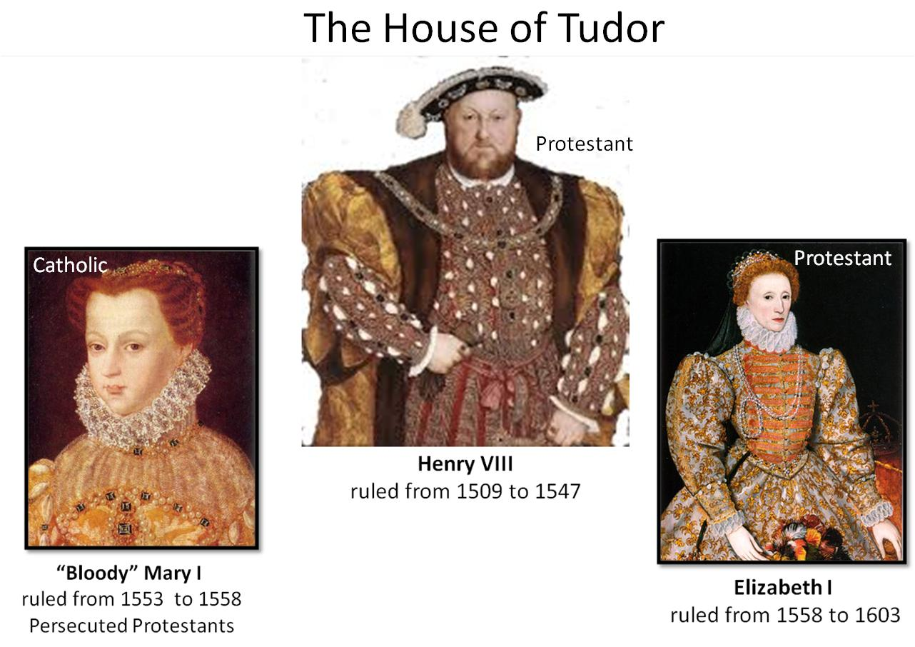

Sanctioned Pirates and Seadogs
Failed colony at Roanoke 1585
Defeat of the Spanish Armada 1588

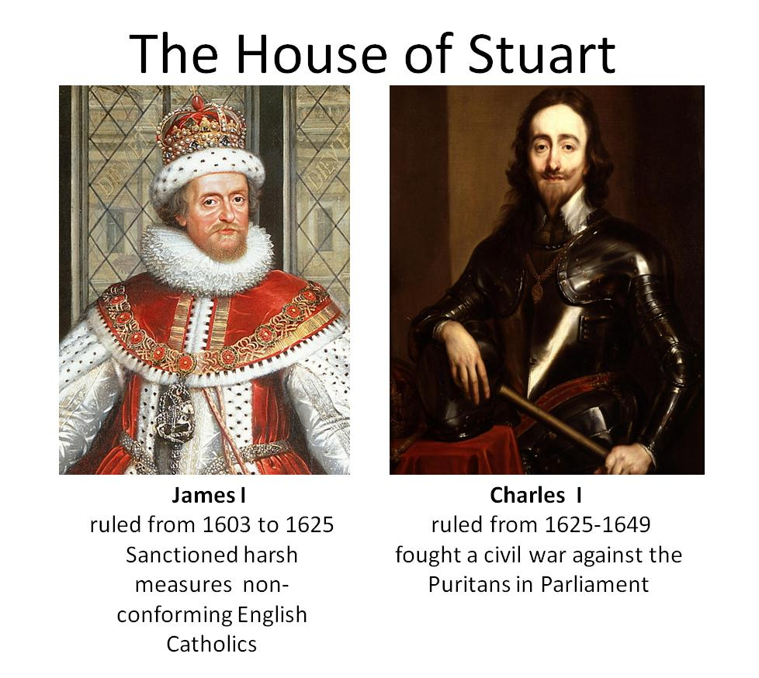

Settlement of Jamestown (1607)

Puritans flee to the Netherlands (1608)

James I is succeeded by his son Charles I in 1625. Charles hated Puritans even more than his father. Accordingly, Puritans began to lose hope of reforming the Anglican Church; in fact, many of them fled for their lives. Nearly 50,000 Puritans will leave England between 1620 and 1640

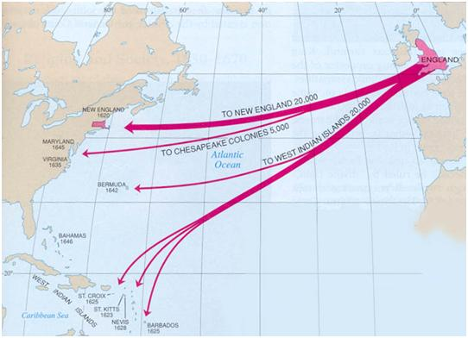

Settlement of Plymouth Colony (1620); Settlement of Massachusetts Bay Colony (1629); Settlement of New Hampshire (1630); Settlement of Maryland (1634); Settlement of Connecticut (1636); Settlement of Rhode Island (1636); Settlement of Delaware (1638); Settlement of Connecticut (1636)
How the states got their shapes

The English Civil War (1642–1651) was a series of armed conflicts and political problems between that pitted the supporters of King Charles I against the supporters of the Long Parliament. The English Civil War led to the trial and execution of Charles I, the exile of his son, Charles II.
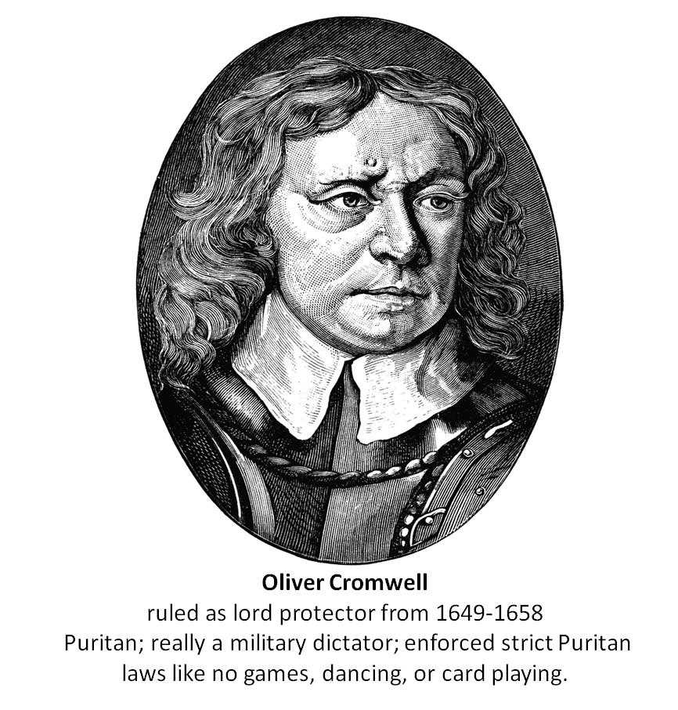
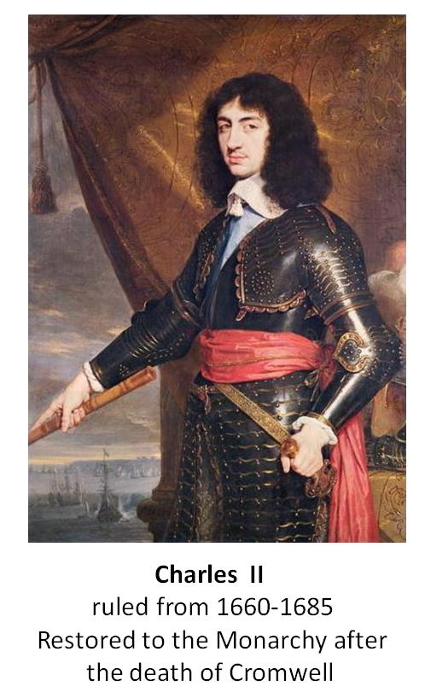
Restoration Colonies
English settlement of North America was seriously curtailed by the conflict between king and Parliament that led to the English Civil War and the rule of Oliver Cromwell (1649–60). Once the monarchy was restored under Charles II, however, colonization resumed. The Restoration Colonies were all proprietorship's granted by Charles to men who had helped him reclaim the throne.

