The Assassination of Abraham Lincoln April 14, 1865
Abraham Lincoln was shot while attending a performance of Our American Cousin at Ford's Theatre with his wife and two guests ( Major Henry Rathbone and his fiancée Clara)

Booth shot the president in the back of the head. Lincoln slumped over in his rocking chair, unconscious. Rathbone jumped from his seat and tried to prevent Booth from escaping, but Booth stabbed the Major violently in the arm with a knife. Rathbone quickly recovered and tried to grab Booth as he was preparing to jump from the sill of the box. Booth again stabbed at Rathbone, and then attempted to vault over the rail and down to the stage. His foot was caught on the Treasury flag, and Booth came down full-face to the audience. He raised himself up and, holding a knife over his head, yelled, "Sic semper tyrannis,“ the Virginia state motto, meaning "Thus always to tyrants."

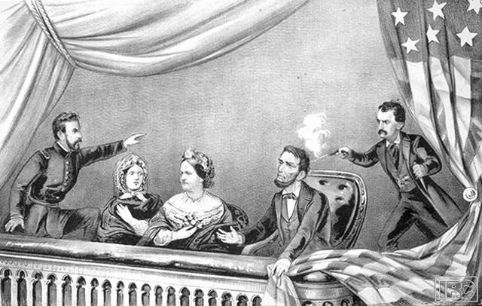

The Civil War Diary of Major Charles Frederick Lewis
Born 1844 – Died 1905 in Schenectady, N.Y.
Served in the Union Army 1862 – 1864

Thursday, April 13, 1865 – Met Lincoln this morning in LaFayette Square – the old man looked very happy and well this night; what a grad homely face he has, and how nobly and unselfishly has he carried himself during these terrible four years. Posterity will appreciate his services to the country, more even than we can.

Friday, April 14, 1865 – (a friend) and I were at the theatre, and sat in the Dress Circle only a few feet from the box; saw the assassin enter it, oh and saw him leap from the box on to the stage and dart behind the scenes. What an awful end to all the talk and hopes of re-union, peace and good-will between the two sections of our unhappy country.

Saturday, April 15, 1865 – Yesterday was a scene of universal rejoicing over the return of peace, is today immersed in gloom and clothed in mourning.

Saturday, April 15, 1865 – I cannot feel that the death of Lincoln, is an immeasurable loss to the country at this time and to no portion will his death be more serious than to the South. It will almost certainly change the temper of the North from kindliness to sternness if not vindictiveness. (Many a day will pass before we will again see in the White House, the peer of Lincoln.) In every sense he was a noble man, and in his life and conduct – well exemplified the remarkable words of his late Inaugural.

The change in the appearance of the City is startling. Andrew Johnson took the oath, and is now the President

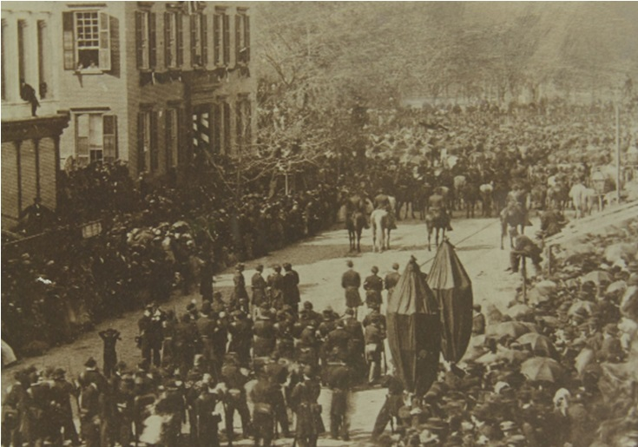

View of Abraham Lincoln's funeral procession, showing the home of Cornelius Van Schaack Roosevelt at the corner of Broadway and Union Square in New York. Two children are visible in the second story window, one of whom is Theodore Roosevelt, the other is his brother Elliott Roosevelt.

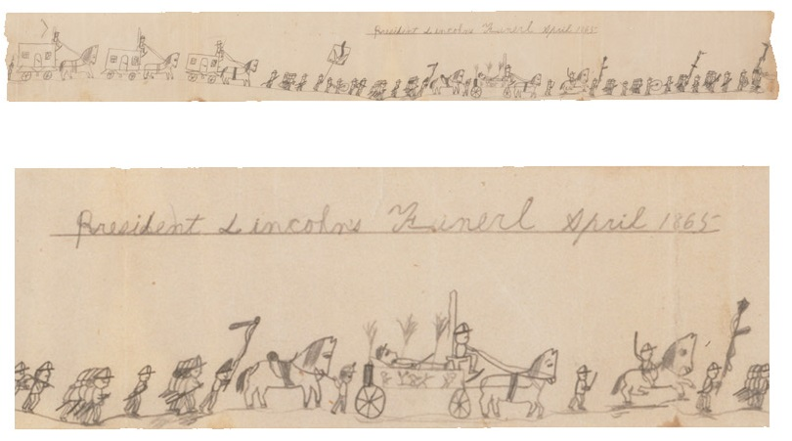
Child's Drawing of Lincoln's Funeral
This drawing by a 9-year-old child depicts the funeral procession of Abraham Lincoln down Washington.
Avenue in Albany on Wednesday, April 26, 1865.

