Talking Points
The Presidency of John Adams
AP Focus:
After Washington’s administration, the Federalists passed legislation that restricted civil and political rights. A response in the form of the Virginia and Kentucky Resolutions offers a states’ rights challenge to questionable federal laws

1796 Presidential Election

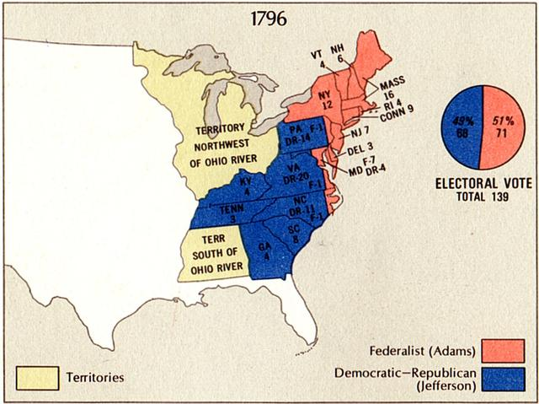
Historical Context - The Election of 1796

The Constitution in 1796 required presidential electors to place the names of two individuals on their ballots; the candidate with the highest vote count, if a majority, became the president and the runner up the vice president.
The results were not anticipated by anyone. Adams won with 71 electoral votes, but was followed by Thomas Jefferson with 68 votes; Thomas Pinckney trailed the leaders with 59. The president was a Federalist, but the vice president was the leader of the Democratic Republicans opposition – an untidy situation.

Slaves Build the new White House

Three Minute Summary of Adams Presidency (YouTube)

Sectionalism (see map above)
Placing the interests of one region over those of the nation as a whole. The Election of 1796 illustrated this > the North voted for Adams; the South voted for Jefferson.

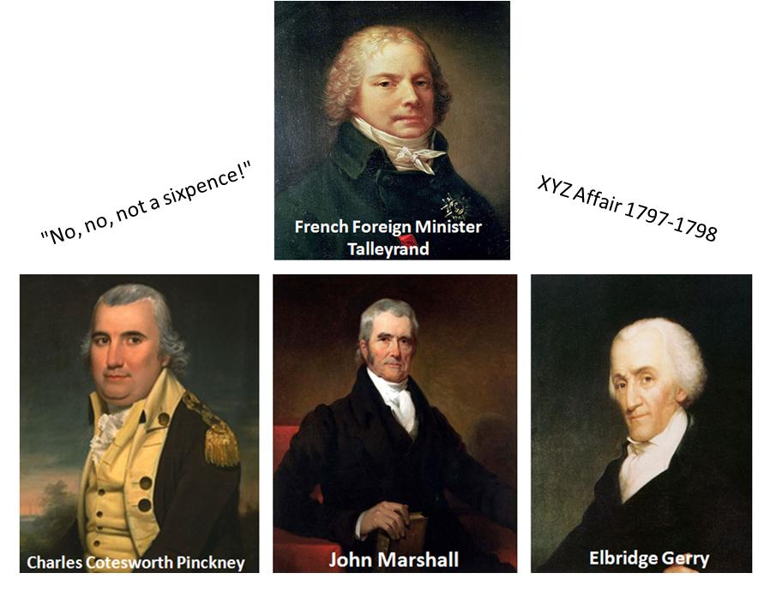

XYZ Affair (1797) “Millions for defense, but not one cent for tribute” Requests of bribes in exchange for negotiations by France. French ships were seizing U.S. vessels carrying British goods since the two countries were at war. 1797 President Adams sent a delegation to Paris in 1797 (including John Marshall). The U.S. delegates secretly approached by three French agents- XYZ . They demanded a large loan and a bribe of $250.000 for the privilege of talking to French foreign minister Talleyrand. Negotiations broke down and Marshall came home—seen as a hero War hysteria swept the U.S.

Alien & Sedition Acts
American citizenship requirements raised from 5 –14 years; jail time or fines for anyone expressing opinions damaging to the government; President could deport violators. Foreigners (immigrants, French and British radicals), and members of the Democratic – Republicans What about the Bill of Rights?

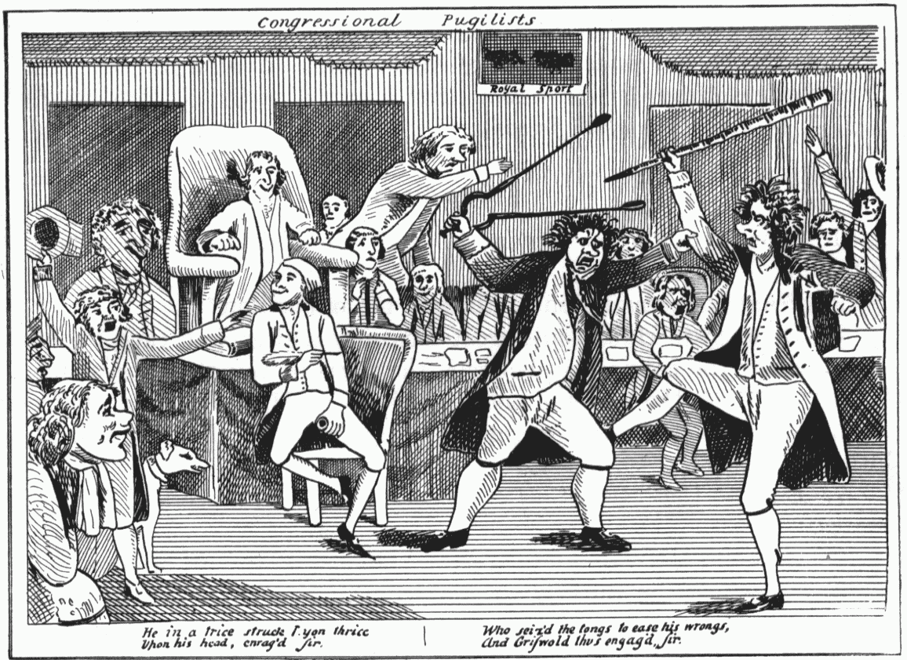
https://www.youtube.com/watch?v=xUH-xtkovxg

Nullification
Principle that states had the right to nullify, or consider void, any act of Congress that they deemed unconstitutional. A major factor in the march toward Civil War.

Virginia & Kentucky Resolutions
These states viewed the Alien & Sedition Acts as unconstitutional because they violated the 1st Amendment and deprived citizens of their rights . Showed the balance of power between the states & the federal government remained a controversial issue.

THEMES TO FOLLOW
“History Doesn’t repeat itself, but at least it rhymes”

Alien and Sedition Acts 1798 A series of 4 laws enacted in 1798 to reduce the political power of recent immigrants to the U.S., who tended to favor the anti-British Democratic Republican Party.
RESULTS: Federal government prosecuted and jailed Republican editors, publishers, and politicians

Espionage and Sedition Acts 1917
A person could be fined up to $10,000/20 years in prison if they interfered with the draft, obstructed the sale of bonds, or saying anything profane, disloyal, or abusive about the war effort
RESULTS: 6,000 arrests for loosely defined anti-war activities (1,500 convictions)
House of Reps refused to seat a Socialists Congressman critical of the war Supreme Court hears Schenck v. U.S case in 1917

The Alien Registration Act of 1940 (Smith Act)
The act, which made it an offense to advocate or belong to a group that advocated the violent overthrow of the government.

RESULTS: This was the basis of later prosecutions of members of the Communist and Socialist Workers parties.

The Patriot Act 2004
Providing Appropriate Tools Required to Intercept and Obstruct Terrorism
RESULTS:
Momentum is growing for change - for a rewrite of the USA PATRIOT Act that respects the need of federal law enforcement to fight terrorism while providing the necessary safeguards to protect constitutional liberties, strengthen congressional oversight, and protect the free expression and privacy rights of citizens. Without such reforms, the terrorists will achieve their greatest victory by undermining the very freedom that has been so vital to the success of American democracy.

