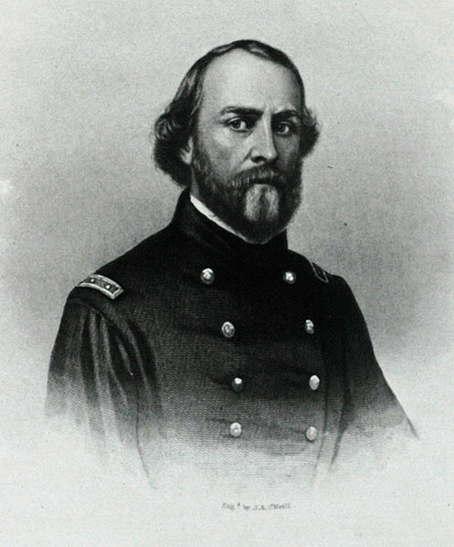

Sullivan Ballou was born the son of Hiram and Emeline (Bowen) Ballou, a distinguished Huguenot family in Smithfield, Rhode Island. He lost both of his parents at a young age and was forced to fend for himself. In spite of this, he attended boarding school at Phillips Academy in Andover, Massachusetts. Following his graduation therefrom, he attended Brown University, where he was a member of Delta Phi, and went on to study law at the National Law School, in Ballston, New York. He was admitted to the Rhode Island bar and began to practice in 1853.
Ballou was active in public service. Shortly after being admitted to the bar, he was elected to the Rhode Island House of Representatives, where he served as a clerk, and later as the speaker. He was a staunch Republican and supporter of Abraham Lincoln.

When war broke out, Ballou immediately left what appeared to be a promising political career and volunteered for military service with the 2nd Rhode Island Infantry. In addition to his combat duties, he served as the Rhode Island militia's judge advocate.
Ballou and 93 of his men were mortally wounded at Bull Run. In an attempt to better direct his men, Ballou took a horse mounted position in front of his regiment, when a 6-pounder solid shot from Confederate artillery tore off his right leg and simultaneously killed his horse. The badly injured Major was then carried off the field and the remainder of his leg was amputated. Ballou died from his wound a week after that Union defeat and was buried in the yard of nearby Sudley Church. After the battle the territory was occupied by Confederate forces. According to witness testimony, it was at this time that Ballou's corpse was exhumed, decapitated, and desecrated by Confederate soldiers possibly belonging to the 21st Georgia regiment. Ballou's body was never recovered.

In place of his body, charred ash and bone believed to be his remains were reburied in Swan Point Cemetery, Providence, Rhode Island. His wife, Sarah, never remarried. She later moved to New Jersey to live out her life with a son, William. She died in 1917 and is buried next to her husband.

Ballou married Sarah Hart Shumway on October 15, 1855. They had two sons, Edgar and William. In his letter to his wife, Ballou attempted to crystallize the emotions he was feeling: worry, fear, guilt, sadness and, most importantly, the pull between his love for her and his sense of duty.
The letter was featured prominently in the Ken Burns documentary The Civil War, where it was paired with Jay Ungar's musical piece "Ashokan Farewell" and read by Paul Roebling. However, the documentary featured a shortened version of the letter, which did not contain many of Ballou's personal references to his family and his upbringing. It has been difficult to identify which of the several extant versions is closest to the one he actually wrote, as the original seems not to have survived. The following is an extended version:

VIDEO CLIP from KEN BURN's CIVIL WAR

July the 14th, 1861
Washington DC

My very dear Sarah:

The indications are very strong that we shall move in a few days - perhaps tomorrow. Lest I should not be able to write you again, I feel impelled to write lines that may fall under your eye when I shall be no more.

Our movement may be one of a few days duration and full of pleasure - and it may be one of severe conflict and death to me. Not my will, but thine 0 God, be done. If it is necessary that I should fall on the battlefield for my country, I am ready. I have no misgivings about, or lack of confidence in, the cause in which I am engaged, and my courage does not halt or falter. I know how strongly American Civilization now leans upon the triumph of the Government, and how great a debt we owe to those who went before us through the blood and suffering of the Revolution. And I am willing - perfectly willing - to lay down all my joys in this life, to help maintain this Government, and to pay that debt.

But, my dear wife, when I know that with my own joys I lay down nearly all of yours, and replace them in this life with cares and sorrows - when, after having eaten for long years the bitter fruit of orphanage myself, I must offer it as their only sustenance to my dear little children - is it weak or dishonorable, while the banner of my purpose floats calmly and proudly in the breeze, that my unbounded love for you, my darling wife and children, should struggle in fierce, though useless, contest with my love of country?

I cannot describe to you my feelings on this calm summer night, when two thousand men are sleeping around me, many of them enjoying the last, perhaps, before that of death -- and I, suspicious that Death is creeping behind me with his fatal dart, am communing with God, my country, and thee.

I have sought most closely and diligently, and often in my breast, for a wrong motive in thus hazarding the happiness of those I loved and I could not find one. A pure love of my country and of the principles have often advocated before the people and "the name of honor that I love more than I fear death" have called upon me, and I have obeyed.

Sarah, my love for you is deathless, it seems to bind me to you with mighty cables that nothing but Omnipotence could break; and yet my love of Country comes over me like a strong wind and bears me irresistibly on with all these chains to the battlefield.

The memories of the blissful moments I have spent with you come creeping over me, and I feel most gratified to God and to you that I have enjoyed them so long. And hard it is for me to give them up and burn to ashes the hopes of future years, when God willing, we might still have lived and loved together and seen our sons grow up to honorable manhood around us. I have, I know, but few and small claims upon Divine Providence, but something whispers to me - perhaps it is the wafted prayer of my little Edgar -- that I shall return to my loved ones unharmed. If I do not, my dear Sarah, never forget how much I love you, and when my last breath escapes me on the battlefield, it will whisper your name.

Forgive my many faults, and the many pains I have caused you. How thoughtless and foolish I have oftentimes been! How gladly would I wash out with my tears every little spot upon your happiness, and struggle with all the misfortune of this world, to shield you and my children from harm. But I cannot. I must watch you from the spirit land and hover near you, while you buffet the storms with your precious little freight, and wait with sad patience till we meet to part no more.

But, O Sarah! If the dead can come back to this earth and flit unseen around those they loved, I shall always be near you; in the garish day and in the darkest night -- amidst your happiest scenes and gloomiest hours - always, always; and if there be a soft breeze upon your cheek, it shall be my breath; or the cool air fans your throbbing temple, it shall be my spirit passing by.

Sarah, do not mourn me dead; think I am gone and wait for thee, for we shall meet again.

As for my little boys, they will grow as I have done, and never know a father's love and care. Little Willie is too young to remember me long, and my blue eyed Edgar will keep my frolics with him among the dimmest memories of his childhood. Sarah, I have unlimited confidence in your maternal care and your development of their characters. Tell my two mothers his and hers I call God's blessing upon them. O Sarah, I wait for you there! Come to me, and lead thither my children.

Sullivan

