Slavery and the Southern People
Chapter #16: The South and the Slavery Controversy, 1793-1860

AP Focus The explosion of cotton production fastened the slave system deeply upon the South, creating a complex hierarchical racial and social that deeply affected whites as well as blacks. REVIEW TIMELINE: African Americans and Slavery

“Lies My Teacher Told Me”

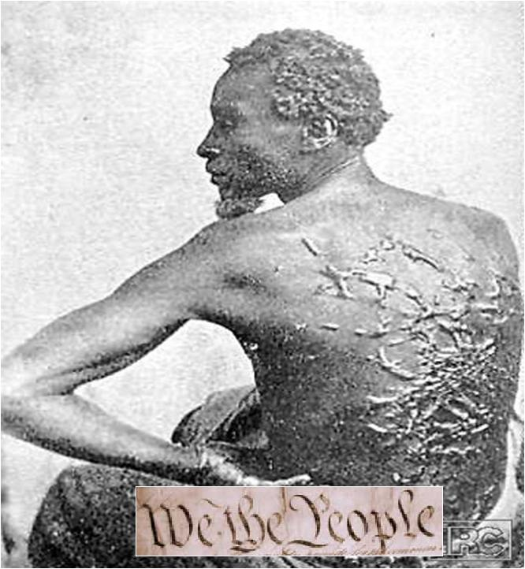
“Slavery is like a sleeping serpent”
Thomas Jefferson

Many Americans were embarrassed by the contradiction posed by a war fought for independence and liberty that kept black thousands of black people in slavery

How do you reconcile the exercise of slavery with the declaration of freedom and liberty? This question led many to set their sights on the elimination of Slavery

Vermont 1777 and New Hampshire 1779 banned slavery outright; Massachusetts in 1780 declared “ all men are born free and equal”

Many religious sects slowly rallied toward the cause against slavery – Pennsylvania Quakers between 1750 and 1800

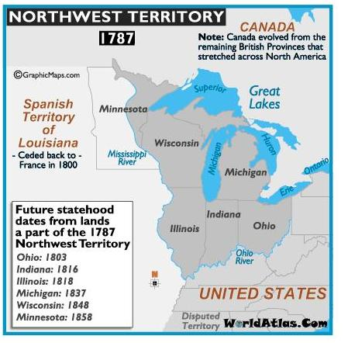

The Northwest Ordinance 1787 – a federal ordinance under the Articles of Confederation that organized the Northwest Territories (modern Ohio, Indiana, Illinois, Michigan, Wisconsin, and Minnesota) declared “ there shall be neither slavery nor involuntary servitude in the said territories”

The whole commerce between master and slave is a perpetual exercise of the most unwitting despotism on the one part and degrading submissionon the other. Indeed I tremble for my country when I reflect that God is just; that his justice cannot sleep forever.”
Thomas Jefferson, 1782

The Constitutional Convention tackles the issues – Debate over representation is centered on the 3/5th compromise and the Constitution grants the power of the federal government to regulate or even abolish the import of slaves after 1808 – the word slavery is even conspicuously avoided throughout the document

“The hour of emancipation is advancing - it will come” Thomas Jefferson

Question? IF THE HOUR OF EMANCIPATION IS ADVANCING, WHY DO WE 620,000 PEOPLE LOSE THEIR LIVES IN THE WAR BETWEEN THE STATES?

Slavery was heavily concentrated in the South WHY?

From Servitude to Slavery in the Chesapeake Region, 1619-1690
Indentured servants Because of the massive amounts of tobacco crops planted by families, "indentured servants" were brought in from England to work on the farms. In exchange for working, they received transatlantic passage and eventual "freedom dues", including a few barrels of corn, a suit of clothes, and possibly a small piece of land
Bacon’s Rebellion (1676): Former servants against the government in 1676. The elite turned to a more controllable force of labor in slaves, which had first been brought to Virginia in 1619.
The crop that demanded slave labor in the 17th century tobacco, was in the 18th century no longer the prize of North American agriculture. As the profitability of tobacco waned, so did the enthusiasm for Slavery

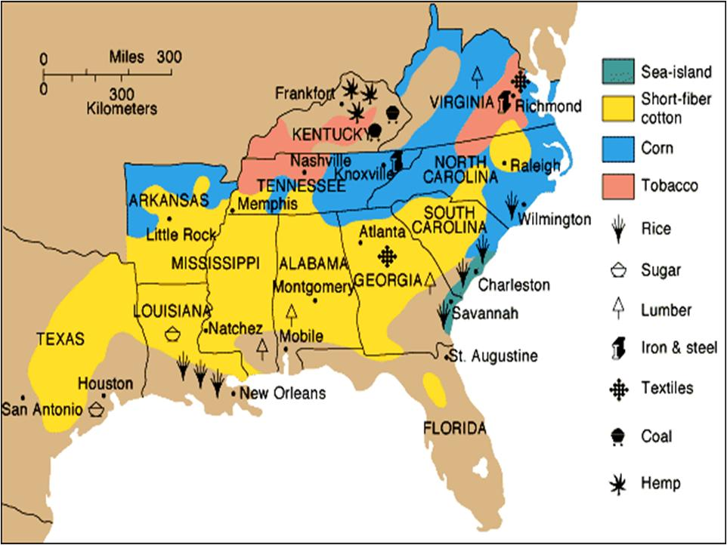

FATAL INVENTIONS
#1 A new series of artificially powered machines fuels the Industrial Revolution in Great Britain and New England. Starting with the spinning jenny, which eliminated the handwork that had gone into making textiles. Within a generation, cheap mass-produced textiles had laid the foundation for the Industrial Revolution

#2 CT’s own Eli Whitney invented the cotton gin in 1793. The cotton gin transformed the processing of raw cotton by eliminating the tedious need to pick the cotton clean of seeds.

IMPACT OF THESE FATAL INVENTIONS
The cost of cotton production dropped, just as the hunger for England’s textile mills was growling even LOUDER

Americas new cash crop – almost as valuable as sugar in the West Indes and much more valuable the tobacco had been to Chesapeake years before

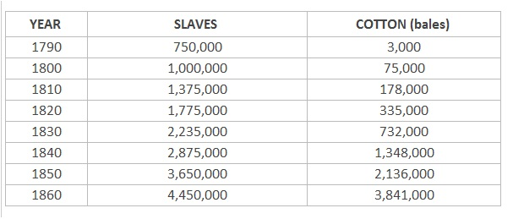

In Defense of Slavery - Southern Ideologies
Chapter #16: The South and the Slavery Controversy, 1793-1860

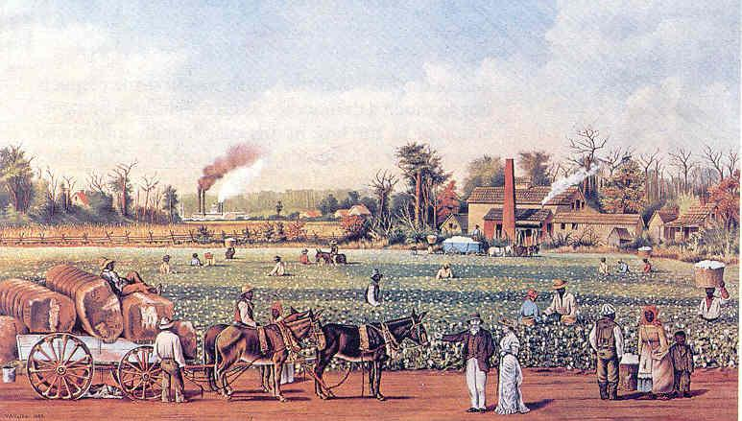

Faced with the need to protect their regions economy, and with the terror posed by Nat Turner and the Amistad case, southerners abandon emancipation and begin to manufacture a pro-slave ideology to suit their ECONOMIC NEEDS and RACIAL FEARS

In the antebellum period, pro-slavery forces moved from defending slavery as a necessary evil to expounding it as a positive good. Some insisted that African Americans were child-like people in need of protection, and that slavery provided a civilizing influence.

Others argued that black people were biologically inferior to white people and were incapable of assimilating in free society. Still others claimed that slaves were necessary to maintain the progress of white society.

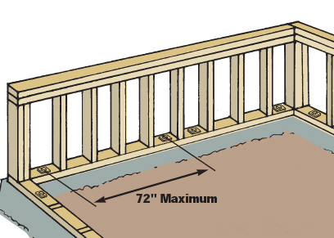

Senator James Hammond (South Carolina) The "Mud-Sill" Theory

"In all social systems there must be a class to do the menial duties, to perform the drudgery of life. That is, a class requiring but a low order of intellect and but little skill"

Fortunately for the South, she found a race adapted to that purpose to her hand. A race inferior to her own, but eminently qualified in temper, in vigor, in docility, in capacity to stand the climate, to answer all her purposes. We use them for our purpose, and call them slaves.
George Fitzhugh (1806-1881) was a social theorist who published radical racial and slavery-based sociological theories in the antebellum era. He argued that "the Negro is but a grown up child" who needs the economic and social protections of slavery.

Fitzhugh described capitalism for spawning a "war of the rich with the poor, and the poor with one another" -- rendering free blacks "far outstripped or outwitted in the chase of free competition." Slavery, he contended, ensured that blacks would be economically secure and morally civilized. His book Cannibals All! was a sharp criticism of the system of "wage-slavery" found in the north. Fitzhugh's ideas were based on his view that the "negro slaves of the South" were considerably more free than those trapped by the oppression of capitalist exploitation.

William Joseph Harper (1790 to 1847)
Stated that slavery was an evil that was pushed on the South for the growth of the country, but that it was necessary for the US to continue down the path of economic stability. One of his main defenses of slavery was that slaves are saved from ever having to be out of work, and that whipping was not harmful to them, because children are whipped all the time.

He also defended the place of women slaves, saying that their stature as helping in the work force actually helped raise women up to men's levels.
Finally, the effect that abolition would have on foreign commerce was covered in Harper's speech. He felt that if slavery was abolished, it would do nothing but hurt the country, rather than help it. Overall economics was valued over morals.

Quote: "Without [slavery], there can be no accumulation of property, no providence for the future, no taste for comfort or elegancies, which are the characteristics and essentials of civilization."

Senator John C. Calhoun's (South Carolina) “Slavery a Positive Good”
"Compare his condition with the tenants of the poor houses in the more civilized portions of Europe. Look at the sick, and the old and infirm slave, on the one hand, in the midst of his family and friends, under the kind superintending care of his master and mistress, and compare it with the forlorn and wretched condition of the pauper in the poorhouse."

The Southern World View
Slavery is what it is – deal with it!!!
Hierarchy and social order – natural order and obsession with social strata – Abolitionists are dangerous because they are challenging this social order

Tradition and social control - Human institutions evolve slowly over time and cannot be altered by human intervention – it is dangerous to abruptly intervene in the evolution of human institutions

What is at stake in this world view?

White Southern defenders of Slavery are like other Americans – products of the enlightenment.

Many believe in the power of intellect and the power of faith and reason to figure problems out. You can be a product of the enlightenment and still be deeply conservative.

Pro-slavery writes challenge the natural rights philosophy – ideas like liberty and freedom are never absolute – nobody is born equal.

Freedom must be balanced in order and this is prescribed in certain stations in life for the various statuses of humans. It must also be balanced with tradition. They see the world as it is, not as it ought to be!!

They have an extremely different point of view on the concept of equality.

Southerners stress human DUTY over human RIGHTS. The world is made up between a struggle between human autonomy and human dependency and you should never give up on that dependency

1820 Edward Brown slavery is the stepping ladder from barbarism to civilization - slavery is a positive good.

1831 Thomas Dew - There is a time for all things, and nothing in this world should be done before its time

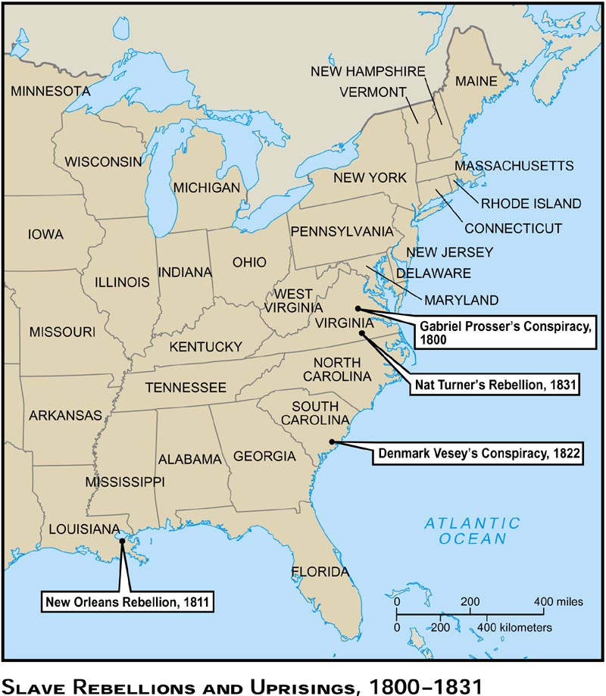

REACTION AND RESISTANCE

1739 Slave revolts in South Carolina (Stono Rebellion), Even after Colonial forces crushed the Stono uprising, outbreaks occurred, including the very next year, when South Carolina executed at least 50 additional rebel slaves.

1800 - Gabriel Prosser's Rebellion - Born prophetically in 1776 on the Prosser plantation, just six miles north of Richmond, Va., and home (to use the term loosely) to 53 slaves, a slave named Gabriel would hatch a plot, with freedom as its goal, that was emblematic of the era in which he lived

The rebellion was barely under way when the state captured Gabriel and several co-conspirators. Twenty-five African Americans, worth about $9,000, were hanged together before Gabriel went to the gallows and was executed, alone

1811 - New Orleans About 25 slaves rose up and attacked the plantation’s owner and family. They hacked to death one of the owner’s sons, but carelessly allowed the master to escape. The whites suffered no casualties, but when the slaves surrendered, about 20 insurgents lay dead, another 50 became prisoners and the remainder fled into the swamps. By the end of the month, whites had rounded up another 50 insurgents. In short order, about 100 survivors were summarily executed, their heads severed and placed along the road to New Orleans. As one planter noted, they looked “like crows sitting on long poles.”

1822 Denmark Vesey Revolt More than 1,000 free and enslaved blacks intended to be a part of this uprising which was planned for sometime in July 1822. South Carolina authorities moved swiftly once the plot was uncovered and Vesey and 36 of his co-conspirators were hanged after a dubious trial. Their executions were accompanied by a massive demonstration of support from defiant free and enslaved blacks that required local militia and federal troops to restore order.

This conspiracy ironically helped politicize black communities throughout the United States particularly after anti-slavery activists began referring to Denmark Vesey as a hero. Frederick Douglass was the first, but not the last, to use Vesey’s name as a battle cry for the first all-black infantry during the Civil War.
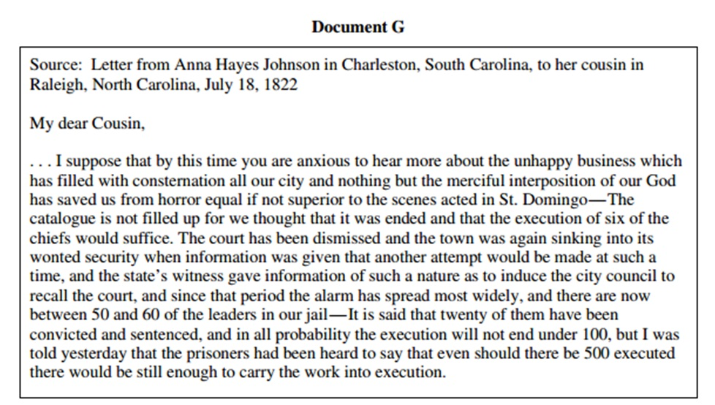

1831 Slave revolt led by Nat Turner in South Hampton, August 22, 1831, Turner and about 70 armed slaves and free blacks set off to slaughter the white neighbors who enslaved them. On Sunday, Oct. 30, a local white man stumbled upon Turner’s hideout and seized him. A special Virginia court tried him on Nov. 5 and sentenced him to hang six days later. A barbaric scene followed his execution. Enraged whites took his body, skinned it, distributed parts as souvenirs and rendered his remains into grease. His head was removed and for a time sat in the biology department of Wooster College in Ohio. (In fact, it is likely that pieces of his body — including his skull and a purse made from his skin — have been preserved and are hidden in storage somewhere.)

Of his fellow rebels, 21 went to the gallows, and another 16 were sold away from the region. As the state reacted with harsher laws controlling black people, many free blacks fled Virginia for good. Turner remains a legendary figure, remembered for the bloody path he forged in his personal war against slavery, and for the grisly and garish way he was treated in death.

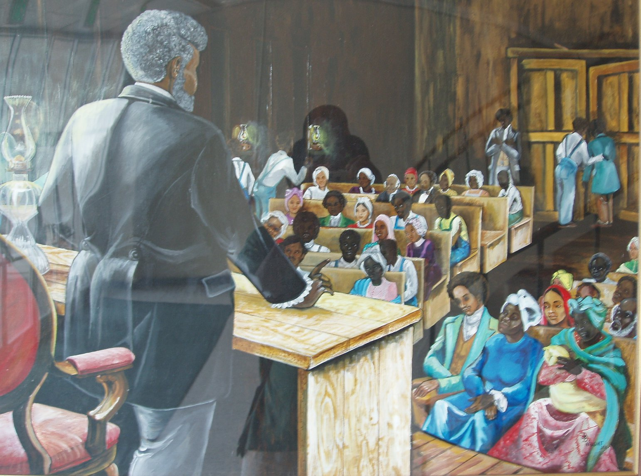
Connections to MLK
1839 Slaves on the Spanish ship Amistad seize control of ship and massacre all but two crew members. The Supreme Court orders slaves freed and returned to Africa

