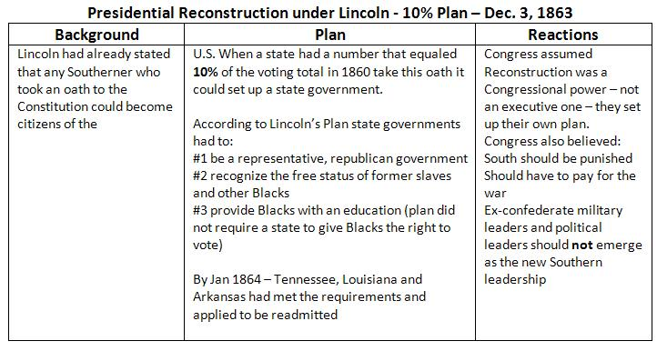

Reconstruction of the South
When the Civil War ended in 1865, many questions arose about the political and physical rebuilding of the eleven southern states that had attempted to leave the Union in 1861. During the next three year, the country was convulsed in conflict about Reconstruction. The most contentious issue of the era was the future of the former slaves. The overriding theme of this struggle was whether President Andrew Johnson or the Radical Republicans would decide the fate of the defeated South and freed people.

The political battle became so heated that, in 1868, President Johnson was impeached. Although the radical Republicans in Congress could not convict him, they gained control of Reconstruction and attempted to revolutionize many of the social and political relationships in the United States.

The chart on the following page offers a concise summary of the major issues and elements of the competing Reconstruction plans. As you study the chart, think about how the plans would appeal to the following groups: freedmen, southern planters, northern Democrats, poor southern whites, moderate northern Republicans, abolitionists, western farmers, and northern factory workers.

