Polk the Purposeful and Party Politics
Election of 1844: "Fifty Four Forty or Fight" and the Rise of Manifest Destiny

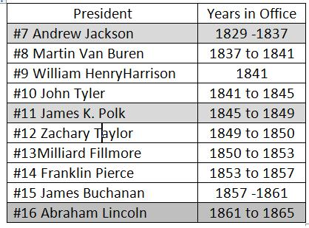

AP Focus - James K. Polk becomes the spokesman for those lured to the West. During his one term in office, the Oregon boundary dispute is settled, The Mexican – American War and cession take place, and California applies for statehood

POLITICS MAKES GOOD SLOGANS
TIPPECANOE AND TYLER TOO Used by the Whig party in 1840, when William Henry Harrison, the hero of the Battle of Tippecanoe, was the Whig presidential candidate, and John Tyler his running mate. The battle, fought in 1811 in Indiana, destroyed the Indian confederacy organized by Tecumseh, a Shawnee chief, and his brother, Tenskwatawa, known as the Prophet.

54°40 OR FIGHT!! A Democratic rallying cry in the 1844 presidential campaign, referring to the dispute over whether the United States or Great Britain owned the Pacific Northwest, which had been under joint control since 1818. American expansionists, led by the Democratic presidential candidate, James K. Polk, demanded that the United

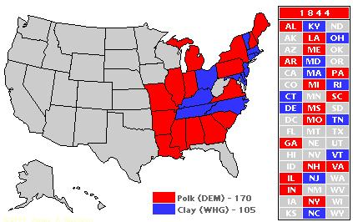

Summary:
John Tyler’s crisscrossing of the political aisle put him in a strange position during the 1844 presidential election. As vice presidential candidate with Whig William Henry Harrison, Tyler was a more polished politician than the heroic Harrison. However, when Harrison died one month into his term of office, Tyler showed his true political colors. Tyler’s use of the veto to strike down Whig legislation and his repeated offers to Democrats to aid on their legislative agenda ensured that he would not be nominated on his own right in the 1844 Whig convention. However, it did leave him in the unique position of switching parties and being nominated as a Democratic candidate. But the Democrats were also wary of Tyler, whose love of political expediency may trump any chance they had at ruling again in the White House.
The favorite heading into the nominating convention of 1844 was former president Martin Van Buren, whose opportunistic personality led him to seek the presidency again. However, he fell victim to the 2/3 rule, which dictated that a candidate receive two thirds of the party delegates for nomination. Tyler’s candidacy became moot when Van Buren and others decided to throw their support behind the unlikely candidate, Tennessean James Polk. The southern and western delegates, who were interested in Polk’s perspective on western expansion, swept Polk to the Democratic nomination. On the Whig side, without an incumbent candidate, the Whigs resorted to their increasingly ancient standard bearer, Kentucky politician Henry Clay, with New Jersey politician Theodore Frelinghuysen as his vice president

