New Directions in Foreign Policy 1900-1917 Foreign Policy Review Notes

AP Focus: Wilson hated war and wanted American foreign policy to be fair and just to all. Conditions in Latin America, however, forced this peaceful president to take military action. Notably, he ordered the US Army to chase Pancho Villa in Mexico.

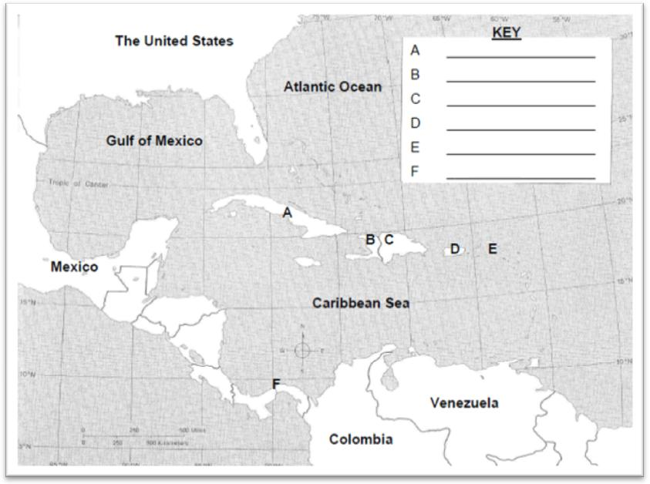

http://geology.com/world/caribbean-map.gif

1901 | Platt Amendment to Cuba's new constitution gives the U.S. the unilateral right to intervene in the island's  political affairs.
1903 | Theodore Roosevelt intervenes to assist Panamanian independence from Colombia. The resulting  Hay-Bunau-Varilla Treaty makes the US sovereign "in perpetuity" in the ten-mile wide Panama Canal Zone.
1904 | Theodore) Roosevelt's Corollary to the Monroe Doctrine declares the U.S. to be the policeman of the Caribbean.  US forces place the Dominican Republic under a customs receivership.
1905 | US Marines land in Honduras.
1906 -1912 | Under the Platt Amendment, US forces occupy Cuba and direct its political and economic development.
1909-1912 | The Dollar Goes Abroad as a Diplomat - William Howard Taft encouraged Wall Street bankers to invest in  foreign areas of strategic interest to the United States. New York bankers thus strengthened American  defenses and foreign policies, while bringing prosperity to America. "Dollar Diplomacy,"  based on the erroneous belief that increased US investment will bring stability and economic prosperity  to Latin America.
1912 | United Fruit Company begins operations in Honduras and later becomes a major force throughout Central  America.
1912-1915 | US Marines intervene in Nicaragua.
1914 | Panama Canal opens and US forces shell and then occupy Vera Cruz, Mexico.
1915-1934 | When political turmoil broke out in Haiti in 1915, Woodrow Wilson dispatched marines to protect American  lives and property. In 1916, he signed a treaty with Haiti providing for U.S. supervision of finances and  the police.
1916-1917 | Moralistic Diplomacy in Mexico - Venustiano Carranza became the president of Mexico. Francisco “Pancho”  Villa, rival to President Carranza, attempted to provoke a war between Mexico and the U.S by killing Americans.  Wilson, rather, ordered General John J. Perishing to break up Villa's band of outlaws. The invading American  army was withdrawn from Mexico in 1917 as the threat of war with Germany loomed.
1916-1924 | US Marines occupy the Dominican Republic

