AP Focus: The Great Depression is a transformative event on many levels. It puts the government in the lives of people and provides security (structural support) to them. We did not employ a socialist government. We did not abandon capitalism. Some claimed FDR went too far, others claimed he did not go far enough. We worked within the system to address economic failures (a continuation of progressive ideals)

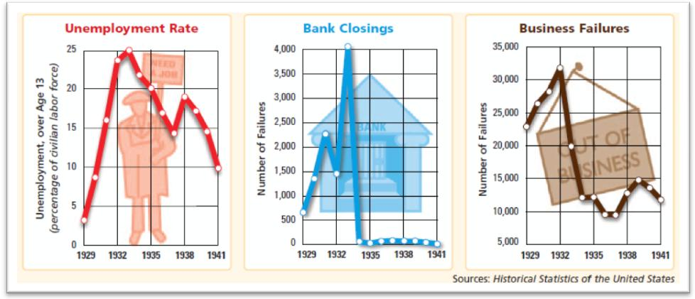
Herbert Hoover : A Republican, President Hoover began to take actions to increase business profits, believing business prosperity would“trickle down” to the average American by way of employment and increased income. To accomplish this, he cut taxes and created theReconstruction Finance Corporation. However, this was too little too late

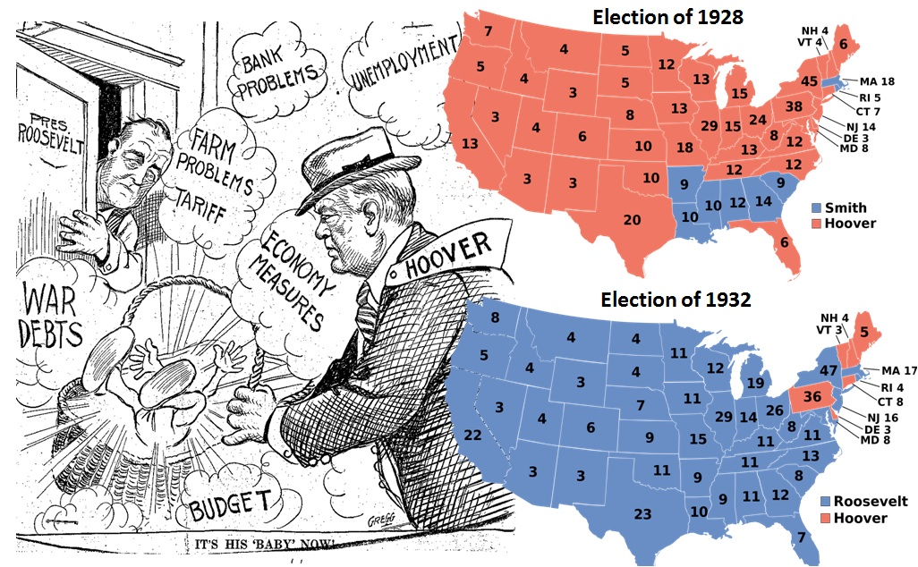

What does 25 percent Unemployment look like?

First 100 Days : the time period FDR requested from the people to let him make a difference. It runs from March 9, 1933 until June 16, 1933. Congress passed more than 15 major pieces of New Deal Legislation They represent a response to the immediate emergency.
Review: The Government's Role in the Economy

Top 10 New Deal Programs

Significant New Deal Programs to Combat the Great Depression
By Martin Kelly,
The Great Depression was the largest and most significant economic depression to affect not only America but also the world. The Stock Market Crash on October 29, 1929 is cited as the beginning of the Great Depression. Herbert Hoover was president when the Crash occurred but felt that the government should not become overly involved in helping individuals dealing with economic troubles. However, this changed with the election of Franklin Roosevelt. He worked to create numerous programs through his New Deal to help those affected worst by the Depression. Following are the top ten programs of the New Deal.

1. CCC - Civilian Conservation Corps
The Civilian Conservation Corps was created in 1933 by Franklin D. Roosevelt to combat unemployment. This work relief program had the desired effect and provided jobs for many Americans during the Great Depression. The CCC was responsible for building many public works and created structures and trails in parks across the nation.

2. CWA - Civil Works Administration
The Civil Works Administration was created in 1933 to create jobs for the unemployed. Its focus on high paying jobs in the construction arena resulted in a much greater expense to the federal government than originally anticipated. The CWA ended in 1934 in large part due to opposition to its cost.

3. FHA - Federal Housing Administration
The Federal Housing Administration was a government agency created to combat the housing crisis of the Great Depression. The large number of unemployed workers combined with the banking crisis created a situation in which banks recalled loans. The FHA was designed to regulate mortgages and housing conditions.

4. FSA - Federal Security Agency
The Federal Security Agency established in 1939 had the responsibility for several important government entities. Until it was abolished in 1953, it administered social security, federal education funding, and food and drug safety.

5. HOLC - Home Owner's Loan Corporation
The Home Owner's Loan Corporation was created in 1933 to assist in the refinancing of homes. The housing crisis created a great many foreclosures, and Franklin Roosevelt hoped this new agency would stem the tide. In fact, between 1933 and 1935 one million people received long term loans through the agency that saved their homes from foreclosure.

6. NRA - National Recovery Act
The National Recovery Act was designed to bring the interests of working class Americans and business together. Through hearings and government intervention the hope was to balance the needs of all involved in the economy. However, the NRA was declared unconstitutional in the landmark Supreme Court case Schechter Poultry Corp. v. US. The Supreme Court ruled that the NRA violated the separation of powers.

7. PWA - Public Works Administration
The Public Works Administration was a program created to provide economic stimulus and jobs during the Great Depression. The PWA was designed to create public works and continued until the US ramped up wartime production for World War II. It ended in 1941.

8. SSA - Social Security Act
The Social Security Act was designed to combat the widespread poverty among senior citizens. The government program provided income to retired wage earners. The program has become one of the most popular government programs and is funded by current wage earners and their employers. However, in recent years concerns have arisen about the viability of continuing to fund the program as the Baby Boom generation reaches retirement age.

9. TVA - Tennessee Valley Authority
The Tennessee Valley Authority was established in 1933 to develop the economy in the Tennessee Valley region which had been hit extremely hard by the Great Depression. The TVA was and is a federally owned corporation that works in this region to this day. It is the largest public provider of electricity in the United States.

10. WPA - Works Progress Administration
The Works Progress Administration was created in 1935. As the largest New Deal Agency, the WPA impacted millions of Americans. It provided jobs across the nation. Because of it, numerous roads, buildings, and other projects were completed. It was renamed the Works Projects Administration in 1939. It officially ended in 1943.

Depression Era Images - The Photographs of Dorothea Lange

http://faculty.washington.edu/qtaylor/Courses/101_USH/new_deal.htm

http://www.angelfire.com/alt/michaelbutt/chapter22.htm

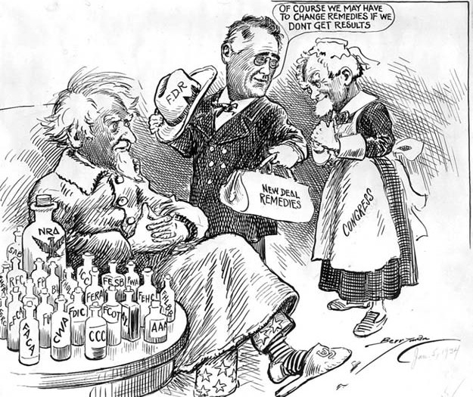
New Deal Cartoon Explained

First New Deal | Second New Deal
Covers the period 1933-1935 and includes all the legislation that is passed to help America bounce back as quick as possible. | Covers the period 1935-1938 and includes  the legislation which focused on social reform,  unemployment and illness.

Supplemental Reading: The New Deal: Then and Now

Relief
FDR wanted relief given to persons in need by providing them with money, loans and jobs.
Measures adopted to restore confidence and provide support … largely successful, some evolved standard banking policy
Emergency Banking Act, 1933
FIRST piece of legislation passed during the New Deal. Set up an immediate 4 day “Bank Holiday” in which all banks closed – to stop the panic. It gave the president power to help banks that were failing

Federal Emergency Relief Agency, 1933
Distributed millions of dollars of direct aid to unemployed workers. Assisted states and cities in caring for the unemployed. Matched funds extended by state and local governments. First legislation approving the giving of money to the poor and unemployed. The beginning of cash payments to people – welfare

Civilian Conservation Corps, 1933
Sent 250,000 young men 18-25 to work camps to perform soil conservation, reforestation and conservation tasks. Removed surplus of workers from cities, provided healthy conditions for boys, provided money for families. Existed until 1941 and employed 2 million men

Tennessee Valley Authority, 1933
Objective : help a specific region by developing electrical power. Provided for the building of 7 hydro-electric dams in the Tennessee River Valley as well as power plants and transmission lines. The dams would provide electric power, flood control and irrigation for crops in 5 states. This increased the standard of living for 3 million people. Will provide power to Oak Ridge Tenn. – the govt. instillation that worked on the atomic bomb. The dams are still running and providing electricity

Public Works Administration, 1933 (established by the NIRA)
Provided money to state and local governments to help major industries (construction, housing, farming) in their area get back on their feet jobs included – road construction, schools, dams, hospitals and bridges between 1933-1939 $5 billion was spent on 35,000 projects and employed ½ a million people - Google Image Search of PWA projects

Works Progress Administration, 1935
Employed 8.5 million workers in construction and other jobs (building roads, schools, hospitals and power plants). More importantly provided jobs for the skilled and the educatedin arts, theater, and literary projects (Federal Arts Project, Federal Writers Project, Federal Theatre Project ) By 1943 $11 billion spent on 1.5 projects

Emergency banking bill
Glass Steagall Act to curb speculation
Civilian Conservation Corps to provide work for unemployed youth
Works Progress Administration to provide work
Public Works Administration

Recovery
FDR wanted to provide recovery for business and agriculture by passing laws that would assist them in getting back on their feet
Measures adopted to provide economic recovery; effective in the short term? … but were controversial and led to a discussion of government role … e.g., supreme court ruling on TVA and NRA

National Recovery Act, 1933
Created the National Recovery Administration (NRA). Set up codes to be used by industries who belonged to the NRA. Codes included abolition of child labor, limited production and price controls, minimum wage and maximum hours. In 1935 this act will be ruled unconstitutional and then replaced by the FLSA and Wagner Act

Home Owners Loan Corp, 1933
$2 billion to help refinance mortgages. In 3 years 1 million home owners were helped

Agricultural Adjustment Act, 1933 and 1937
Helped increase farm profits by reducing production. Set up Agricultural Adjustment Administration – which controlled wheat, cotton, corn production by paying farmers not to plant that crop.

The AAA paid farmers not to grow crops and not to produce dairy produce such as milk and butter. It also paid them not to raise pigs and lambs. The money to pay the farmers for cutting back production of about 30% was raised by a tax on companies that bought the farm products and processed them into food and clothing. The AAA also became involved in trying to help farmers destroyed by the creation of the dust-bowl in 1934.

In 1936 the Supreme Court declared the AAA unconstitutional. The majority of judges (6-3) ruled that it was illegal to levy a tax on one group (the processors) in order to pay it to another (the farmers). In 1938, another AAA was passed without the processing tax. It was financed out of general taxation and was therefore acceptable to the Supreme Court.

Federal Housing Administration, 1934
Provided money to insure mortgages made by lending institutions. By 1941 $3.5 Billion in mortgages insured. Still a major way to finance a home today

Tennessee Valley Authority for regional development and energy generation
Agricultural Adjustment Act to control production levels
National industrial Recovery Act to curb over production
National Recovery Act to establish codes and price quotas

Reform
FDR wanted to establish reform by passing legislation that would prevent another depression from ever happening again
Measures focused on reforming business practices; milestone measures in creation of the modern welfare state?
Glass-Steagall Banking Act, 1933
One of the most significant pieces of legislation passed under FDR. Separated commercial and investment banks. Increased the authority of the Federal Reserve to prevent major stock speculation in the future. Created FDIC – Federal Deposit Insurance Corporation – to insure all bank deposits so people didn’t lose money if a bank failed. Still used today!

Securities Exchange Act, 1934
Set up regulations on the purchase of stocks and bonds and the Securities and Exchange Commission to supervise the stock market. Gave the Federal Reserve the power to prevent “buying on margin.” Still a major US commission – they still control the stock market

Social Security Act, 1935
Federal program of benefits to people who retired at 65. Provided for benefits to dependent children based on wages earned by deceased parent, unemployment compensation, provided money for states to cover maternity and child care, money to assist the handicapped. Money would come from a payroll tax paid by workers - still in use today

National Labor Relations Act, 1935
The National Labor Relations Act, NLRA, or Wagner Act (after its sponsor, New York Senator Robert F. Wagner) limits the means with which employers may react to workers who create labor unions engage in collective bargaining, and take part in strikes and other forms of concerted activity in support of their demands.

The Act does not apply to workers who are covered by the Railway Labor Act, agricultural employees, domestic employees, supervisors, federal, state or local government workers, independent contractors and some close relatives of individual employers.

Under section 9(a) of the NLRA, federal courts have held that wildcat strikes are illegal, and that workers must formally request that the National Labor Relations Board end their association with their labor union if they feel that the union is not sufficiently supportive of them before they can legally go on strike.

Fair Labor Standards Act, 1938
Replaced codes set by the NIRA. Established minimum wage and maximum hours, payment for overtime (time and ½), no child labor (15 yrs. And under) only non-hazardous jobs for those under 18. Still the standards we use today.

Securities and Exchange Commission to regulate stock market
Federal Deposit Insurance Corporation to insure bank deposit
Wagner Act: establishes the National Labor Relations Board; offers protection for labor
Social Security Act provides pension for workers

