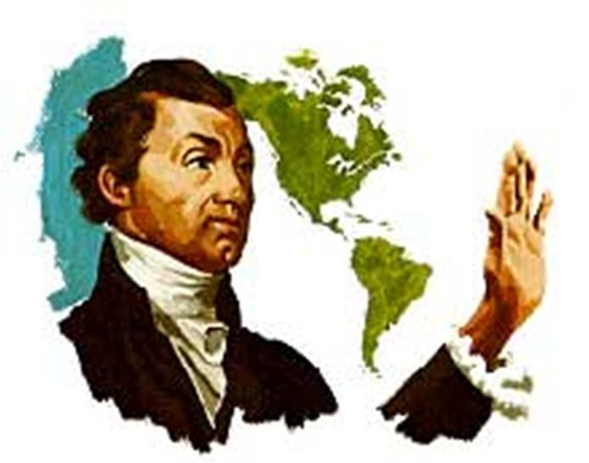
http://www.tubechop.com/watch/4147002

Monroe Doctrine

NON - COLONIZATION and NON-INTERVENTION

Historical Context: 1810-1824 – Spanish colonies in Latin America had won and/or were winning their independence from Spain. U.S. and Great Britain thought that this was great because these new republics made great trading partners. No Spain was a definite positive. U.S. was also getting a little concerned about the existence of Russia in Alaska
Great Britain asked the U.S. to make a joint statement that opposed intervention of any European country in the Western hemisphere. Also asked to state that neither Great Britain nor the United States would attempt to annex any part of the hemisphere. Monroe asked JQ Adams what he thought Adams said let them make their statement and we can make our own – stand alone

John Quincy Adams wrote up the statement – and Monroe issued it in a speech to a joint session of Congress. Known as the Monroe Doctrine US would stay out of Europe and Europe would stay out of Western hemisphere

Doctrine – a big statement from a nation without a military to back it up – we were in no position to stop anyone who wanted to come into our hemisphere It did show the desire of the US to be taken seriously by the rest of the world

