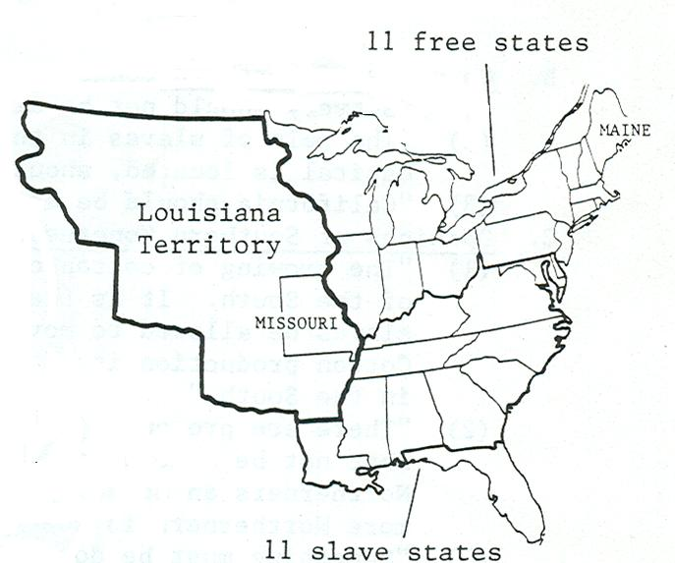

Missouri Statehood First serious controversy over slavery since the creation of the constitution.

1820 – There were 11 free states and 11 slave states. if we admitted Missouri that would upset the balance in favor of the slave states.

When Missouri did apply for admission to the union as a slave state an amendment was added to the bill by Representative Tallmadge (NY)

http://www.tubechop.com/watch/4147069

Tallmadge Amendment said...

"And provided, that the further introduction of slavery or involuntary servitude be prohibited, except for the punishment of crimes, whereof the party shall have been fully convicted; and that all children born within the said State, after the admission thereof into the Union, shall be free at the age of twenty-five years."
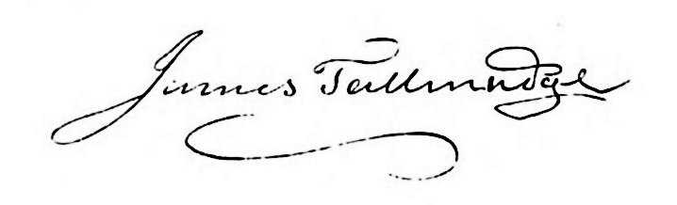

No more slaves in Missouri
Any slaves born in Missouri would gain their freedom at age 25

The amendment passed in the House, but was defeated in the Senate

Significance – caused a huge political storm!!!!

Slave states held that Congress had no right to attach conditions upon a state applying for admission
Congress and the free states looked at the Northwest Ordinance as an example of Congress being able to prohibit slavery.
What was really the fight – Slavery ???
NO – the fight was “who had the power?” It was clearly a states’ rights vs. federal government issue

Compromise was reached – Missouri Compromise of 1820
#1 Missouri would enter the Union as a slave state
#2 Maine would enter the Union as a free state
#3 A line would be drawn at 36*30’ – the southern border of Missouri
#4 Slavery would be allowed below the line and slavery would be prohibited above the line
#5 The only exception would be the state of Missouri – above the line – but a slave state

