Lyndon Baines Johnson - The Great Society
Born out of initiatives that developed in Pres. Franklin D. Roosevelt's New Deal and expanded in Pres. Harry S. Truman's administration and then in Pres. John F. Kennedy's New Frontier, the Great Society encompassed President Lyndon B. Johnson's "War on Poverty"

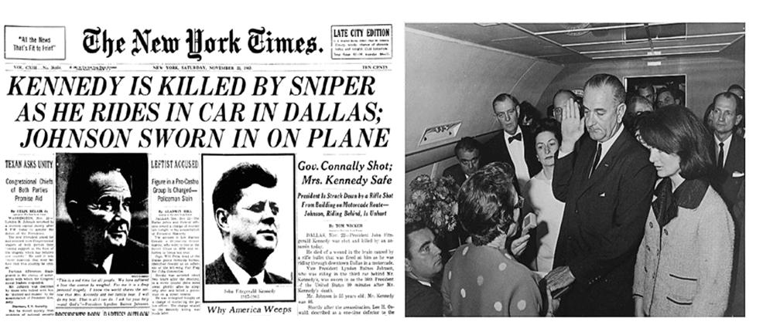

Background - Who is LBJ?

In the Election of 1964 Johnson is challenged by conservative Republican Barry Goldwater for president, but wins in a landslide. LBJ platform of "The Great Society" was a sweeping set of New Deal-type economic and welfare measures aimed to transform America. Public sentiment aroused by Michael Harrington’s The Other America (1962) which showed 20% of US population and over 40% of blacks lived in poverty. Compelling description of impoverished areas of America. Played a role in persuading President Johnson to make the war on poverty the centerpiece of his Great Society

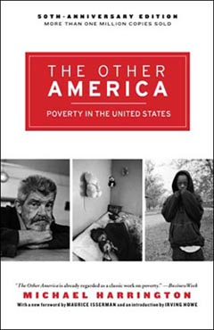

Michael Harrington - Poverty: Hopeful or Hopeless" - Part 1

Primary Goals of the Great Society (The War on Poverty)
#1 Use the federal government to enhance social welfare
#2 Use educaton and job training to help disadvantaged people overcome the cycle of poverty that has been limiting their opportunities

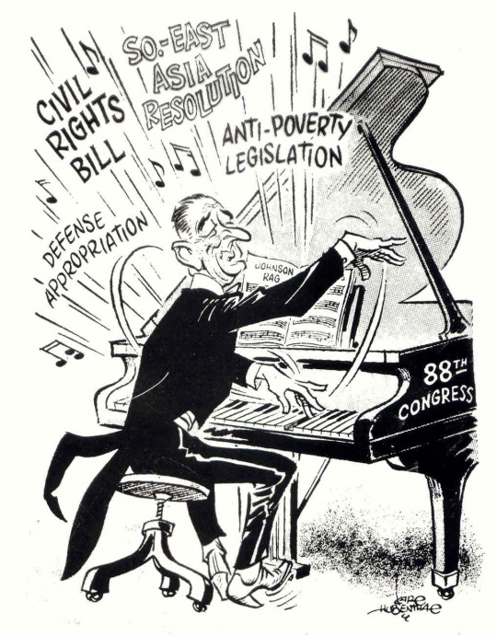

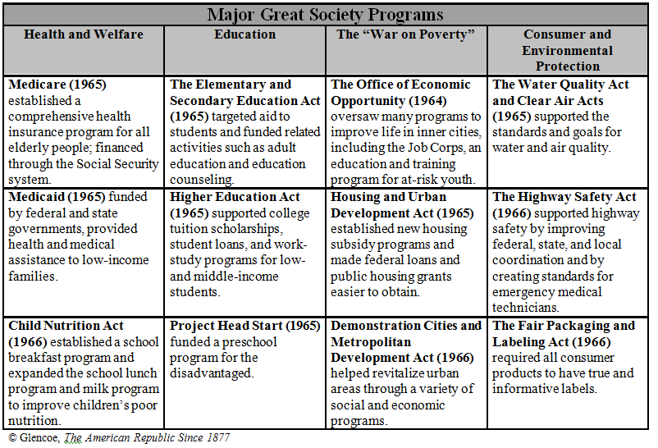

Analysis of Great Society Programs

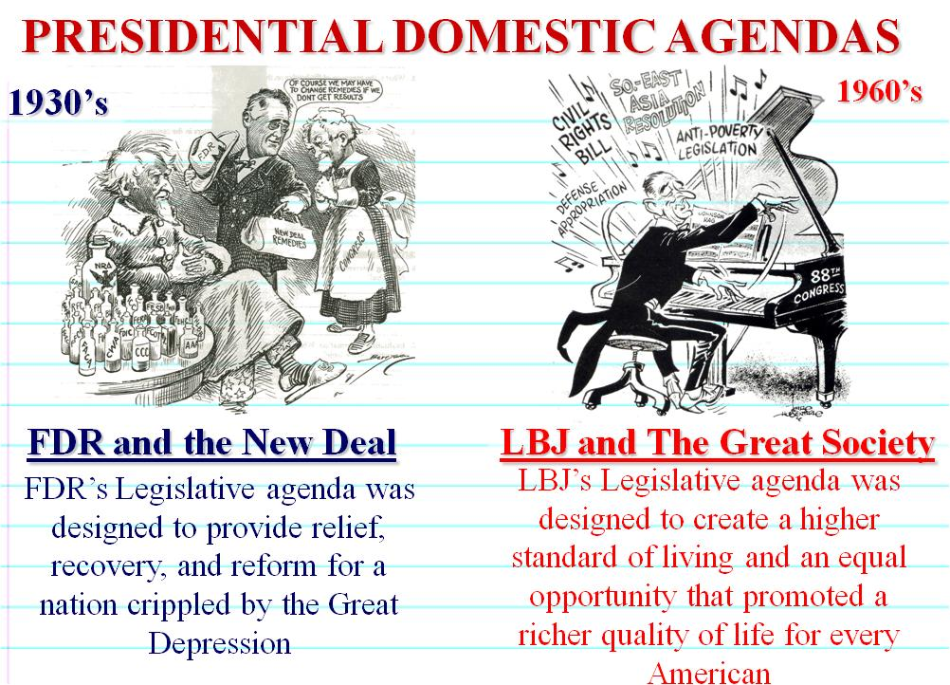
Similarities between the New Deal and the Great Society

#1 Both the New Deal and the Great Society used the government to enhance social welfare
#2 Both the New Deal and the Great Society included the following:
- Government sponsored employment programs
- Government support of the arts
- Federal programs to encourage housing construction
- Federal legislation to help the elderly

Differences between the New Deal and the Great Society
#1 Preschool education for disadvantaged children was an innovative Great Society Program. This was not an extension of the New Deal
#2 In contrast to the New Deal, The Great Society included federal legislation protecting civil liberities of African American

