APUSH Talking Points 5.2
Thomas Jefferson’s Second Term

France and Great Britain are at war (same old story)

Napoleon is getting the upper hand on the land
Great Britain is dominating the seas - Both countries tried to stop the other from getting supplies from other nations – from neutral nations
1805  France issues the Berlin-Milan Decree | 1805  Britain Issues the Orders in Council
What did it do?  Closed ALL European ports to trade with  Britain. The French seized any ship going  from the continent to Great Britain | What did it do?  Restricted trade of neutral countries.  Set up a blockade between America and the continent

Homework Re-set America: A Nutcracked Neutral
10. In what way did the struggle between France and Britain affect the United States?

The British began to seize American ships. Because of conditions in the British navy lots of British sailors had left the Navy and come to America to join the American Navy Britain wanted the sailors back IMPRESSMENT (they took Americans too!!)

Chesapeake Affair (1807)
Chesapeake/Leopard Incident- Started when the American ship (Chesapeake) encountered the British ship (Leopard). Chesapeake refused to allow the ship to be searched by the Leopard, so the Leopard opened fire. Chesapeake surrendered and four men were dragged off to be impressed, so Jefferson expelled all British warships from American waters and denounced impressments.

1807 –Jefferson believed that both Great Britain and France needed our trade – he believed that if we stopped trading with them they would see it was wrong to go after neutrals

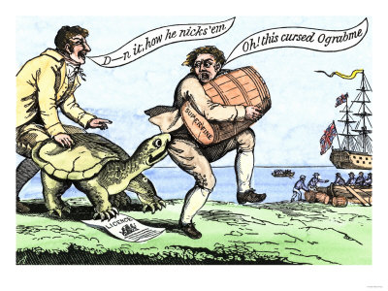

1807- Embargo Act was passed
no American ship can leave an American port for a foreign port
no foreign vessel can load a cargo at an American port
coastwise shipping must post a bond twice the value of the ship and cargo
once delivery was made the bond would be repaid
Jay’s Treaty (1795) had been ineffective and unpopular – but it hadn’t hurt anyone
The Hated Embargo
11. Who opposed the embargo and why?

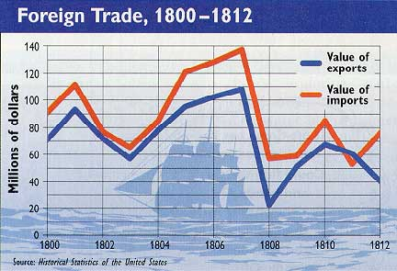

The Embargo Act hurt some…SUCH AS
#1 Merchants in New England (wealthy people in NE)
#2 Shippers and people who ran the ports (who were mostly Federalists)

In New England the states refused to enforce the act there weren’t enough Federal Officials to get the enforcement done they needed help from the states – and they didn’t get it Connecticut – called the act unconstitutional (Sound familiar???) smuggling was going on all over the north east THE ACT WAS A FLOP

1808- Jefferson took his cues from Washington and decided not to run again
1809 – a couple of days before Jefferson left office a new act was passed Non-Intercourse Act

What did it say? We could trade – just not with ports controlled by Britain or France

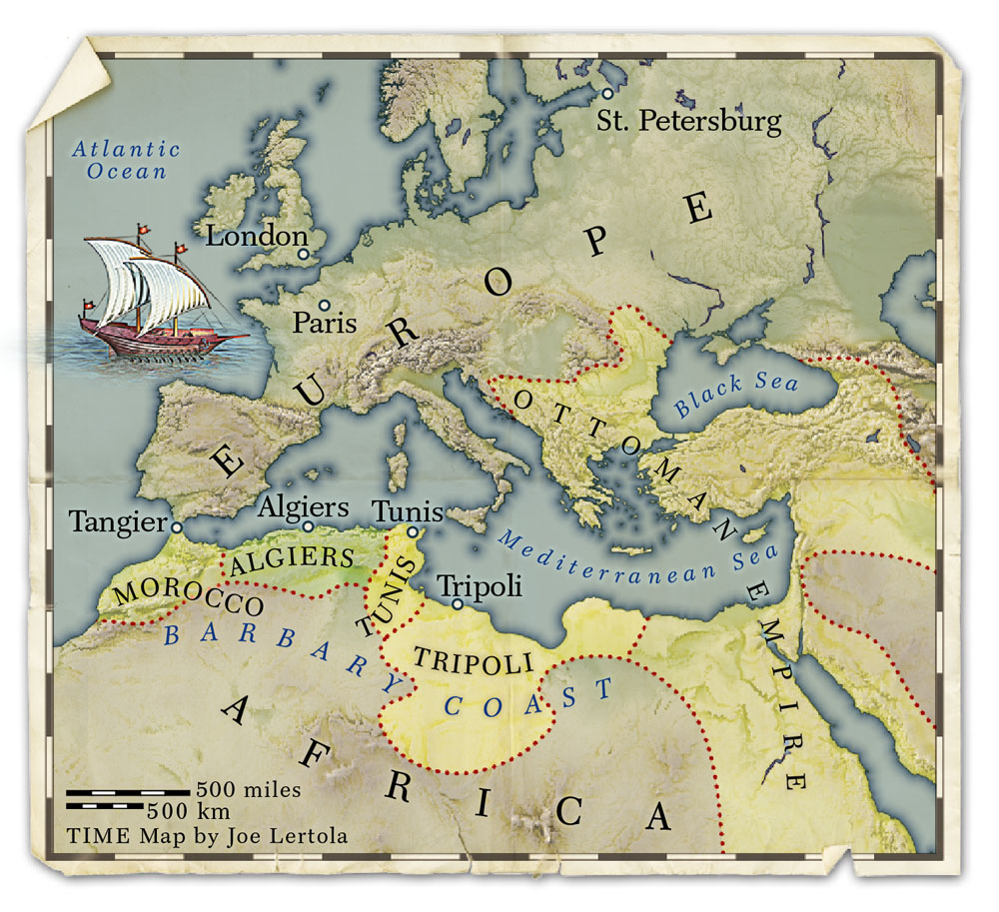
Read More: The First Barbary War

War between USA and Tripolitania, 1801-05. Tripolitania corresponded to modern northwestern Libya. The Barbary pirates continued to attack US vessels in the Mediterranean Sea, and disagreements as the level of tribute required from the US. The US Navy had been reduced (thanks to TJ reduction in government spending - oops)

A peace treaty is signed, US pays a symbolic ransom of $60,000 and Tripoli frees about 300 US captives

