Talking Points-Thomas Jefferson’s First Term

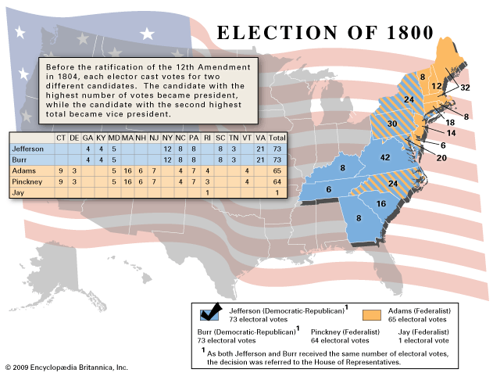

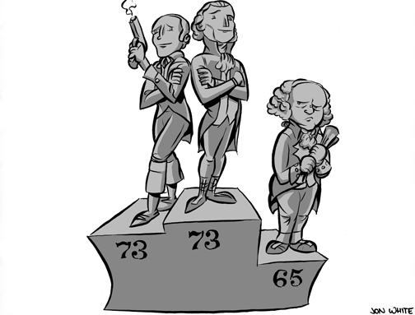

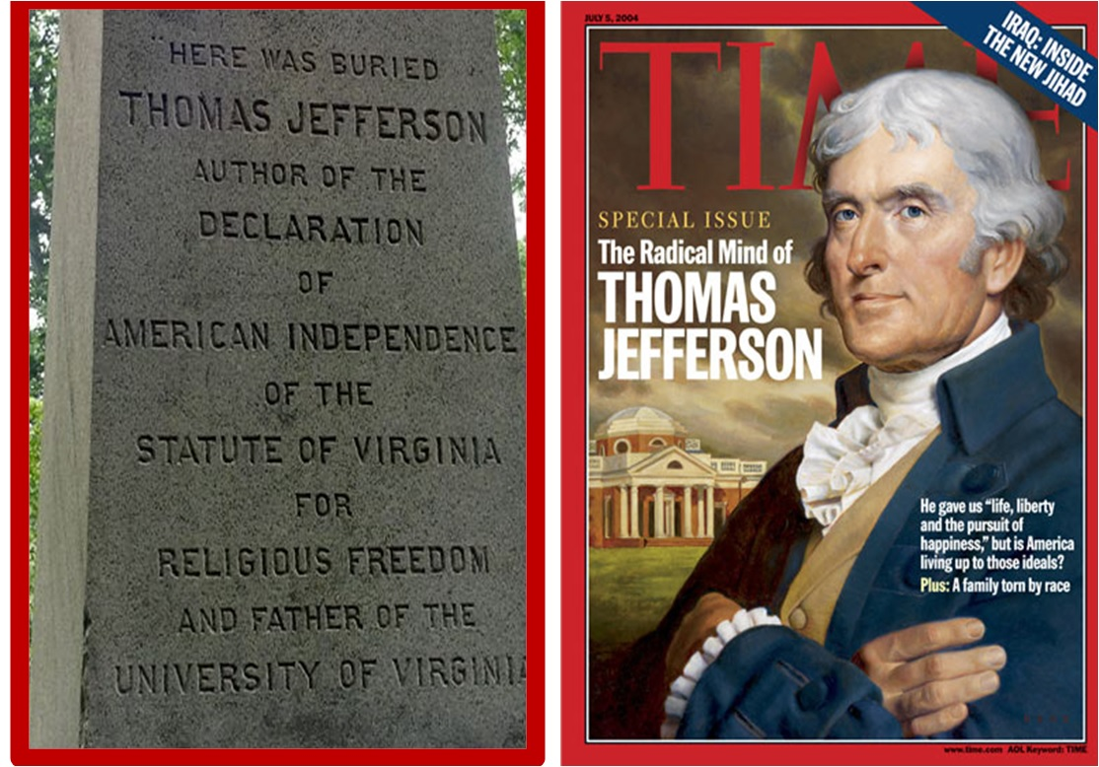

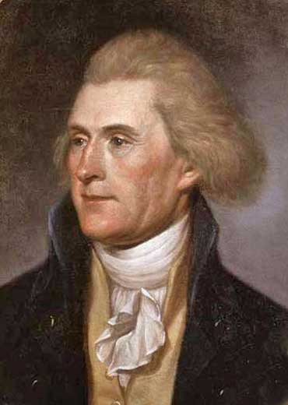

Presidency of Thomas Jefferson (March 4, 1801 – March 4, 1809)
Man with a lot of experience, made James Madison his Secretary of State, made Albert Gallatin his Sec. Of Treasury

Jefferson’s Goals
#1 Scale back government spending
#2 friendships but no alliances
# 3 strict interpretation of the Constitution

First Job – the spending!!!
Scale down Hamilton’s plan (reduced and eventually eliminated the excise tax) ; got more money from import duties (tariff) and sale of western lands (price reduced to $1.25 an acre; minimum purchase 80 acres; created easy payment plans)

Cut spending HOW? -Reduction in military and diplomatic spending

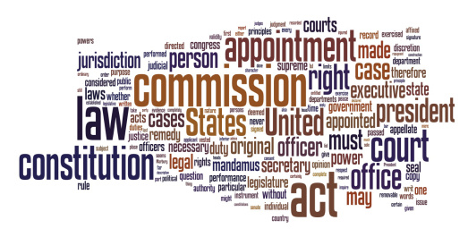

First Big Problem – The Dead Clutch of the Judiciary

Facts: Nov 1800 – Adams and the Federalist lost control of the Presidency and Congress as Jefferson and the Democratic-Republicans were to take office in March. In order for the Federalists to keep any control they had to dominate the only remaining branch – the Judiciary. Federalist Congress then passed a new law Judiciary Act of 1801. Reduced the number of Supreme Court Justices.

Created new judgeships – including Justice of the Peace. Some of the last commission were signed at midnight prior to Jefferson’s Inauguration (“Midnight Judges”)

Marbury v. Madison (1803): William Marbury had been one of the “midnight judges” appointed by John Adams in his last hours as president. He had been named justice of peace for D.C., but when Secretary of State James Madison decided to shelve the position, Marbury sued for its delivery. Marshall dismissed the case, but he said that the Judiciary Act of 1789 was unconstitutional, thus suggesting that the Supreme Court could determine the constitutionality of laws (AKA, “judicial review”).

The Next Big Issue – The Louisiana Godsend and The Empire of Liberty (2:59)

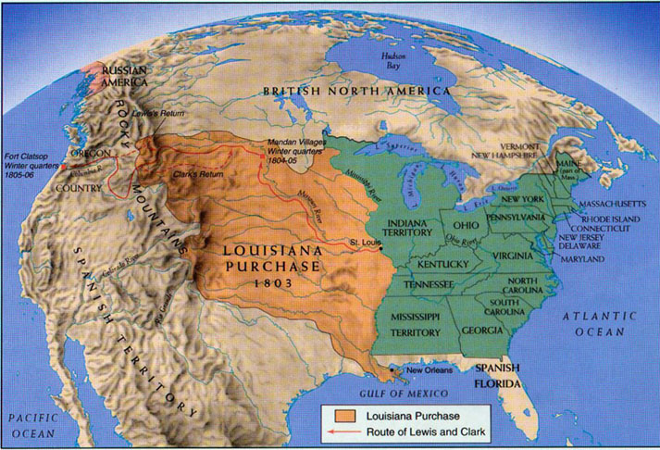

TJ asked for $2 million to buy the port - requested money in case we had to go to war over the river and/or the port gave– Robert Livingston and James Monroe – permission to ask France to sell us the port for $2 million

Napoleon
had hopes of regaining control of some land in the western hemisphere fighting against Toussaint L’Ouverture in the West Indies France lost because of a combination of yellow fever and slow reinforcements. The Louisiana Purchase was finalized on April 30, 1803.
Jefferson had a dilemma, since the Constitution said nothing about purchasing foreign land, but on the other hand, this deal was simply too good to pass up!

After considering an amendment, Jefferson finally decided to go through with the deal anyway, even though nothing in the Constitution talked about land purchases. Jefferson had been a strict interpreter of the Constitution, but he was now using a loose interpretation.

Federalists, normally loose interpreters, took a strict interpretation and opposed the purchase. Federalist didn’t want the new lands because they correctly foresaw new lands meant new settlers and new states, which meant more farmers and more Republicans.

Thus, both parties made a full 180° turnaround from their previous philosophical beliefs about the Constitution simply because of the practical matters at hand.

The Senate quickly approved the purchase with Jefferson’s urging, and the Louisiana Purchase doubled the size of the United States. This was the biggest bargain in history averaging 3 cents per acre. The purchase created a precedent of acquisition of foreign territory through purchase.

Summary of Jefferson’s First Term
#1 doubled the size of the country

#2 increased our trade

#3 Eliminated a foreign threat (France) in North America

#4 Reduced debt and domestic taxes

#5 Increased the power of the executive office

All of this was very good – 1804 re-election was no problem - Term #2 wasn’t so good – problems began in Europe

