APUSH Talking Points
The Presidency of James Monroe - An Era of Good Feelings?
1815 and beyond - The Post War Afterglow

AP Focus New Englanders and the Federalist party strongly condemned the War of 1812. The Federalists met to discuss their grievances in Hartford Connecticut in 1814. Many considered discussing secession at a future meeting, which because the war ended never convened. Era of Good Feelings (1817-1825) A name for President Monroe’s two terms, a period of strong nationalism, economic growth, and territorial expansion. Since the Federalist party dissolved after the War of 1812, there was only one political party and no partisan conflicts

A Quick Summary of James Monroe's President

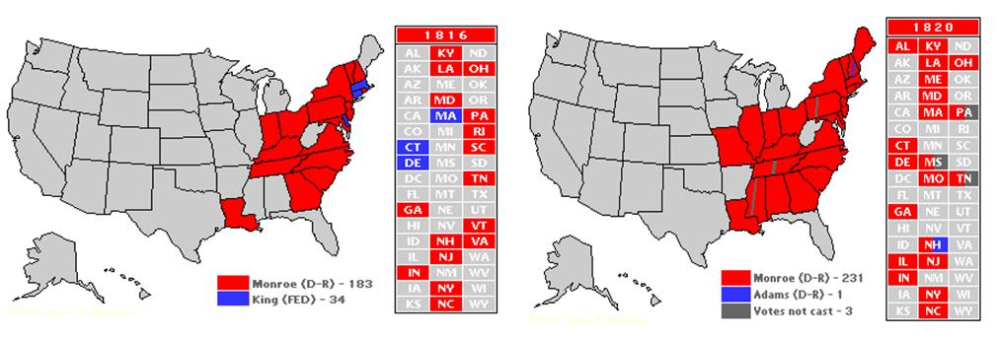
Election of 1816 | Election of 1820
Federalist pretty much dead on the national level  Republicans go with James Monroe –  former Sec. Of State under James Madison  It was an easy victory | Monroe will run basically unopposed  Thus the “Era of Good Feelings”  John Marshall and his rulings continued  to be the only Federalist strong hold

List of TWO term Presidents

