Imperialistic Impulses – An Empire Beyond the Seas

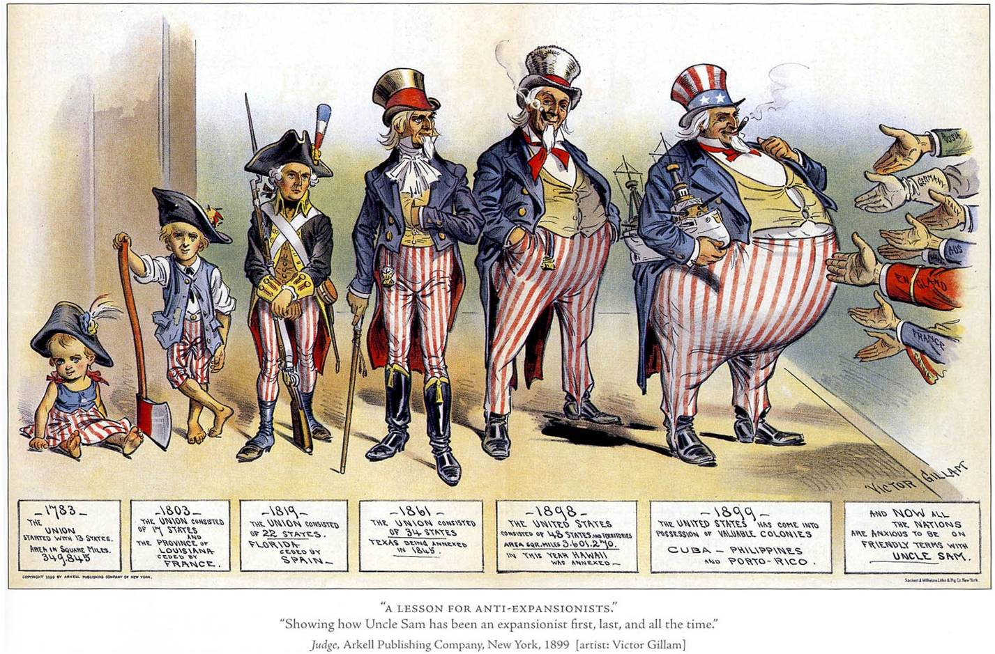

AP Focus Ever since the 1790’s, U.S. foreign policy had been centered on expanding westward, protecting U.S. interests abroad, and limiting foreign influences in the Americas. The booming post civil war economy created the basis for a major shift in U.S relations with the rest of the world

The United States goes from looking INWARD to looking OUTWARD. This includes a national conversation concerning ideas and opinions that will impact the United States other countries.
Imperialism integrates nicely into our recently explored topics and themes
- Industrialization and economic transformation (Age of industry)
- Issues of Race and how it structures perceptions and policy (immigration)
- The power of ideas (Social thought in the Gilded Age)

All of theses threads feed into a transformative event – an old fashion exploration of history - the Spanish American War (1898). The United States is beginning the transformation from a locally concerned smaller nation to a larger nation on the verge of becoming a world power.

IMPERIALISTIC IMPULSES - (Historical)
U.S. should be expanding abroad and using its economic strengths and growing population to foster this expansion

Who is promoting this idea? Elites (intellectuals, writers, businessmen with trade connections, and politicians) WHY?

Most Americans are narrowly focused on the US because they lack foreign travel experience or aren’t interested. However, when this small segment of the population begins to look outward it gains a lot of support WHY? Adventure, glamorizing and romanticizing empire building

TIME LINE
A Review of American Expansion and Conquest

HISTORICAL IMPULSE
1845 Manifest Destiny – idea promoted to encourage coast-to-coast expansion. Dominated American politics from 1800-1855

1876 William Seward is the first to pursue policy of “imperialism” with his acquisition of the Midway Islands and his purchase of Alaska. Alaska became known as “Seward’s” folly, later a mineral rich and strategically important piece of real estate

1890’s Remember Frederick Jackson Turner’s Frontier Thesis? The census of 1890’s determines the frontier is now closed. We have always had a frontier to expand and provide an outlet for expansion and expression. Result – discussion about pursing land and territories beyond our borders

RELIGIOUS IMPULSE
Pious missionaries, inspired by books like the Reverend Josiah Strong’s Our Country: Its Possible Future and Its Present Crisis, looked overseas for new souls to harvest. Strong trumpeted the superiority of Anglo-Saxon civilization and summoned Americans to spread their religion and their values to the “backward” peoples. Christianity motivating people to go halfway around the worlds to spread the word. By 1900 there are 100,000 Christian converts in China. Globalization of Christianity is both positive and progress oriented.
MILTIARY IMPULSE
The development of a new steel navy also focused attention overseas. Captain Alfred Thayer Mahan’s book of 1890, The Influence of Sea Power upon History , 1660–1783 , argued that control of the sea was the key to world dominance. (One of the most influential public policy books ever published)

Mahan analyzed the role a Navy played in history. He determined the US needed to look beyond its borders and have a strong Navy to protect its economic interests. Nice summary of Mahan's Influence (7 minutes)

Read by the English, Germans, and Japanese, as well as by his fellow Americans, Mahan helped stimulate the naval race among the great powers that gained momentum around the turn of the century. This books impacts intellectuals and elites concerned about expansion and economic development

Navy power is at the center of National success. This becomes a source of nationalistic pride – its is right and proper to have a strong Navy!!

This issue LINKS nationalistic feelings with economic issues. The book is published when the US is experience recurring crises and financial depressions (Panic of 1893). Translation? Foreign markets and strong Navy could be the key to helping us out of depressions.

The US has already started to rebuild the Navy with steel changing the outer structure of ships.

● this starts a global arms race and leads to competition (Think WWI)
● Building a Navy becomes a national priority
● Evidence: 1870 4,000 enlisted by 1890 10,000 enlisted

