Staying true to the edicts of President Washington (Farewell Address) and the Monroe (Monroe Doctrine), the United States remained basically isolated in foreign affairs through 1898. During that period American’s attention was on industrialization and expansion within the United States. As U.S. industry led to increased trade, some Americans sought to acquire lands to build a canal to link the Atlantic and Pacific Oceans and islands in the Pacific to use as refueling stations. The United States gained colonies in the Philippines, Guam, and Puerto Rico as a result of their victory in the Spanish American War. These actions resulted in the U.S. foreign policy changing from isolation to imperialism in the 1890’s.

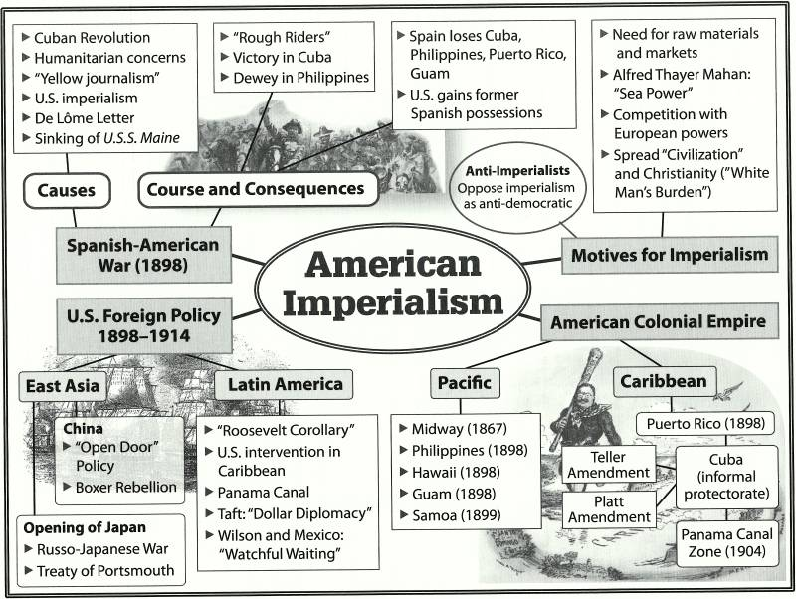

ARGUMENTS AGAINST IMPERIALISM
THE U.S. REVOLUTION AND DEMOCRACY
Anti-imperialists argued it was immoral for the U.S. to rule weaker colonies when American colonists overthrew British colonial rule in 1776 to set up a democracy.

“DOES THE U.S. CONSTITUTION “FOLLOW THE FLAG?”
Many feared that the constitutional rights enjoyed by Americans would be extended to the foreign people of the new colonies ruled by the U.S. Since the colonies would be very distant from the U.S., it would be extremely difficult to assimilate new peoples with vastly different customs and beliefs.

ARGUMENTS FOR IMPERIALISM

CLOSING THE FRONTIER

BUSINESS INTERESTS

EUROPEAN IMPERIALISM

NAVAL POWER

MISSIONARY SPIRIT

SOCIAL DARWINISM

