**The Northern and Southern World View**Impact of the Transportation and Market Revolution

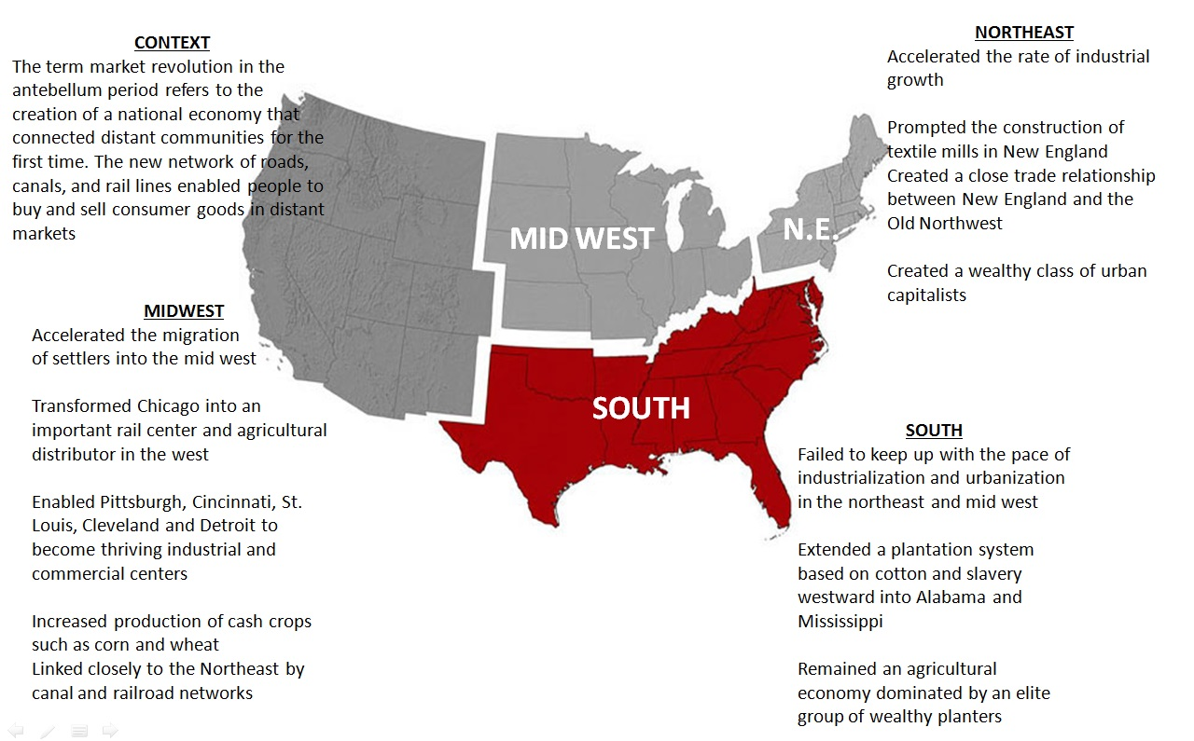

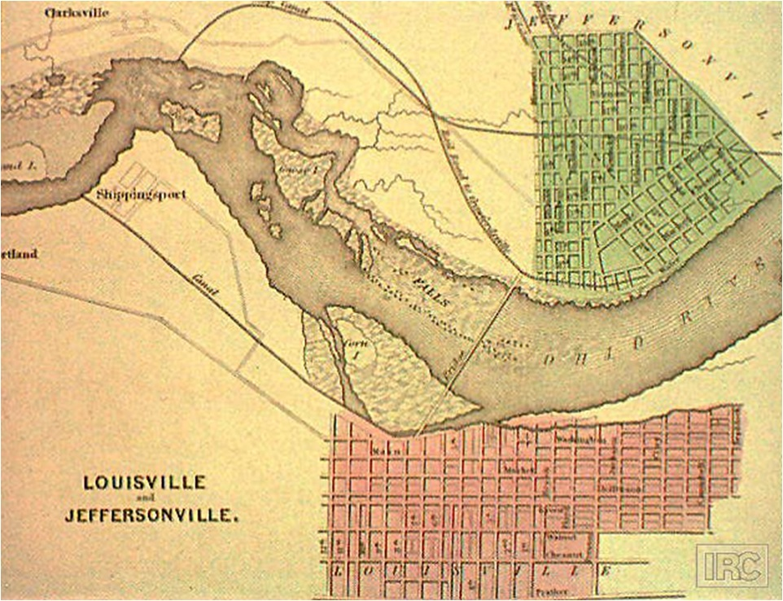

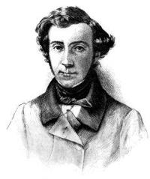

Alexis de Tocqueville came to the United States from France in 1831.  He traveled throughout the country studying the American people and their institutions, their economy, and their ways of living.  In 1832 de Tocqueville arrived in New Orleans.  On this trip he was interested in finding out about some of the differences between the North and South.  He was especially interested in observing slavery and gave his views about its effects upon Americans and their nation.  He also wrote about the rapid expansion of the United States.

 Scarcely a hundred years after the settling of the colonies, the planters were struck by the extraordinary fact that the states that had few slaves increased in population, in wealth, and in prosperity more rapidly than those states that had many slaves.  This result seemed difficult to explain, especially since all the settlers, who were Europeans, had the same habits, the same civilization, and the same laws.

The difference was vividly shown when settlements reached the banks of the Ohio River.  Rolling lands with rich soil extend along both shores of the Ohio.  On either bank of the river the air is equally wholesome and the climate equally mild.  Each bank forms the frontier of a large state.  The state upon the left bank is called Kentucky.  The one upon the right bank is called Ohio.  These two states differ only in one way.  Kentucky has admitted slavery, while Ohio has prohibited it.  Thus the traveler who floats down the Ohio River may be said to sail between liberty and servitude.  A brief inspection will convince anyone which of the two states is more favorable to humanity.

 Upon the left bank (Kentucky) the population is small.  From time to time one sees a group of slaves in the poorly farmed fields.  Forest lands are everywhere.  Society seems to be asleep, the people seem to be idle.  Nature alone offers a scene of activity and life. From the right bank (Ohio), on the contrary, a busy hum is heard, proclaiming the presence of activity.  The fields are full of  abundant harvests.  The elegance of the houses indicates the taste and activity of the worker.  People seem to be enjoying that wealth and satisfaction which is the reward of work.

   The influence of slavery extends still further.  It affects people’s character.  Upon both banks of the Ohio the character of the people is enterprising and energetic.  But this vigor is used very differently in the two states.  The white inhabitants of  Ohio, forced to live by their own efforts, regard prosperity as the chief aim of their existence.  Since the land they occupy presents inexhaustible resources for their activity, their greed is extraordinary.  They desire wealth, and boldly seize every opportunity that fortune opens to them.

  The Kentuckians scorn not only labor but all the undertakings that labor promotes.  As they live in idleness, their tastes are those of idle people.  Money has lost some of its value in their eyes.  They want wealth much less than pleasure and excitement.  The energy which their neighbors devote to becoming wealthy is used by them for field sports and military exercises.  Thus slavery prevents the whites not only from becoming wealthy, but even from desiring to become so.

 In Europe it is generally believed that slavery has made the interests of one part of the Union opposite to those of the other.  I have not found this to be the case.  Slavery has not created interests in the South opposite to those of the North.  But it has changed the character and the habits of the people of the South.

  The citizens of the southern states become domestic dictators from infancy.  The first idea they acquire in life is that they are born to command.  The first habit they learn is that of ruling.  Their education tends, then, to give them the character of a proud and hasty people- angry, violent, impatient toward obstacles but easily discouraged if they cannot succeed at the first attempt.

   Americans of the North see no slaves around them in their childhood.  They are not even taken care of by free servants, for they are usually obliged to provide for their own wants.  As soon as they enter the world, they see the need to do things for themselves.  They soon learn to know exactly the limits of their power.  They never expect to use force against those who oppose them.  They know that the surest means of obtaining the support of other people is to win their favor.

            If two people are united in society by the same interests and, to a certain extent, the same opinions but with different characters and a different style of living, these people will probably not agree.  The same is true of two societies within a nation.

            It is difficult to imagine a strong union between a nation that is rich and strong and one that is poor and weak.  Union is even more difficult to maintain when one side is losing strength and the other is gaining it.  The rapid increase in population and wealth in certain northern states threatens the independence of the southern states.  The weak generally mistrust the justice and the reason of the strong.  The states that increase less rapidly than the others look upon those others with envy and suspicion.  This is the cause of the deep-seated uneasiness and unrest one sees in the southern states.  These states are a striking contrast to the confidence and prosperity common to other parts of the Union.

 If the changes I have described were gradual ones, the danger would be less.  But the progress of American society is rapid.  Thus the prosperity of the United States is the source of its most serious dangers.  It tends to create in some of the states that overpowering excitement which accompanies a rapid increase of fortune.  Meanwhile it awakens in other states those feelings of envy, mistrust, and regret which usually accompany the loss of wealth.  The Americans look at their extraordinary progress with joy, but they would be wiser to consider it with sorrow and alarm.  The people of the United States must inevitably become one of the greatest nations in the world.  Their offspring will cover almost the whole of North America.  What urges them to take possession of it so soon?  Riches, power, and fame cannot fail to be theirs at some future time.  But they rush in search of this large fortune as if only a moment remained for them to make it their own.



**SUMMARY OF FILM:**Amistad is an historical drama film directed by Steven Spielberg based on the true story of an uprising in 1839 by newly captured African slaves that took place aboard the ship La Amistad off the coast of Cuba, the subsequent voyage to the Northeastern United States, and the legal battle that followed their capture by a United States revenue cutter. It shows how, even though the case was won at the federal district court level, it was appealed by President Martin Van Buren to the Supreme Court, and how former President John Quincy Adams took part in the proceedings.