Talking Points
Foreign Policy Under George Washington

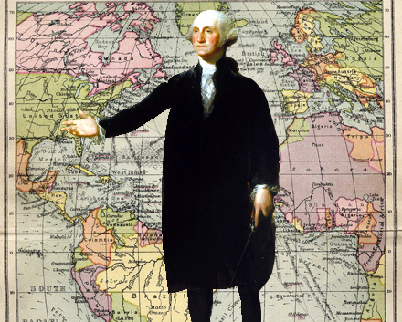

WASHINGTON’S NEUTRALITY PROCLAMATION (1793) https://www.youtube.com/watch?v=a5wCl3aAMEQ

U.S. still obligated to France under the Franco-American alliance of 1778 and the US had pledged to protect French West Indies from enemies (Jeffersonians favored the Alliance) President Washington believed war should be avoided at all costs WHY? U.S. was militarily weak in 1793 and should stay out of the war. (Hamilton & Jefferson in agreement)

Neutrality Proclamation of 1793 - Proclaimed U.S. neutrality toward the war between Britain and France and warned citizens to be impartial to both Britain & France

Citizen Genet - French envoy/ profiteer who tried to entice U.S. profiteers to outfit French ships and supply the French war cause; he recruited Americans in this effort. Genet believed Neutrality Act did not truly reflect American public opinion and suggested bypassing Washington by appealing directly to the voters. Washington demanded his withdrawal & Genet was replaced.

America & France benefited from U.S. neutrality HOW? America's neutrality meant it could still deliver foodstuffs to the West Indies. France did not officially ask the U.S. to honor the Franco-American treaty. If U.S. entered war, British navy would blockade U.S. coasts and cut off supplies the French relied on.

JAY TREATY (1794)
Background: British continued harassing American frontier settlers and U.S. ships on the oceans. The British remained in their northern frontier posts on U.S. soil (a violation of the Peace treaty of 1783) They also sold firearms and alcohol to Indians who attacked American settlers and their navy seized about 300 U.S. ships in West Indies starting in 1793. Hundreds of Americans impressed into service on British vessels; hundreds of others imprisoned.

Diplomatic Developments: Federalists were unwilling to go to war because the U.S. depended on 75% of its customs duties from British imports. Jeffersonians argued that U.S. should impose an embargo against Britain. Washington sent Jay, the Chief Justice of the Supreme Court, to London in 1794. The Jeffersonians feared the conservative Jay would sell out U.S. interests. Jay feared war with Britain and was willing to appease her.

Treaty Provisions: (America won few concessions) The British renewed their pledge to remove their posts from U.S. soil (as in 1783). They consented to pay damages for recent seizures of American ships. In addition the British refused to guarantee against future maritime seizures and impressments or the inciting of Native Americans to violence on the frontier. The was U.S. forced to pay pre-Revolution debts owed to British merchants

Reactions: The Jay Treaty was so lopsidedly pro-British that the Federalist administration was embarrassed. Jeffersonian outrage resulted in creation of the Democratic-Republican party. The South felt betrayed that northern merchants would be paid damages. Southern planters would be taxed to pay pre-Revolution debt.

Results: War with Britain was averted. Washington pushed for ratification of the treaty realized war with Britain would be disastrous to the U.S.A. The Senate narrowly approved the treaty in 1795.

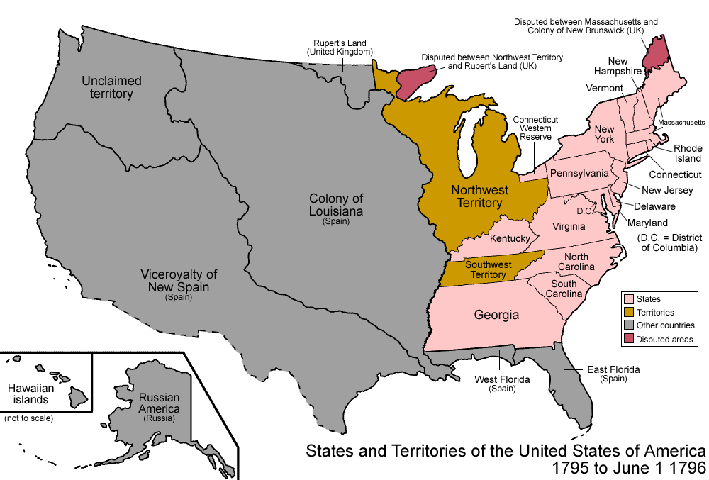

PINCKNEY TREATY (1795)
Background: Spanish feared an Anglo-American alliance and sought to appease U.S.

Spain was a declining power in Europe and their influence was declining on the American frontier

Treaty provisions: (Spanish concessions) The US was granted free navigation of the Mississippi River to the U.S. including right of deposit at the port city of New Orleans. This yielded large area north of Florida that had been in dispute for over a decade. The 31st parallel recognized as legal border between U.S. and Spanish Florida. Ratified by Senate in 1796.

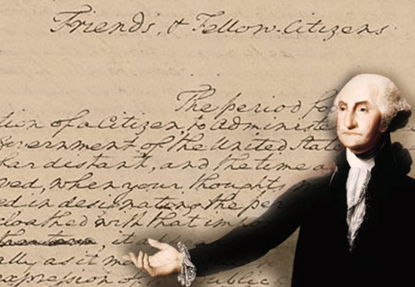

Washington had reluctantly accepted a second term at the urging of his supporters (Unanimously re-elected)

Washington lost his nonpartisan standing when he became a Federalist verbal abuse from Jeffersonian wing was significant

Refused to accept a third term as President setting a precedent for the 2-term presidency Washington exhausted physically and weary of verbal abuse

Content of Farewell Address (1796) Warned against evils of political parties and warned against permanent foreign alliances (like treaty with France) Isolationism became dominant U.S. foreign policy for next 100 years.

SUMMARY: S.A.F.E - $tay Away from Foreign Entanglements

REVIEW OF WASHINGTON’s PRECEDENTS
#1 President relied on and consulted regularly with his cabinet
#2 Chief executive gained the right to choose his own cabinet -- This custom grew out of Congress' respect for Washington
#3 Presidential cabinet used to promote domestic programs (Hamilton)
#4 Two-term office for president
#5 After Jay resigned from the Supreme Court, Washington went outside the Court to select a new Chief Justice

