Foreign Affairs in the Inter-War Years
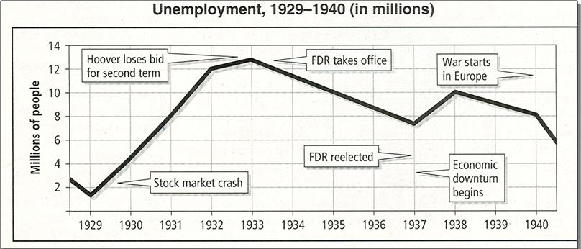
1919 | Treaty of Versailles | Punished Germany severely; League of Nations sought collective security but without  support from the US, USSR and Germany, the League was crippled.
1921-1922 | Washington Disarmament Conference | Sought to reduce naval arms race between U.S., Japan & Britain and resolve disputes  in the Pacific. Five Power Treaty (5-5-3 battleship ratio) and other agreements  lacked enforcement provisions. U.S. naively gave Japan the advantage  in the Pacific (Open Door in China preserved)
1922 | Benito Mussolini  (Italy) | Fascist dictator of Italy from 1922-1943. Wanted to recreate the Roman Empire.
1924 | Joseph Stalin  (USSR) | After Lenin died in 1924, he defeated Trotsky to gain power in the U.S.S.R. He created  consecutive five year plans to expand heavy industry. He tried to crush all opposition  and ruled as the absolute dictator of the U.S.S.R. until his death
1924 | The Dawes Plan | Under the Dawes Plan, Germany's annual reparation payments would be reduced,  increasing over time as its economy improved; the full amount to be paid,  however, was left undetermined.
1928 | Kellogg-Briand Pact | Made war illegal except for defensive purposes. Major flaws: No enforcement  mechanism; aggressors could use "defensive purposes" argument when  attacking. Gave Americans a false sense of security in the 1930s.
1928 | Clark Memorandum | Reversal of the BIG Stick Policy of Teddy - states the U.S. WILL NOT intervene  in Latin America for its own national purposes
1929 | Good Neighbor Policy | Latin America - American investment in Latin America grew from $1.3 billion  in 1914 to $3.5 billion in 1929. American exports also increased substantially.

Pan-Americanism. Under FDR's direction, Americans endorsed non-intervention in Latin American affairs in the 1930s. This was a rejection of Uncle Theodore's Roosevelt Corollary and increased support from Latin American nations (United front against Nazi’s)

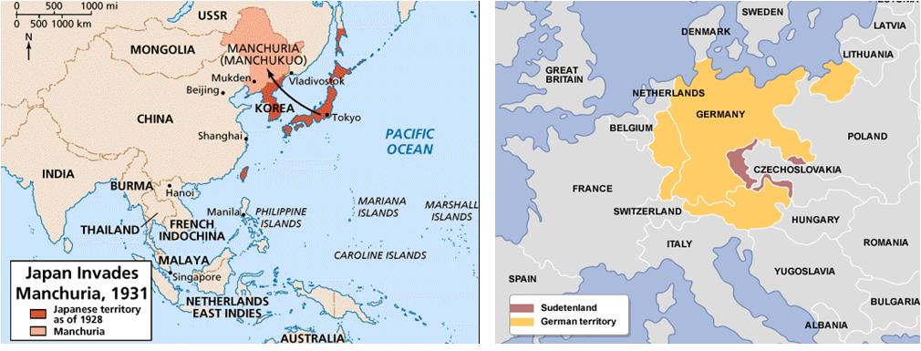

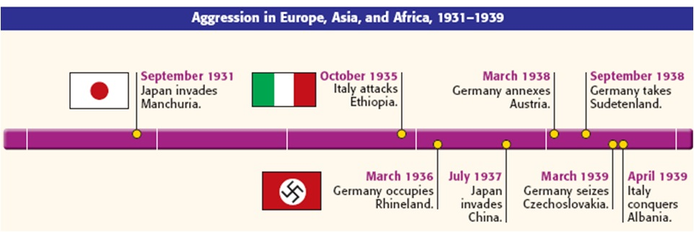
1931 | Japan invades Manchuria | League of Nations condemns action; no enforcement  Japan violated Nine Power Treaty and the Kellogg-Briand Pact;  Japan withdraws from League of Nations
1931 | Hoover-Stimson Doctrine | President Hoover refused economic or political sanctions but did  not recognize Japanese conquest
1933 | Adolf Hitler  (Germany) | German facist dictator. Leader of the National Socialist Workers Party,  or Nazis. Elected Chancellor of Germany in 1933, he quickly established  himself as an absolute dictator.
1933 | London Economic Conference | Purpose: Confront the global depression Goals: stabilize national  currencies and revive international trade. Significance: showed  Hitler and Mussolini U.S. would not intervene in Europe  Resulted in more international isolationism and extreme  nationalism. Perhaps as important as Munich Conference  (1938) in showing lack of resolve among the democracies.

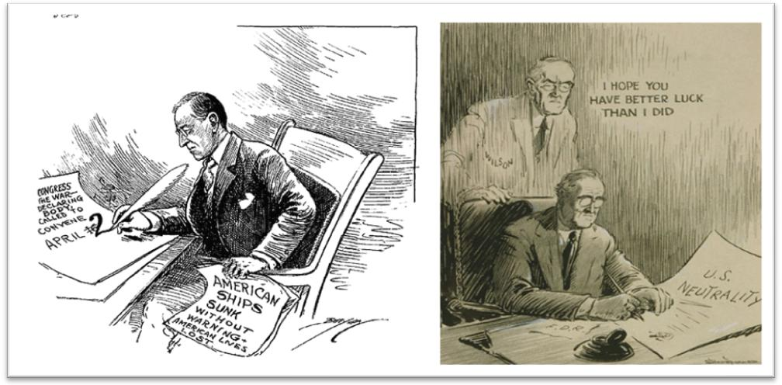

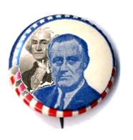

Neutrality Acts 1935 to 1937
“Your boys are not going to be sent to any foreign war”
http://nyti.ms/1UePlvY

The four Neutrality Acts of the late 1930s represented an effort to keep the United States out of "foreign" wars, an effort resulting in part from widespread questioning of the reasons for and results of America's participation in World War I.
"Storm-cellar neutrality proved to be tragically shortsighted. America falsely assumed that the decision for peace or war lay in its own hands, not in those of the satanic forces already unleashed in the world." – American Pageant Page 805

"'Appeasement' of the dictators, symbolized by the ugly word Munich, turned out to be merely surrender on the installment plan. It was like giving a cannibal a finger in the hope of saving an arm." – Page 807 American Pageant

1938 | Invasion of the Sudetenland | In 1938, Hitler turned his attention to the Sudeten area of Czechoslovakia.  The nation of Czechoslovakia had been created after WWI. Two Slavic peoples, the Czechs and the Slovaks, came together to form the country along with three million German speakers from the Sudeten area on the border with Germany, and smaller numbers of Hungarians, Ukrainians and Poles. The 20 years since its creation had seen its democracy and economy flourish.
1938 | Munich Conference,  (Appeasement) | On Sept. 29, Germany, Italy, France, and Great Britain signed the Munich Pact, which gave Germany the Sudetenland. British Prime Minister Neville Chamberlain justified the pact with the belief that appeasing Germany would prevent war.  Czechoslovakia loses Sudetenland (could have waged successful defense) Hitler guarantee of independence of Czechoslovakia Hitler claims he will not make any more territorial demands in Europe. March 1939, Hitler invades rest of Czechoslovakia (six mos. later)
1939 | Non Aggressionpact between Germany and U.S.S.R | August 23, 1939 - Germany and Russia agreed not to attack each other, which allowed Hitler to open up a second front in the West without worrying about defending against Russia. Granted Western Poland to Germany, but allowed Russia to occupy Finland, Estonia, Latvia, and Eastern Poland. Hitler intended to break the pact.

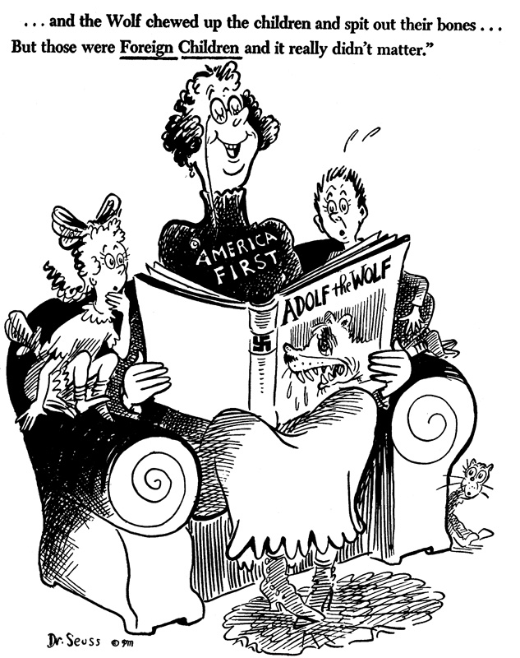
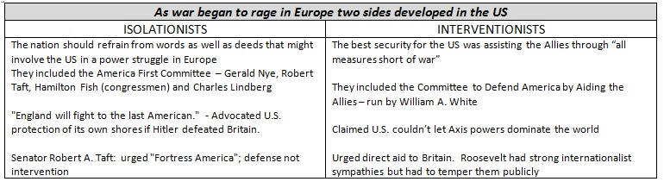

Neutrality Act ( 1935)
Spanish Civil War (1936)
Neutrality Acts ( 1936 to 1939)
FDR "Arsenal of Democracy" speech (1939)
Embargo of 1940
Selective Service and Training Act ( September 1940)
Destroyer-Bases Deal ( September 1940)
The Four Freedoms Speech (January 1941)
Lend-Lease (April 1941)
Embargo of 1941
Atlantic Conference and the Atlantic Charter (August 1941)
Pearl Harbor 1941
"...Pearl Harbor was not the full answer to the question of why the United States went to war. This treacherous attack was but the last explosion in a long chain reaction." – Page 820

