The Impact of 1492

Historical Narrative: COLUMBUS - ADMIRAL OF THE OCEAN SEA
-King of Portugal refused to fund voyages

-August 1492 leaves for Cathay (China)

-Native of Genoa who represented the new age of explore - resilient, courageous, and
confident

Motivation born of desperation: Wanted to take Christianity to heathen lands. Three vessels (Nina, Pinta, and Santa Maria). He maintains discipline and encourages hope. Lands after 10 weeks Oct 12 1492

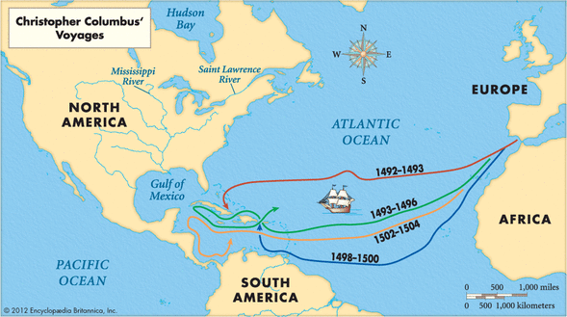

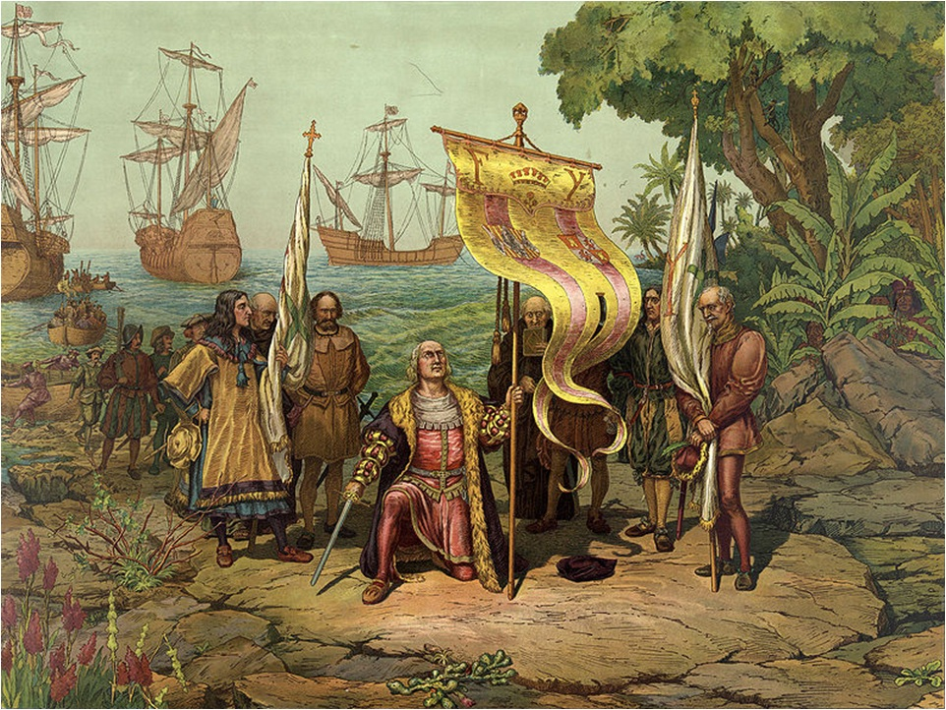

CC lands in the Bahamas and Cuba, but thinks he is in the Far East. He hopes to convert the natives to “our holy faith by love, not force”.

Columbus “discovered” a world that had been inhabited for 12,000 to 40,000 years.

By 1500 15 million Native Americans speaking 30 languages occupied the continent.

Scouts return with reports of no spices, jewels, and returns to Spain confident he has found passage to the orient.

New conclusion = stumbled upon a new land mass – fertile to a limitless degree

1493, 1498, 1502- Political distractions in Europe- The news of Columbus’s voyages excites only merchants, explorers, and dreamers
***Columbus blazes the trail allowing other explorers to easily secure funding for future voyages.

All of these came together to encourage long voyages of discovery. Columbus’s voyage for Spain marked the most important economic intersection of people and places in human history.

The Impact of the Age of Exploration = Globalization (Global Networks)
An exchange of goods, services, and cultures developed among the continents of Europe, Asia, Africa, and the Americas

International Trade

Redistribution of wealth

Diffusion of European values and religion

Triangular slave trade 1500-1800 - “African Diaspora”

Redistribution of world’s population (voluntary and involuntary)

Redistribution of plants and animals - “Columbian Exchange”

Disease Indians are unprepared and unexposed to European disease

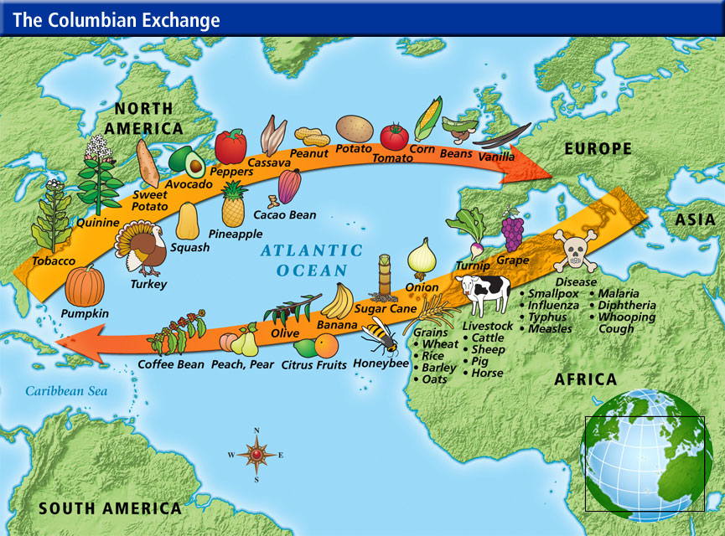

The Impact of the Age of Exploration = Globalization (Global Interaction)

Living Bravely- Rules are suspended “Living Bravely" or without restraint. Europeans could build their own social structures beyond Europe. This leads to unbridled greed, enormous accumulation of wealth (organized thievery), brutality, heartless slaughter, exploitation by Spaniards.

Treaty of Tordesillas (1494) Spain and Portugal, with pope’s approval, divides claims by a line of demarcation in the Atlantic Ocean. Southeast of line = Portuguese; southwest of line = Spanish. The Dutch, English, and French refuse to accept it.

See Chart Below!!!
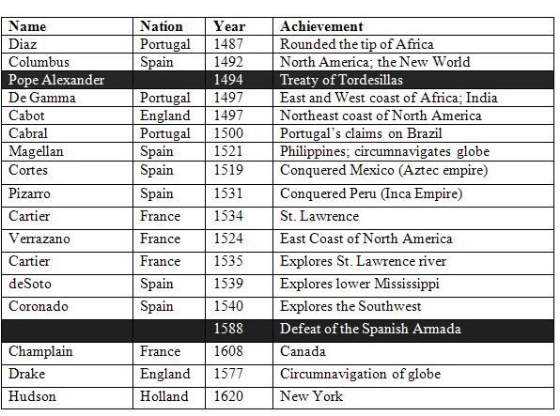
Spain secured its claim to Columbus’s discovery in the Treaty of Tordesillas (1494), dividing with Portugal the “heathen lands” of the New World. The lion’s share went to Spain, but Portugal received compensating territory in Africa and Asia, as well as title to lands that one day would be Brazil

Spanish Conquistadors
The Renaissance & Elizabethan Age of Exploration to the New World was dominated by the Spanish Conquistadors. The success of the Spanish Conquistadors in acquiring monopolies on much of the Eastern spice trade and their expeditions to the New World brought great wealth and power to Spain. The new discoveries made by the Spanish Conquistadors brought untold riches in terms of gold and silver and spices and it also brought power and influence...

The Motives of the Spanish Conquistadors "Profitable Havoc"
The motives of the Spanish Conquistadors and their patrons were prompted by:
- Wealth - gold, silver and spices
- Power
- Prestige
- Increasing opportunities for Spanish trade

CASE STUDY: Spanish conquistador Hernán Cortés arrived in Tenochtitlan on November 8, 1519. At this time it is believed that the city was amongst the largest in the world alongside Paris and Constantinople. The most common estimates put the population at around 200,000 to 300,000 people. Aztec ruler Moctezuma II, thinking Cortés to be the returning god Quetzalcoatl, welcomed him with great pomp. Some of the conquistadors had traveled as widely as Venice and Constantinople, and many said that Tenochtitlan was as large and fine a city as any they had seen.

The Encomienda System
Under the encomienda system, conquistadors and other leaders (encomenderos) received grants of a number of Indians, from whom they could exact “tribute” in the form of gold or labor. The encomenderos were supposed to protect and Christianize the Indians granted to them, but they most often used the system to effectively enslave the Indians and take their lands.

Juan Ginés de Sepúlveda Belittles the Indians (1547)
Bartolomé de Las Casas Defends the Indians (1552)
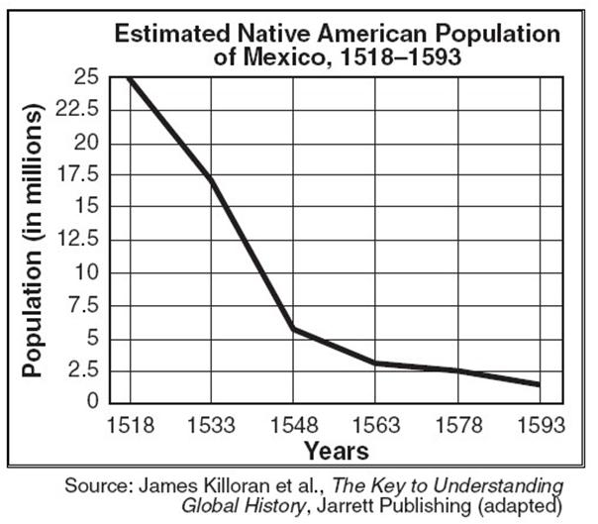
SPANISH COLONIAL ORGANIZATION
The Spanish crown’s determination to create an institutional framework designed to ensure compliance by its officials and the obedience of its overseas subjects and encouraged the creation of bureaucracy’s in accordance to crown priority to the exploitation of wealth.

The need for formal government was eventually necessary and they imposed the old order (Viceroys) and a caste system developed

THE COLONIAL CASTE SYSTEM
Peninsulares ( People born in Spain)
Creoles (People of Spanish decent born in the colonies)
Mestizos (Native American and European mix)
Mulattoes (African and European mix) Native American and African mix.

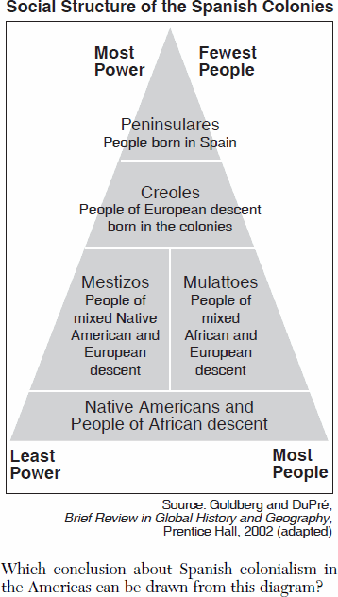

SPANISH EXTRACTION of MINERAL RESOURCES
Much of Spain's exploration of the Americas centered on the desire to find gold and silver. These precious metals were valuable because they were used to make coins, which were the basis of most of Europe's monetary systems.

RESULTS OF EXTRACTION
From the 16th to the 18th century, Spanish mines in Mexico and South America produced roughly 80 percent of the world's silver production and 70 percent of gold at a time when these precious metals were the most widely accepted international currency.

Too much gold is like too much birthday cake!!!

New World wealth in Spain drives prices up 300 to 500%. Part of this reason was the rapid increase in money (then silver and gold) chasing a fixed amount of goods.

Getting gold to Europe was not easy

The Spanish Mission System – “A Wealth of Souls to Harvest”
The Spanish clergy, particularly Jesuits and Franciscans, played a critical role in settling the Southwest using the mission system. Their missions were designed to spread Christianity among, and establish control over, native populations. In some areas, they forced Indians to live in mission communities, where the priests taught them weaving, blacksmithing, candle-making, and leather-working, and forced them to work in orchards, workshops, and fields for long hours.

The missions were most successful in New Mexico (despite an Indian revolt in 1680) and California and far less successful in Arizona and Texas

In addition, as Indians converted, a form of Catholicism that was unique to the Americas developed to accommodate the converts.

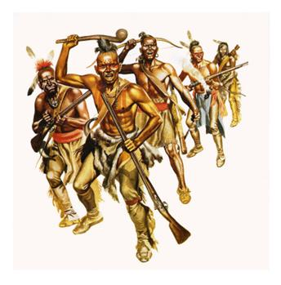

Native Reaction to Spanish Policy

Disease crippled the Native American populations – No defense/immunity build up to small pox, measles, typhoid, whopping cough, dysentery, Cholera, and self inflicted Alcoholism

The Pueblo Revolt of 1680, or Popé's Rebellion, was an uprising of most of the Pueblo Indians against the Spanish colonizers in present day New Mexico. The Pueblo killed 400 Spanish and drove the remaining 2,000 settlers out of the province. Twelve years later the Spanish returned and were able to re-occupy New Mexico with little opposition.

Podcast Link - Pueblo Revolt (29 minutes)

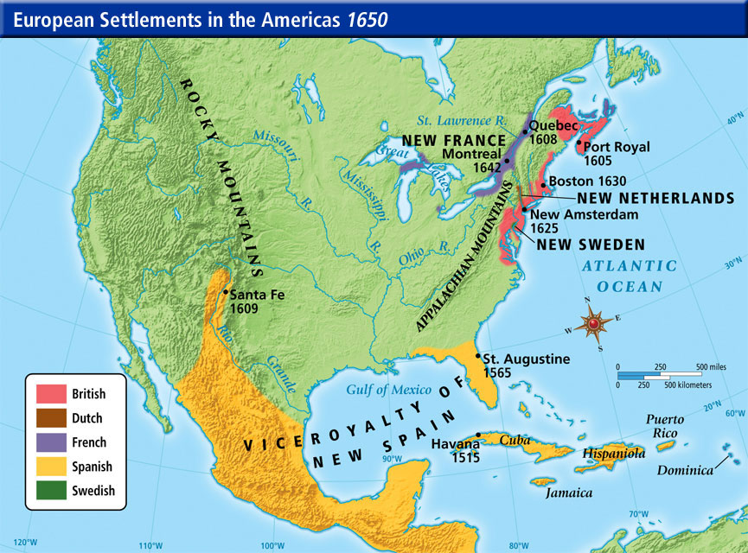

SPANISH SNAP SHOT

The misdeeds of the Spanish in the New World led to the birth of the “Black Legend.” This false concept stated that the conquerors just tortured and killed the Indians, stole their gold, infected them with smallpox, and left little but misery behind.

By the numbers: Due to Spanish rule, the Indian population in Mexico went from 20 million to 2 million in less than a century!!!!

The Spanish employed fewer resources in farming and more resources into science and engineering, writing and improved military technology.

Non-Military Technology -Iron tipped plow, windmill, and water wheel freed up more people to pursue other things.

The Spanish, who had more than a century’s head start over the English, were genuine empire builders and cultural innovators in the New Word.

The Spanish paid the Native Americans the high compliment of fusing with them through marriage and incorporating indigenous culture into their own, rather than shunning and eventually isolating the Indians as their English adversaries would do

