APUSH Talking Points
Weaknesses with the Articles of Confederation

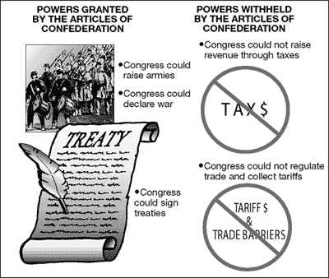

During the years immediately following the Revolutionary War, the colonies organized themselves into a new American government. The Articles of Confederation (1781-1789) served as the foundation for this first attempt at a national government and while a failure, it was the lessons learned under the articles that helped strengthen the government formed by the Constitution.

PROBLEMS UNDER THE ARTICLES of CONFEDERATION
REVIEW VIDEO on THE ARTICLES (15 Minutes)

Weaknesses | Consequences
No Chief Executive – Congress used committees to  Get their work accomplished  No executieve leadership | No one leader to organize things, no one person for a foreign nation to deal with, committees didn’t  work well together
Passing a law took approval of 9 of the 13 states  One State, One Vote | With 5 “small” and 8 “large” states it was almost impossible to get an agreement, delegates from all states weren’t around.
Amending the document required approval of 13 of the 13 states  Amendments required unanimous vote | This never happened, so even when changes were needed, they couldn’t happen
Congress could request the states pay taxes, but they could not force them to pay. Congress could borrow money. "Government by supplication" | Most states had debts of their own and were slow to pay the requested amount if they paid it at all.  Congress borrowed money from foreign nations, but all that did was increase our national debt
Congress possessed no power to control commerceforeign or domestic | Made it difficult for nations to trade with the US because of the different state regulations. Congress had no power to protect US industries with duties.
Congress could make treaties but had no power to require the states to follow them | Couldn’t force the states to live up to the Treaty of Paris
Congress could make laws but had no power to force the states to abide by them | They could ask, but they couldn’t force. So if a law had been passed the 4 states that disagreed could just not follow it
No National court system | No way to settle disputes between states

