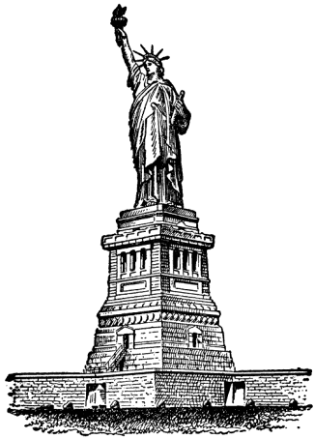
America: The Story of Us

Boom ~ Episode 8

Discussion Questions:
- How did the US change after huge amounts of oil were discovered in Texas in 1901? Do you think this event still shapes our lives today?

- The price of oil plummets from $2.00 a barrel to _________ _________.

- What is the revolutionary process that Henry Ford uses to make cars more efficiently?

- What sign is put up in California that is still there today?

- Why did Los Angeles city leaders need to seek water sources outside the city? What do you think were the risks of brining in water from beyond the city limits?

- How many men died building the aqueduct that brought water to Los Angeles?

- What was the ‘Great Migration’ and why did it take place?

- Why do you think there was so much tension and violence against African Americans in urban areas in the 1920s and 1920s?

- What were some of the reasons for and against Prohibition in the 1920s?

- What new national pastime was developed because of the supped up cars?

- Who is the most notorious gangster in Chicago, Illinois?

- Despite the ban on alcohol, why do you think sales of liquor continued and what were some of the methods police used to stop it?

- Why is the 18th Amendment finally repealed?

Culture of the 1920s:
- Discuss how the culture of the 1920s broke and transgressed different boundaries in American society, especially the accepted roles for women?

- Discuss some of the tenets of the Harlem Renaissance.

- Compare and Contrast Urban and Rural Areas in the 1920s:

- Discuss the role of advertising in the 1920s.

http://www.youtube.com/watch?v=dubvgA7Je7Y
Story of US: skip water… 19 - 26

The century: start with New York 4:18 – 20:25 (women), KKK 27:01 –
https://www.youtube.com/watch?v=RN7ftyZigYs

