America as a World Power – Spanish American War

AP Focus: The Spanish-American War saw the U.S. gain Hawaii, Puerto Rico, Guantanomo Bay in Cuba, the Philippines, and other smaller islands. Anti-Imperialists were angered by anti-democratic aspects of imperialist efforts

AP Free Response Question - Analyze the extent to which the Spanish-American War was a turning point in American foreign policy

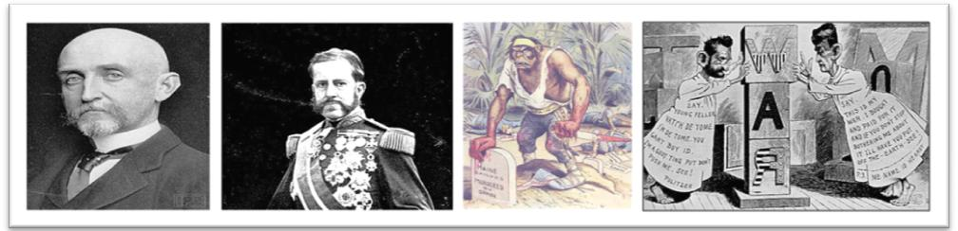

#1 Humanitarian Causes - Spanish General “Butcher” Weyler placed Cuban civilians in concentrations camps. Over 200,000 (mainly women and children) died of hunger and disease. The atrocities in Cuba were sensationalized by “yellow press” (Pulitzer and Hearst attempted to outdo each other with sensational treatment of the news (exaggerated stories and falsified as accounts to sell newspapers) Cuba Libre

U.S. sent Battleship Maine to Cuba in 1898: Aimed to protect and evacuate Americans if danger occurred while also giving voice to popular distaste for Spain’s reconcentration policies. (Sent ostensibly as a “friendly visit”)

#2 The de Lome letter (Feb. 9, 1898): Hearst sensationally headlined a stolen private letter written by Spanish minister in Washington, Dupuy de Lome that portrayed McKinley as corrupt and indicated Spain lacked good faith in instituting reforms in Cuba.

Immediate cause of Spanish American War (Feb. 15, 1898): The explosion of USS Maine killed 266 men. Spanish investigation announced explosion as internal, presumably accidental. American version reported blast caused by a mine.

“ A Splendid Little War” The public, prodded by yellow press, demanded war to free the abused Cubans. McKinley sent war message to Congress on April 11, 1898. The President urged armed intervention to free oppressed Cubans. Congress agreed!

U.S. invasion of Cuba - Spanish fleet eventually landed at bottle-shaped Santiago Harbor where they were promptly blockaded by the more powerful American fleet.
The Spanish-American War By the Numbers…. Cost: $250,000,000
Combat deaths: 385 American battle deaths (1/20th the number lost at Gettysburg)
Non-combat deaths: 4,000 + deaths from disease and poisoned meat

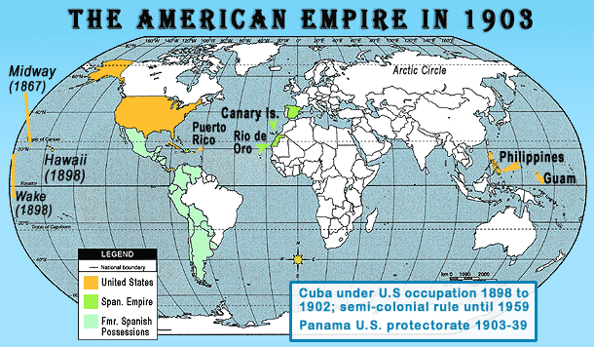
Acquisitions: Puerto Rico and Guam were ceded (To surrender possession of, especially by treaty) to the United States as indemnity (compensation for a particular loss suffered), and the Philippines were surrendered to the United States for a payment of $20 million.

Spanish American War as a Turning Point
To what extent was the Spanish-American War a turning point in American foreign policy ?

TIMELINE
Manifest Destiny/Imperialistic Expansion v. Domestic/Global

1898 | Spanish American War - (Territorial Acquisitions: Guam, Puerto Rico, Philippines)
1899 | Open Door Policy - China
1900 | Boxer Rebellion- China
1900-03 | The Philippine Insurrection
1903-14 | Panama Canal
1904 | Roosevelt Corollary to the Monroe Doctrine

#1 The war represented the first major military engagement beyond United States borders since the Mexican-American War (1846-48) and led to an assertion of United States interests throughout the Caribbean
#2 Spanish-American War (1898) represented a major step away from generations of a foreign policy that, for most part, emphasized isolationism with respect to most areas beyond the continental United States. Remember SAFE
#3 As a result of the defeat of Spain, the United States eventually established control, or took possession, of the Philippines (1898), Puerto Rico, Cuba, and then Midway, Guam, Wake Island, and (American) Samoa (1899). At the same time the United States formally annexed Hawaii as well.
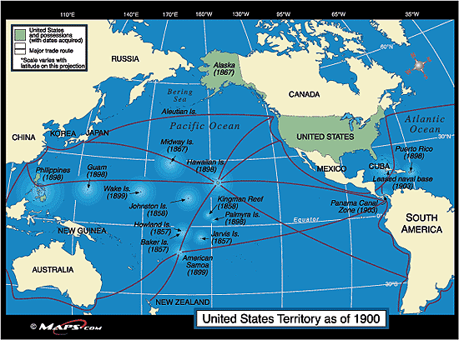

#4 The war’s outcome led to huge increases in the United States naval budget and United States military involvement in the Philippines, resulting in a three-year war (1899–1902) to pacify the Filipino people.

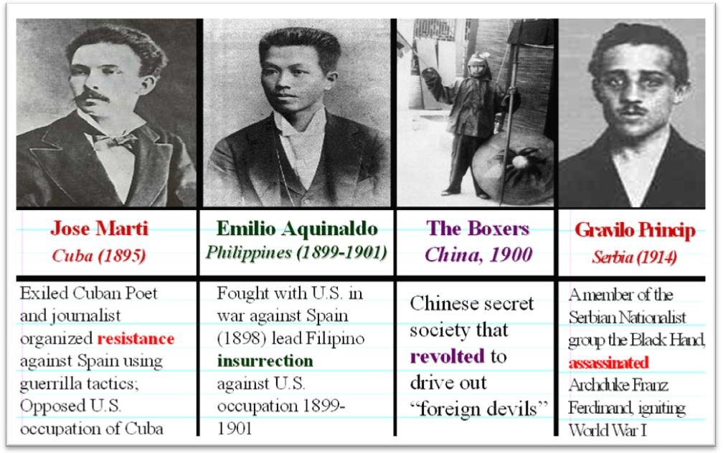

#5 The Spanish-American War accelerated policies promoting overseas investments, as seen in the Open Door policy regarding China (1899–1900) and later as “dollar diplomacy” under President Taft (1909-13).

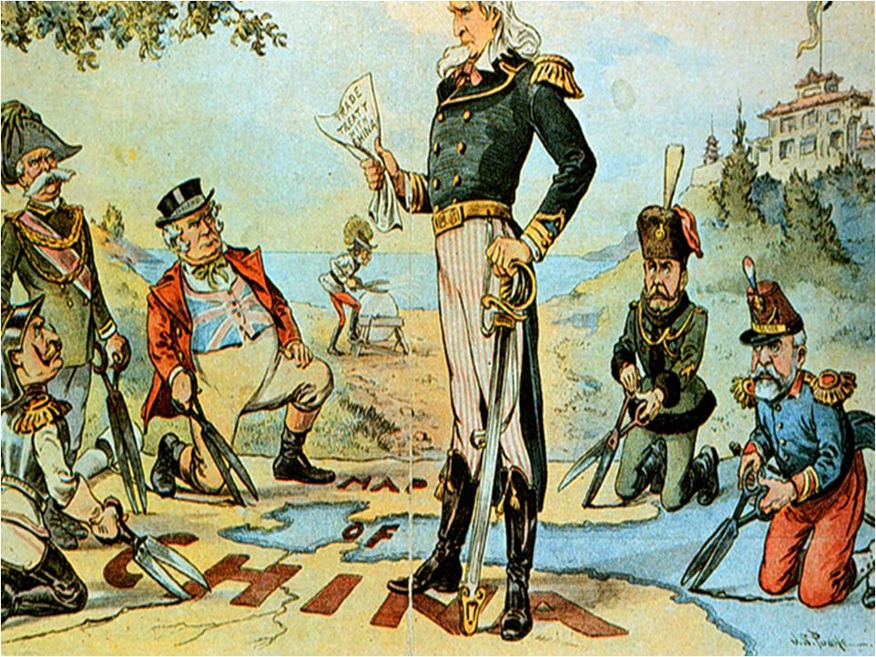

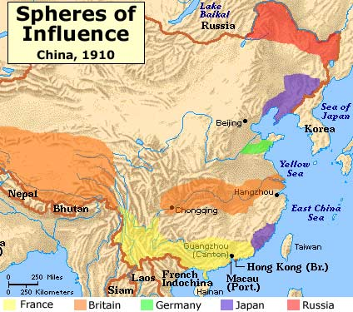

The Boxer Rebellion 1900 .The “Boxers” staged an uprising to drive out foreigners and restore China to isolation. China took matters into their own hands with the Boxer Rebellion. The uprising took place in response to foreign "spheres of influence" in China, with grievances ranging from opium traders, political invasion, economic manipulation, to missionary evangelism In this, the Chinese rose up to oust/kill foreigners who controlled their cities. 200 foreigners and thousands of Chinese Christians were killed.

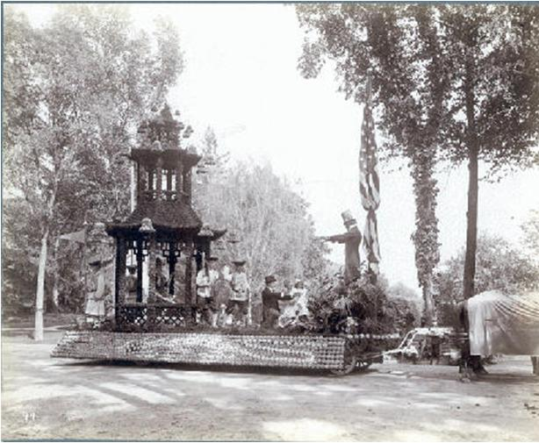

#6 Spanish-American War (1898) could also be seen President Theodore Roosevelt’s engineering a revolt in Panama against the Colombian government (1903) and then negotiating for the Panama Canal Zone and construction of the Panama Canal (completed in 1914).

Uncle Sam Creates Puppet Panama
On November 3, 1903, Panamanians, who feared the United States would choose the Nicaraguan route for the canal, made a successful revolution led by Bunau-Varilla. Bunau-Varilla became the Panamanian minister to the United States and signed the Hay-Bunau-Varilla Treaty in Washington. The treaty gave the U.S. control of a 10-mile zone around the proposed Panama Canal.

Building the Panama Canal
“A continent divided, a world united”
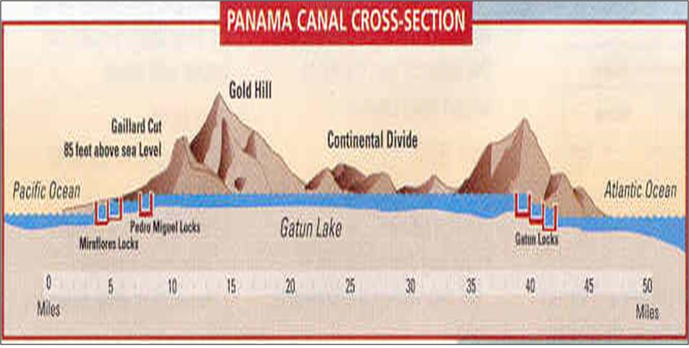

Timelapse video through the Canal 2006
REVIEW: Transportation Innovation 1825 to 1956

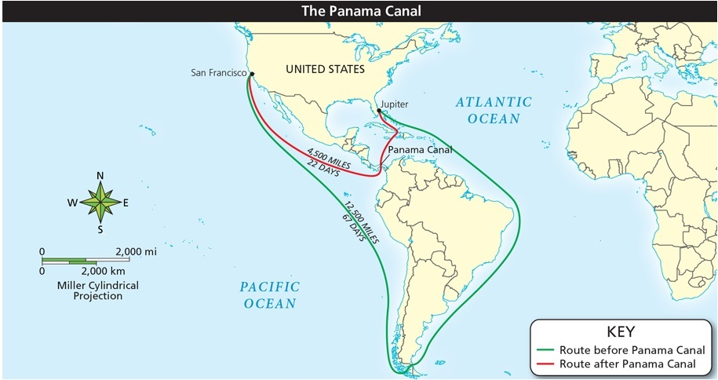
#7 These events were stepping stones to Theodore’s Roosevelt’s Corollary to the Monroe Doctrine and the United States assertion of a sphere of influence over the Caribbean for strategic reasons (1904). Following from that policy position came United States intervention in Cuba, Nicaragua, Haiti, Dominican Republic, and Mexico, and the purchase of the Danish West Indies (renamed the Virgin Islands) to keep German influence out of the region (1906-17).

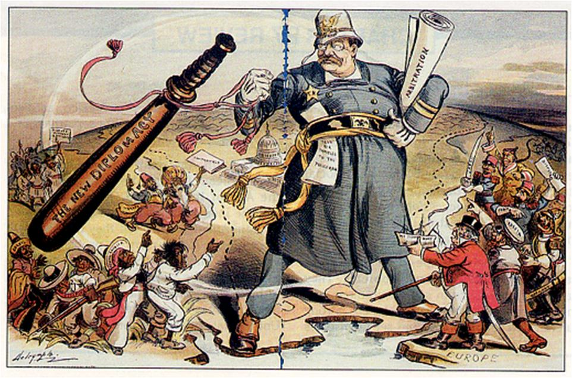#8 Roosevelt’s decision to send the Great White Fleet (much of the United States Navy) around the world (1907-09), and especially to Japan, was a bold step to assert United States claims to the role of a major player in international diplomacy, as had been his mediation of the Russo-Japanese War two year earlier (1905).

