A Treaty Rejected 1919

The Betrayal of Great Expectations
The Senate Rejections the Treaty of Versailles

Backlash against the Great War - Questioning the wisdom of having participated in a war that had caused many American deaths and wounded . Stories of Allied greed and desire for revenge disillusioned many who thought that the war had been fought to “make the world safe for democracy”

Rising intolerance towards things “un-American”
Ku Klux Klan reborn
Second Red Scare
The Great Migration

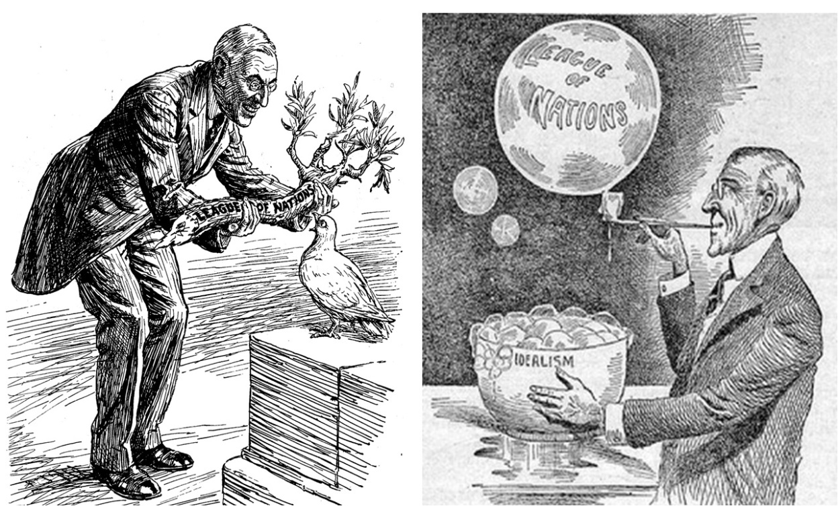

In our system of government, Presidents NEGOTIATE TREATIES with other countries (through their Secretary of State normally, although in this case Wilson was directly involved in the Paris negotiations). THEN, they have to bring the Treaty back and have it approved by 2/3 of the US Senate (this is called the “Advice and Consent” power of the Senate.

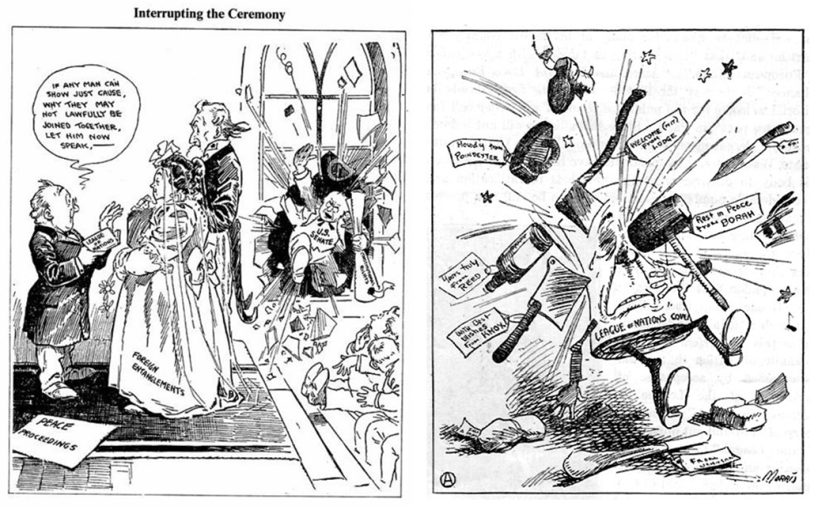

Another important aspect to this story is the BREAKDOWN of the Senate that Wilson was dealing with. Essentially, you can divide the 96 Senators this way as far as the Treaty was concerned:

48 (50% of them) were in the INTERNATIONALIST camp – that is, they were supportive of Wilson’s position concerning the Treaty and thought the League of Nations was a good idea.

32 (33% of them) were RESERVATIONISTS – that is, they could support the Treaty but had major reservations about it.

16 (17%) of the Senators were IRRECONCILABLE – that is, they were simply not going to support the Treaty no matter what. Robert LaFollette of Wisconsin, for example, was in this camp. He had opposed our entry into World War I and, in fact, gave a very famous speech (In Defense of Free Speech During Wartime) after he had been attacked for his anti-war vote.Document A clearly reflects this position.

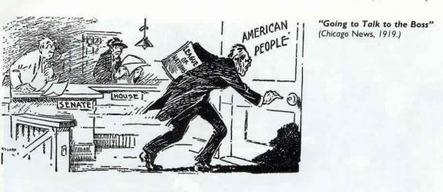
In an attempt to speed up the passing of the treaty in the Senate, President Wilson decided to go to the country in a speech making tour. He would appeal over the heads of the Senate to the sovereign people. The speeches in the Midwest did not go as well as in the Rocky Mountain region and on the Pacific Coast. On his return to Washington, Wilson suffered a stroke and suffered from physical and nervous exhaustion.

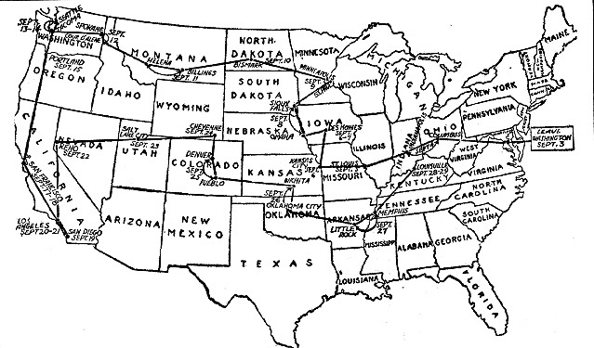

Vote in Senate November 1919
Lodge Amendments, Senate rejection.
Wilson refuses to Compromise with Senate over concerns
Vote in Senate March 1920
Lodge Amendments, Senate rejection
The "Solemn Referendum" of 1920
President Wilson proposed to settle the Treaty issue in the forth coming presidential campaign of 1920 by appealing to the people for a solemn referendum"

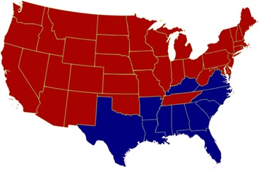

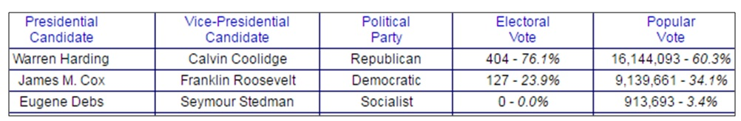
The Betrayal of Great Expectations
The Treaty of Versailles was the only one of the four peace treaties not to succeed. After the war, America did not embrace the role of global leader. In the interests of its own security, the United States should have used its enormous strength to shape world-shaking events. It instead permitted the world to drift towards yet another war.

