"A Hell of a Storm" 1848 to 1854
Thematic Connections and Illustrative Examples

Context: The issue of slavery in the territories acquired from Mexico disrupted American politics from 1848 to 1850. There where bills before Congress to establish the territories now of Utah and New Mexico and large swaths of land that could become more than two states. The Compromise of 1850, orchestrated by Henry Clay, attempted to deal with the issue of slavery.

In March 1848, there were roughly 157,000 people in the California territory. Just 20 months later, following the massive influx of settlers, the non-native population had soared to more than 100,000. And the people just kept coming.

By the mid 1850s there were more than 300,000 new arrivals—and one in every 90 people in the United States was living in California. All of these people (and all of this money) helped fast track California to statehood. In 1850, just two years after the U.S. government had purchased the land, California became the 31st state in the Union

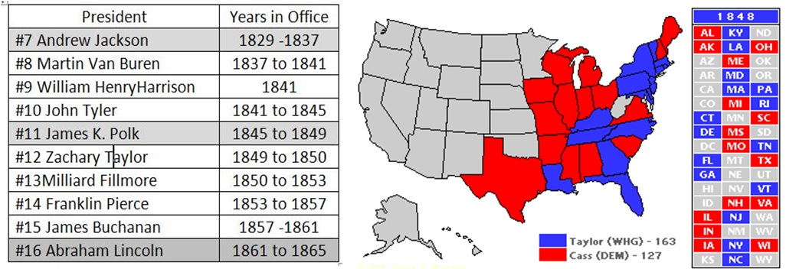

Both of the major parties hoped to avoid the slavery issue's divisiveness in 1848. Since President Polk refused to consider a second term, the Democrats turned to Lewis Cass of Michigan, a rather colorless party loyalist. Cass advocated "popular sovereignty" on the slavery issue, meaning that each territory should decide the question for itself — a stance that pleased neither side. The Whigs nominated Zachary Taylor, hero of the Battle of Buena Vista, whose earlier military blunders had been forgotten. Taylor had no political experience and had never voted.

The election picture was clouded by the presence of two other parties. The Liberty Party, which had run with some success on an anti-slavery platform in 1844, tried again in 1848, but lost its issue to a stronger challenger. The Free-Soil Party nominated former president Martin Van Buren, who garnered nearly 300,000 votes—more than enough to deny victory to Cass and the Democrats.

PLANS FOR THE WESTERN TERRITORIES
What kind of future will America have? Four plans are going to come together around this debate over slavery in the territories

#1 The Wilmot Proviso (a rally cry of the Free Soil Movement). David Wilmot proposed an amendment that stated that the territory from Mexico should remain slave-free. The language was borrowed from the Northwest Ordinance. All but one northern state legislature endorsed it. All southern legislatures condemned it (a sign of things to come???).

#2 State sovereignty (states' rights) The question of the individual's constitutional right of ownership in slaves as property and transport of slaves as property. State sovereignty, states' rights was indeed deeply at the root of the South's growing position here that, ultimately, no Federal Legislature, President--no Federal authority--existed to stop slavery's expansion.

#3 Popular sovereignty (a compromise position) not a new idea in the midst of the Mexican War and its aftermath – the idea that there would be no Act of Congress on slavery in the territories. Take Congress out of the story and simply let the people in the Western Territory have a vote. Let them have a referendum. Let there be popular democracy.

#4 Geographical division – Remember the Missouri Compromise of 1820 the 36º30' parallel from the Mississippi River to the Pacific Ocean and slavery would never exist north of that line. The problem was that half of California was already north of that line.

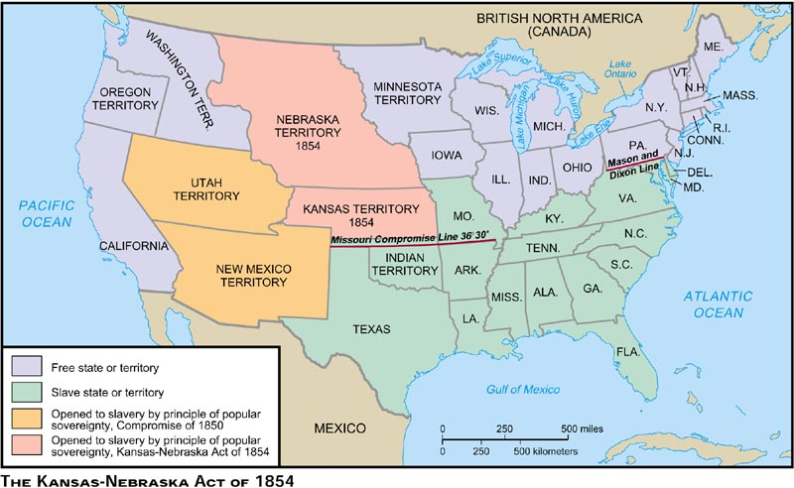

"A Hell of a Storm" The Impending Crisis of the Union, 1840 to 1854
For years South Carolina had talked about secession (1830’s Tariff issue). Talk of
secession had become a perpetual threat…. The tide begins to shift because of a clash of interests (between 1820-1854) abolition of slavery vs. territorial expansion - Remember the word is COMPROMISE

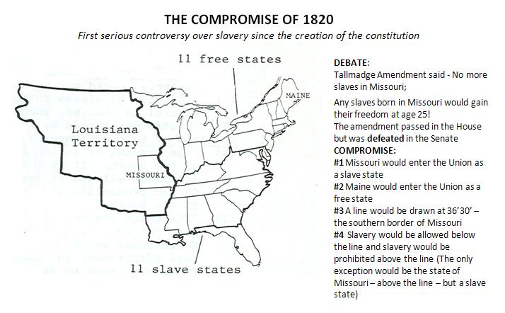

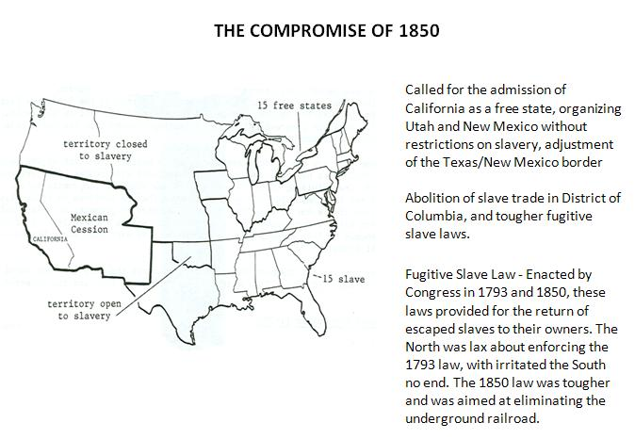

IMAGE ANALYSIS - Debating the Compromise of 1850

CASE STUDIES - REACTIONS TO THE FUGITIVE SLAVE ACT
Harriet Beecher Stowe (1853) and Harriet Tubman (1860)

REVIEW: Key Works of Art and Literature

Harriet Beecher Stowe wrote Uncle Tom’s Cabin in 1852. The book was loosely based on a visit to a plantation in Kentucky. The book, which exposed the evils of slavery, was a best seller in the North and helped the abolitionists’ cause. Southerners, on the other hand, believed the book exaggerated or lied about slavery.

It sold 300,000 copies in the first year, by far broke every sales record of any book ever published, ever, anywhere. Reprinted into at least 20 languages in its first five years of existence. Made into stage plays within two years. It brought an awareness to the slavery problem as never before.

http://utc.iath.virginia.edu/uncletom/key/kyhp.html

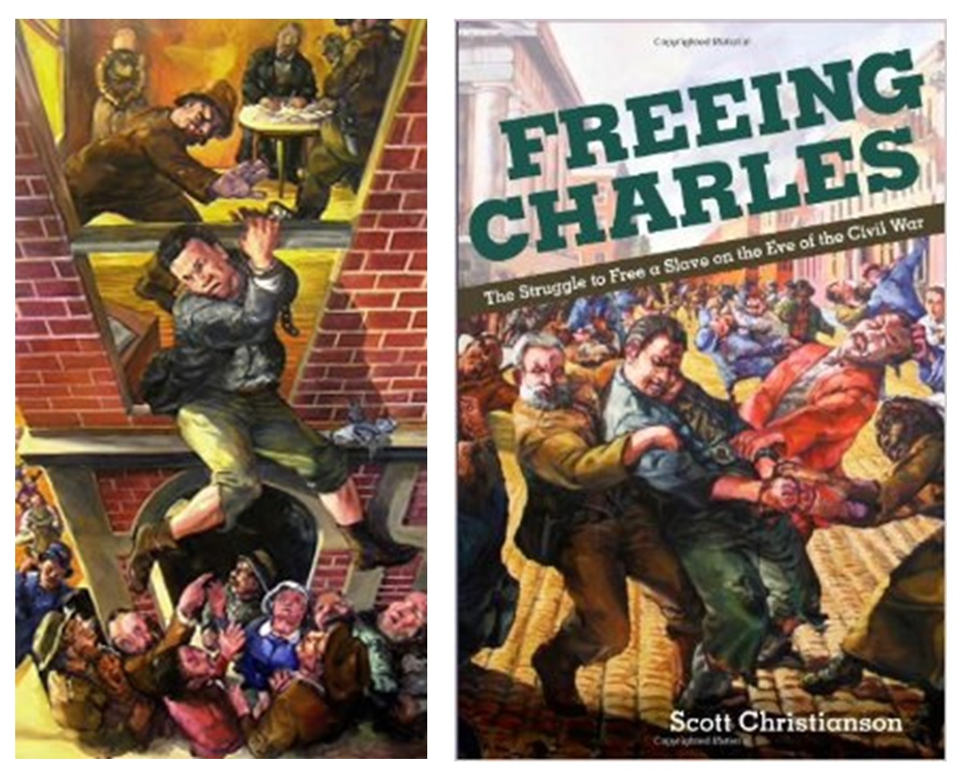

On April 26, 1860, escaped slave Charles Nalle was kidnapped from a Troy bakery and taken to the District Circuit Court at State and First Streets, in Troy where he was to be sent back to Virginia under the Fugitive Slave Act. Hundreds of people, including Harriet Tubman, rushed to the site where a riot ensued, allowing Nalle to escape across the Hudson to West Troy and ultimately to freedom.

READ MORE ABOUT THE RESCUE of CHARLES NALLE and ADDITIONAL LINKS ABOUT FUGITIVE SLAVES

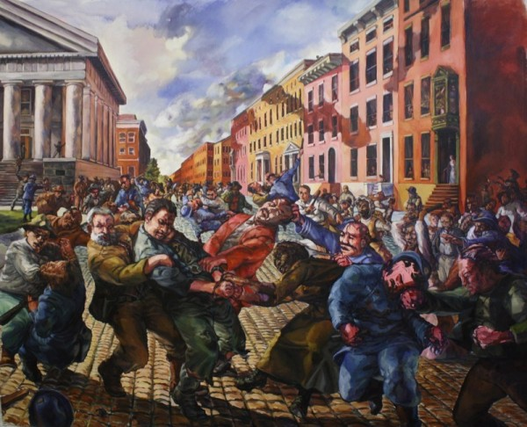
A Ride for Liberty Born in 1824 in Lovell, Maine, Eastman Johnson took to art early in life, setting up a portrait studio in Augusta when he was 18 years old. He later worked in Boston and Washington, D.C., and in 1849 travelled to Europe where he received extensive training in drawing and painting.
In 1859, Johnson opened an exibit in New York which featured Negro Life in the South. It was a turning point in his career -- one which would lead to his becoming, for many years, the foremost genre painter in the United States.
This painting, A Ride for Liberty -- The Fugitive Slaves, depicts a black family fleeing toward freedom. It is based on an incident which Johnson witnessed during the Civil War battle of Manassas. The mother, holding a small child in her arms, looks back apprehensively for possible pursuers.

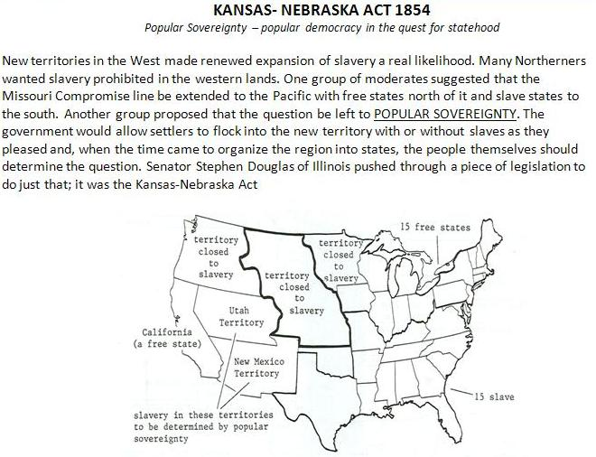

Interactive Map: 1820 to 1854

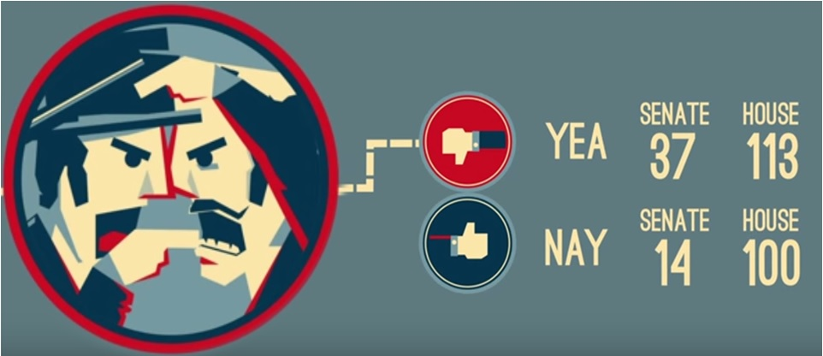
The Congressional Vote on the Kansas-Nebraska Act (1854)
How one piece legislation divided the nation (Ted Ed - 6 mins)
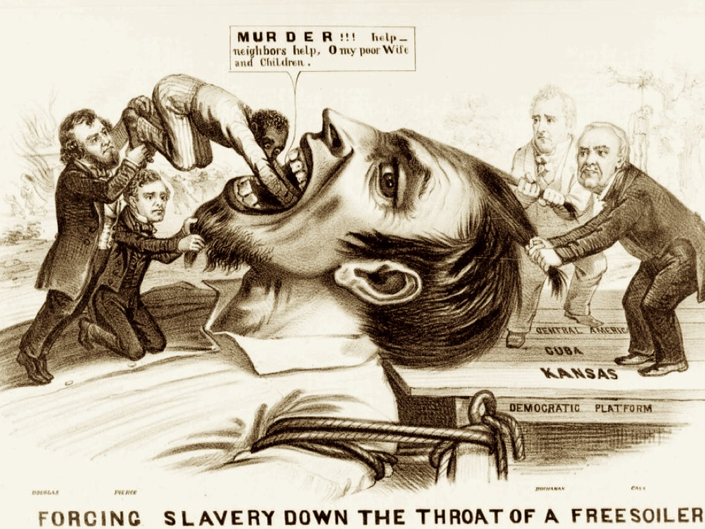

In 1855, Kansas held elections to choose a legislature--either pro or anti-slave. Hundreds of border ruffians from Missouri rode into Kansas and voted illegally. Kansas was in chaos; newspapers called the territory Bleeding Kansas. Brutal murders, masterminded by John Brown occurred at Pottawatomie Creek. By late 1856, over 200 people had been killed. To many people, this brutal act was just more proof that slavery led to violence.

By March of 1855, only one year, less than a year, 11 months after the passage of the Kansas-Nebraska Act, they held their first election for a territorial legislature in the Territory of Kansas. An estimated 5,000 so-called border ruffians — or that meant Missourians — flocked over into Kansas for a day or two to vote.The census — they took a rapid census in the early spring of 1855 in Kansas — recorded 2,905 eligible voters in all of Kansas. In that territorial legislation election, 6,307 people voted; way more than half of the people registered to vote voted. Something was wrong.

They elected a pro-slavery legislature, adopted a pro-slavery constitution overnight. And Free Soilers cried foul, formed their own attempt at a government that summer. And by January of 1856, the beginning of the next year, in a sense, in essence, there were two fledgling territorial governments in Kansas, one free soil, one pro-slavery. And it was then — that spring of 1856 — that what we call Bleeding Kansas, this border frontier, civil war, this village against village, river ravine against river ravine, broke out. Before it played out over about a year and a half about 250 people would be killed — many of them in nighttime raids and vigilante violence — and millions in treasure.

