Name: _________________________ Date: ___________
The Immigrant Experience
Essential Questions:
1. Why do Immigrants come to the United States and what impact did they have upon society?
2. What was life like for Immigrants in the US during the 19th century?
Objective:
Students will be able to analyze
Task: You and your group will examine the multiple theories that historians have proposed for how immigrants are incorporated into American society. Once you have read the short documents your group will pick the theory that you agree with the most and write a properly structured body paragraph to support your chosen argument.
The Melting Pot Model |  | The Salad Bowl Model |  | The Multiple Consciousness Model
Summarize |  | Summarize |  | Summarize
Strengths | Weaknesses | Strengths | Weaknesses | Strengths | Weaknesses

Theories on Immigrant Incorporation into American Culture
Culture Assimilation – the process by which characteristics of members of immigrant groups and the host societies come to resemble one another
1. Melting Pot
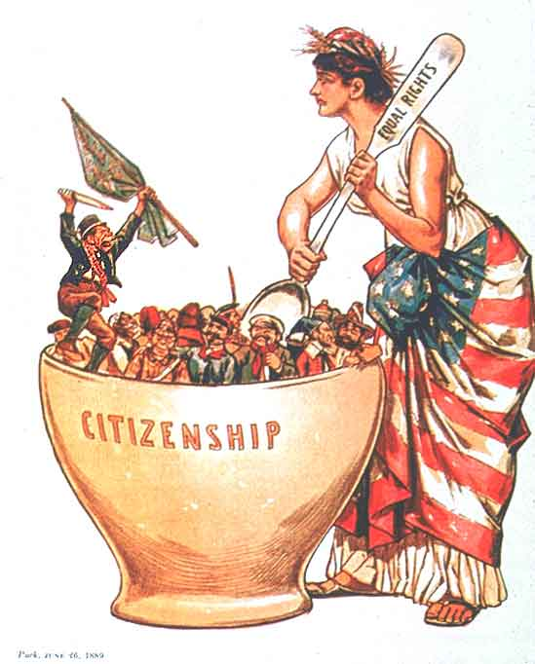
The growing diversity of the immigrants coming into the United States during the late 1800s and early 1900s and the rapid rise of industrialization led to the creation of the melting pot theory. This theory was name after the play title The Melting-Pot, written in 1908 by Israel Zangwill. This play centered on an interracial marriage and the symbolism of the melting pot became popular. Historians who favored this theory believed that the United States was a giant melting pot that could welcome people from anywhere and infuse upon them the culture and ideals of their new American homeland. In this theory immigrants of different cultural backgrounds, with varied skin pigmentations, dressed in their colorful ancestral costumes, would walk through a symbolic melting pot upon arrival in the United States and reappear on the other end as members of a homogeneous culture. This is generally viewed as the classic assimilation theory and supports the idea that immigrants follow a ‘straight-line’ towards American culture, with immigrants who have lived in America the longest showing the most ‘American’ like cultural traits. Early versions of the theory have been criticized as "Anglo-conformist" because immigrant groups were depicted as conforming to unchanging, middle-class, white Protestant values and losing their original cultural identity.
http://immigrationinamerica.org/364-assimilation-theories.html

Theories on Immigrant Incorporation into American Culture
Culture Assimilation – the process by which characteristics of members of immigrant groups and the host societies come to resemble one another

2. Salad Bowl/ Cultural Pluralism
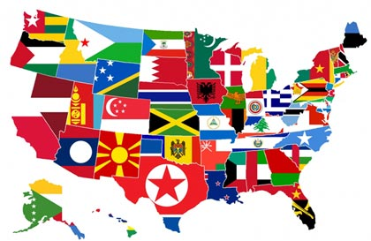
The idea of Cultural Pluralism or Multiculturalism arose in the wake of the Civil Rights movement and the reform of the immigration policy during the 1960’s. The rising presence of cultural diversity and the strengthening voice of immigrants and minorities began a series of vast social and political transformations. Diversity began to be perceived with a growing appreciation and historians began to reexamine how immigrants were incorporated into American culture. The salad bowl model states that immigrants retain aspects of their unique cultural identity and never completely merge into a single uniform American culture. This model suggests that American society is made up of many different, and unique individual cultures that, while living together, never fully merge with one another. The salad bowl suggests a peaceful co-existence of many different cultures, enriching the whole nation.
The cultural traditions and economic contributions of immigrants are respected, acknowledged, and applauded. Instead of forcing immigrants to be assimilated to any prescribed cultural norm, different cultural groups are encouraged to express themselves in reshaping and redefining what the mainstream culture is. Supporters of this model argue that being American is not tied to a single culture, but rather to citizenship and loyalty to the United States. Thus, one does not need to abandon one's own cultural heritage in order to be considered "American". Critics tend to oppose the idea saying that America needs to have a common culture in order to preserve a common "American" identity.
http://immigrationinamerica.org/454-cultural-pluralism.html

Theories on Immigrant Incorporation into American Culture
Culture Assimilation – the process by which characteristics of members of immigrant groups and the host societies come to resemble one another

3. ‘Child’s Plate’ or Multiple Consciousness model (Hyphenated Americans)
Although the experiences of European groups coming to the United States in the early-20th century suggest that full assimilation would generally occur within three to four generations, there was no fixed timetable that could predict this process. Many immigrants never experienced this full assimilation and felt like they were living with two separate identities. Some immigrants struggled between two identities that at times seem to be mutually exclusive while others felt more comfortable identifying themselves with different social and personal identities.
The multiple consciousness model suggest that immigrants can be loyal to both their new American nation and their old nation and culture. In this messy model the old and new cultural identities blur together, as children merge food on their plates, but still retain the unique characteristics that make them distinguishable from one another. Immigrants can retain pride in their heritage but also positively contribute to their new nation and commit themselves to becoming American citizens. Opponents of this model argue that retaining a duel identity is impossible. That one individual cannot be loyal to two separate nations at the same time. There have been calls to revive efforts to encourage "Americanization" of the newcomers, but many researchers now express doubt that the old assimilation model works. For one thing, today there seems to be less of a dominant culture to enter. American culture is much more multicultural than it once was and people no longer fit into the neat ethnic boxes that they once did.
http://www.migrationpolicy.org/article/assimilation-models-old-and-new-explaining-long-term-process

