1968
Setting the Stage: The year 1968 marked many changes for the United States. It signaled the end of the Kennedy-Johnson presidencies, the end of the civil rights movement, and the beginning of the end of the war in Vietnam. More than that, it meant a change in public attitudes and beliefs.
January 31 The North Vietnamese launch the Tet offensive. Nearly 70,000 North Vietnamese troops will take part in this broad action, taking the battle from the jungles to the cities. The offensive will carry on for weeks and is seen as a major turning point for the American attitude toward the war. At 2:45 that morning the US embassy in Saigon is invaded and held until 9:15AM.

February 1 During police actions following the first day of the Tet offensive General Nguyen Ngoc Loan, a south Vietnamese security official is captured on film executing a Viet Cong prisoner by American photographer Eddie Adams. The Pulitzer Prize-winning photograph becomes yet another rallying point for anti-war protestors. Despite later claims that the prisoner had been accused of murdering a Saigon police officer and his family, the image seems to call into question everything claimed and assumed about the American allies, the South Vietnamese.
February 4 Martin Luther King Jr. delivers a sermon at his Ebenezer Baptist Church in Atlanta which will come to be seen as prophetic. His speech contains what amounts to his own eulogy. After his death, he says, "I'd like somebody to mention that day that Martin Luther King Jr. tried to give his life serving others. I'd like for somebody to say that day that Martin Luther King Jr. tried to love somebody... that I tried to love and serve humanity,. Yes, if you want to, say that I was a drum major for peace... for righteousness."
February 27 Walter Cronkite reports on his recent trip to Vietnam to view the aftermath of the Tet Offensive in his television special Who, What, When, Where, Why? The report is highly critical of US officials and directly contradicts official statements on the progress of the war. After listing Tet and several other current military operations as "draw[s]" and chastising American leaders for their optimism, Cronkite advises negotiation "...not as victors, but as an honorable people who lived up to their pledge to defend democracy, and did the best they could."
March 16 Senator Robert Kennedy, former Attorney General and brother of former president John F. Kennedy (1961-63) ends months of debate by announcing that he will enter the 1968 Presidential race.
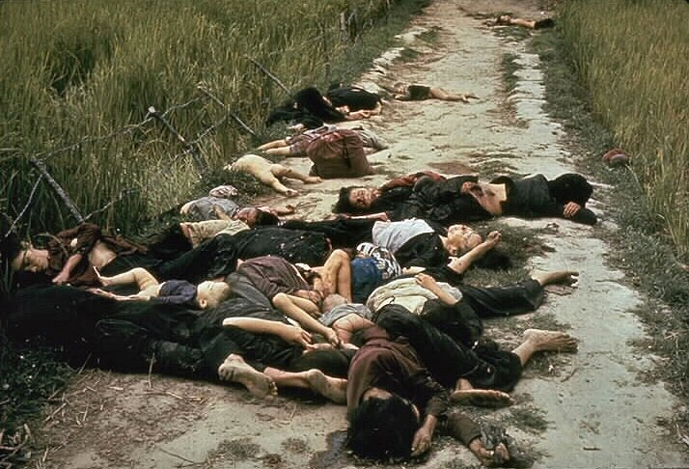
March 16 Although it will not become public knowledge for more than a year, US ground troops from Charlie Company rampage through the hamlet of My Lai killing more than 500 Vietnamese civilians from infants to the elderly. The massacre continues for three hours until three American fliers intervene, positioning their helicopter between the troops and the fleeing Vietnamese and eventually carrying a handful of wounded to safety. View the BBC Special Report on the incident.

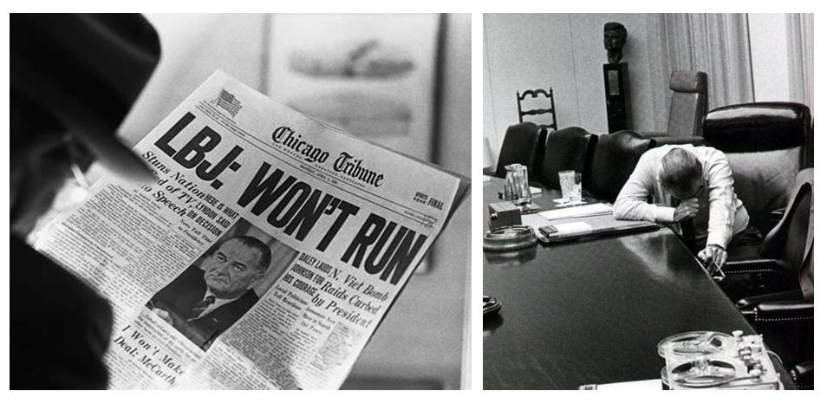
March 31 President Lyndon Johnson delivers his Address to the Nation Announcing Steps To Limit the War in Vietnam and Reporting His Decision Not To Seek Reelection. The speech announces the first in a series of limitations on US bombing, promising to halt these activities above the 20th parallel.
April 3 Civil rights leader Martin Luther King Jr. delivered his "mountaintop" speech to a rally of striking sanitation workers in Memphis, Tenn., less than 24 hours before he was assassinated
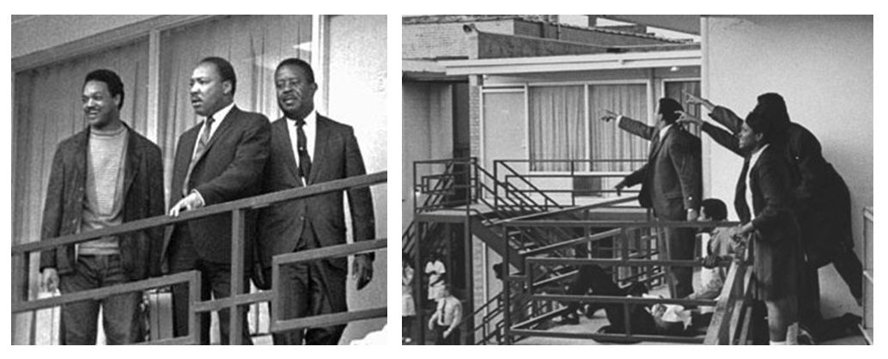
April 4 - While supporting sanitation workers' strike which had been marred by violence in Memphis, King is shot by James Earl Ray. Riots result in 125 cities.
-Robert Kennedy, hearing of the murder just before he is to give a speech in Indianapolis, IN, delivers a powerful extemporaneous eulogy in which he pleads with the audience "to tame the savageness of man and make gentle the life of this world."
The King assassination sparks rioting in Baltimore, Boston, Chicago, Detroit, Kansas City, Newark, Washington, D.C., and many others. Across the country 46 deaths will be blamed on the riots.
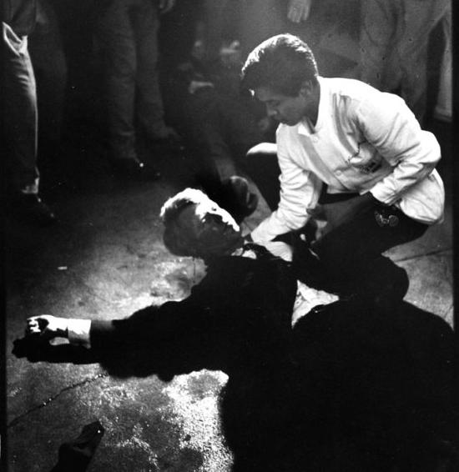
June 4/5 On the night of the California Primary Robert Kennedy addresses a large crowd of supporters at the Ambassador Hotel in San Francisco. He has won victories in California and South Dakota and is confident that his campaign will go on to unite the many factions stressing the country. As he leaves the stage, at 12:13AM on the morning of the fifth Kennedy is shot by Sirhan Sirhan, a 24 year old Jordanian living in Los Angeles.
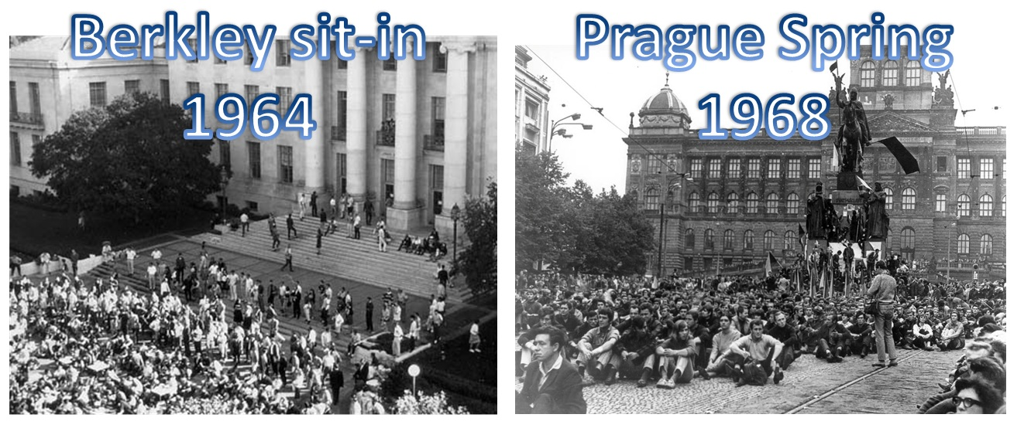June 27 As the "Prague Spring" continues in Czechoslovakia Ludvik Vaculik releases his manifesto "Two Thousand Words". This essay, criticizing Communist rule in Czechoslovakia and concluding with an overt threat to "foreign forces" trying to control the government of the country was seen as a direct challenge to the Soviet Administration who extended ongoing military exercises in the country, and began planning for their invasion later in the summer.
June 28 A bill adding a 10 percent surcharge to income taxes and reducing government spending is signed by President Johnson. The president effectively admits it has been impossible to provide both "guns and butter."

July 24 At the Newport (Rhode Island) Folk Festival singer Arlo Guthrie performs his 20 minute ballad "Alice's Restaurant" to rave reviews
August 8 At their Party convention in Miami Beach the Republicans nominate Richard M. Nixon to be their presidential candidate. Nixon has been challenged in his campaign by Nelson Rockefeller of New York, and Ronald Reagan of California.
August 20 The Soviet Union invades Czechoslovakia with over 200,000 Warsaw Pact troops, putting an end to the "Prague Spring," and beginning a period of enforced and oppressive "normalization."

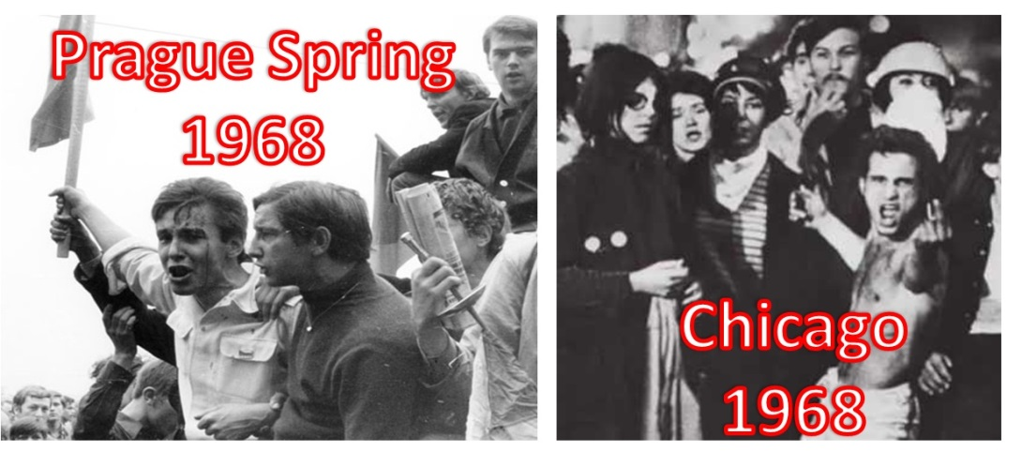
August 26 Mayor Richard Daley opens the Democratic National Convention in Chicago. While the convention moves haltingly toward nominating Hubert Humphrey for president, the city's police attempt to enforce an 11 o'clock curfew. On that Monday night demonstrations are widespread, but generally peaceful. The next two days, however, bring increasing tension and violence to the situation.
August 28 By most accounts, on Wednesday evening Chicago police take action against crowds of demonstrators without provocation. The police beat some marchers unconscious and send at least 100 to emergency rooms while arresting 175. Mayor Daley tried the next day to explain the police action at a press conference. He famously explained: "The policeman isn't there to create disorder, the policeman is there to preserve disorder." Twenty-eight years later, when the Democrats next held a convention in Chicago, some police officers still on the force wore t-shirts proclaiming, "We kicked their father's butt in '68 and now it's your turn."
September 7 Women's Liberation groups, joined by members of New York NOW, target the Miss America Beauty Contest in Atlantic City. The protest includes theatrical demonstrations including ritual disposal of traditional female roles into the "freedom ashcan." While nothing is actually set on fire, one organizer's comment - quoted in the New York Times the next day - that the protesters "wouldn't do anything dangerous, just a symbolic bra-burning," lives on in the derogatory term "bra-burning feminist."

September 29 This date marks the thirtieth anniversary of Neville Chamberlain's Munich agreement ceding Czechoslovakia's Sudatenland to Hitler. This action widely seen as a major contributing factor to the devastation of World War II. The domino theory which underlay so much of American action in Vietnam can be seen as a direct response to the failure of international response to the German dictator.
October 3 (Party Split gives Nixon the win) George Wallace, who has been running an independent campaign for the presidency which has met significant support in the South and the Midwest, names retired Air Force Chief of Staff Curtis E. LeMay to be his running mate. At the press conference, the general is asked about his position on the use of nuclear weapons, and responds: "I think most military men think it's just another weapon in the arsenal... I think there are many times when it would be most efficient to use nuclear weapons. ... I don't believe the world would end if we exploded a nuclear weapon."

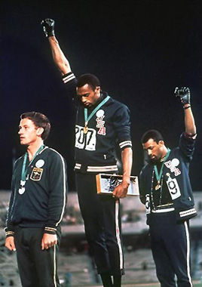
October 12 The Summer Olympic Games open in Mexico City. The games have been boycotted by 32 African nations in protest of South Africa's participation. On the 18th Tommie Smith and John Carlos, US athletes and medalists in the 200-meter dash will further disrupt the games by performing the black power salute during the "Star-Spangled Banner" at their medal ceremony.

October 31 President Johnson announces a total halt to US bombing in North Vietnam.

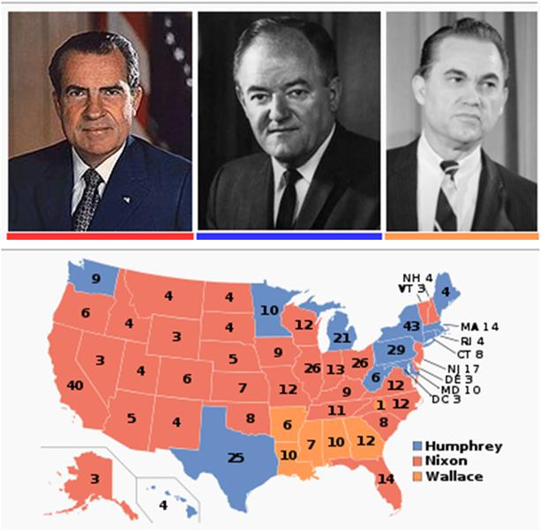

November 5 Election Day. The results of the popular vote are 31,770,000 for Nixon, 43.4 percent of the total; 31,270,000 or 42.7 percent for Humphrey; 9,906,000 or 13.5 percent for Wallace; and 0.4 percent for other candidates.

http://en.wikipedia.org/wiki/United_States_presidential_election,_1968

November 14 National Turn in Your Draft Card Day is observed with rallies and protests on college campuses throughout the country.
December 21 The launch of Apollo 8 begins the first US mission to orbit the Moon.

